GIST publishes the late Professor Kyoung-Woong Kim's posthumous work, 『Environment and the Future of Possibility: An Environmental Engineer's Final Discourse』 on the 22nd

- A posthumous collection of conversations between the late environmental engineers Kyoung-Woong Kim (GIST) and Professor Jae-Won Cho (UNIST)… Re-examining the environment not as a target of protection or a policy tool, but as a central principle of thought that permeates technology, society, and ethics

- Professor Kim's humanitarian life trajectory is also captured in the conversation… Unfinished discourse that addresses key contemporary issues such as climate, energy, AI, and quantum science through fundamental questions, leaving questions for future generations

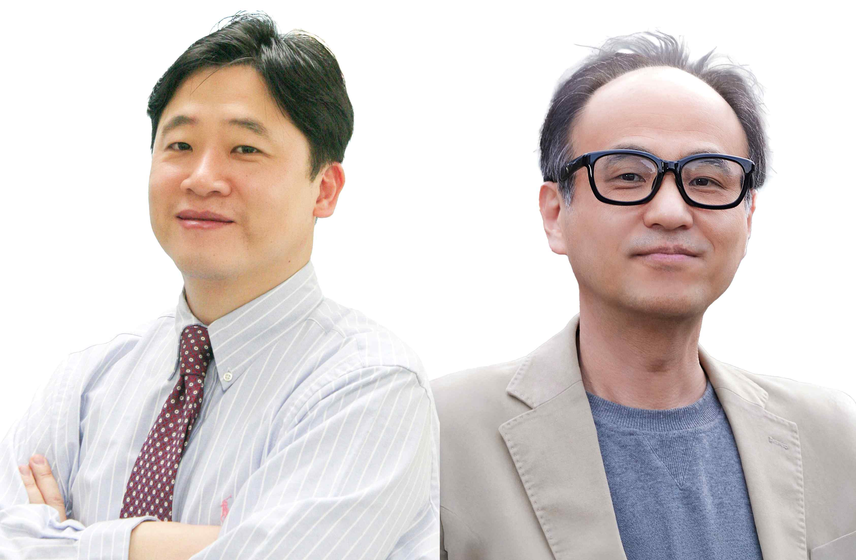

▲ (From left) The late Professor Kyoung-Woong Kim of the Department of Environment and Energy Engineering at GIST and Professor Jae-Won Cho of the Department of Earth, Environmental, Urban and Civil Engineering at UNIST

The Gwangju Institute of Science and Technology (GIST, President Kichul Lim) announced the publication of "Environment and the Future of Possibility: An Environmental Engineer's Final Discourse," a book compiling conversations between the late Professor Kyoung-Woong Kim, an environmental engineer who passed away this fall, and his longtime colleague and co-author, Professor Jae-Won Cho of the Department of Earth, Environmental, Urban and Civil Engineering at UNIST, on Monday, the 22nd.

"Environment and the Future of Possibility: An Environmental Engineer's Final Discourse" poses pervasive questions from the perspective of an environmental engineer. Beyond academic debate, it fundamentally reexamines the world we live in and the possibilities we should choose for the future. Rather than limiting the environment to a target of protection or a means of policy, it focuses on repositioning it as a central principle of thinking that encompasses technology, society, and ethics.

The publication project, which initially faced potential suspension, was finally released through GIST Press, the university press of GIST, where Professor Kim had worked for 28 years as a researcher and educator, thanks to the collective efforts of fellow professors who commemorated the deceased.

This book fully captures Professor Kim's deep concern for the environment, his scholarly approach, and his questions for future generations, which he deeply contemplated until the end of his life.

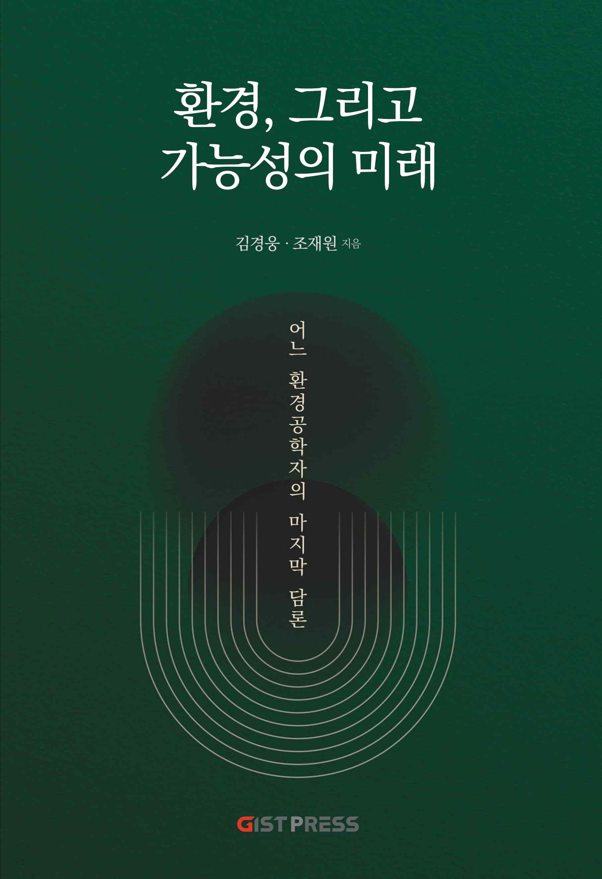

▲ Cover of the book "Environment and the Future of Possibility: An Environmental Engineer's Final Discourse"

Professor Kim, a world-renowned researcher in the field of soil and groundwater contamination remediation, has not only achieved academic success, serving on the editorial board of international journals and winning numerous domestic and international academic awards, but has also dedicated himself to extending his research findings to the lives of humanity.

His work includes the "Ongdalsam Project," which developed a water purification system that operates without electricity and distributed it to water-scarce regions; the "GIST Hope Water Purifier," a non-powered membrane water treatment device that removes contaminants solely through gravity, distributed to over 20 countries, including Nepal, Indonesia, and the Philippines; and the project that established an environmental engineering degree program at the Royal University of Phnom Penh in Cambodia. These projects demonstrate that environmental engineering can extend beyond mere knowledge and directly connect to human dignity.

This life's journey forms the foundation for the conversations and reflections unfolding in this book. Core contemporary issues, such as the climate and energy crisis, population issues, the ethics of artificial intelligence (AI), and the values ​​of the quantum computer era, are presented to readers not as a list of technological solutions, but as questions about what responsibilities humans and society will choose.

The conversation between two professors, who have worked together in environmental research and education for over 30 years—a field often touted as a "promising discipline" but rarely at the forefront of the times—persuasively demonstrates that the environmental perspective is the fundamental principle that can transcend and reunite all issues.

The book clearly demonstrates that environmental discourse will ultimately remain the "principle of all principles." It also offers the insight that the zeitgeist of future technologies, represented by current artificial intelligence and upcoming quantum computers, cannot be fully understood without an environmental perspective.

This transcends the dichotomy of optimism or rejection of technological progress, prompting a rethinking of the conditions and responsibilities upon which technology rests.

The two authors, possessing differing perspectives, interpret their relationship as a "friendship between the gaps and the spaces," and this is reflected throughout the book in the form of dialogue and monologue.

Their conversation, which lingers on questions rather than definitive conclusions, ends incomplete. However, this does not signify an interruption; it signifies that the next generation must continue Professor Kim's lifelong practice of "questions that connect the environment to life." The book concludes by leaving this void for his students and readers to fill.

Professor Jae-won Cho expressed his condolences, saying, "I feel that the void left by my friend's departure holds the potential to fill a world facing crisis." He added, "The seat next to me is empty, but the temporality my colleague left behind will endure forever."



