Researcher Jeong-yoon Hwang of the GIST Energy Valley Institute of Technology received a commendation from the Mayor of Gwangju for his contributions to the development of the Gwangju energy industry

- Implementing a wide range of field-focused activities, from energy policy and strategic planning to establishing a platform for industry-academia-research collaboration

- "As a strong partner in the Gwangju energy industry, contributing to the creation of a sustainable ecosystem"

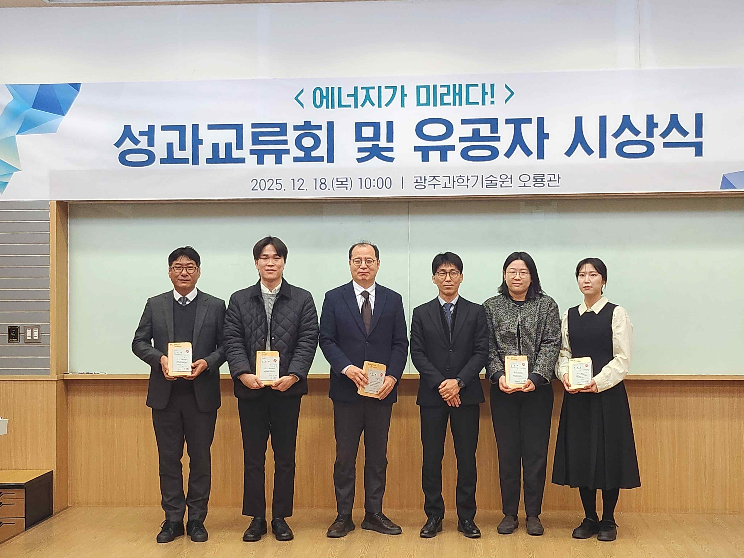

▲ Researcher Jeong-yoon Hwang (right) of the GIST Energy Valley Institute of Technology, who received the Gwangju Metropolitan Mayor's Award for his contributions to revitalizing the Gwangju energy industry and fostering industry-academia-research cooperation, poses for a commemorative photo with officials and recipients.

The Gwangju Institute of Science and Technology (GIST, President Kichul Lim) announced that Researcher Jeong-yoon Hwang of the Energy Valley Institute of Technology received the Gwangju Metropolitan Mayor's Award on Thursday, December 18, in recognition of his contributions to the sustainable development of the Gwangju region's energy industry and the establishment of a cooperative ecosystem.

Researcher Hwang has contributed to strengthening the competitiveness of Gwangju's energy industry and fostering a sustainable ecosystem through a wide range of field-oriented activities, including ▴ energy industry policy and strategic planning, ▴ establishment of an industry-academia-research cooperation platform, ▴ planning and operating energy events, and ▴ discovering and supporting the growth of promising energy companies.

The Energy Valley Institute of Technology forms and operates a topic-specific energy expert planning committee to reflect the changing energy industry environment, policy, and industry demands each year.

This year, it operated four divisions: ▴ distributed energy, ▴ batteries, ▴ hydrogen, and ▴ RE100 Industrial Complex, and achieved results in discussing the direction of the regional energy industry from a mid- to long-term perspective and producing a planning report.

Furthermore, to foster broad exchanges between industry, academia, and research organizations, it has consistently planned and operated various networking events, including energy industry technology exchange meetings held in the first and second halves of the year, expert seminars, and advisory meetings.

In the first half of the year, it hosted a technology exchange event for local companies called "G.E.T. & Re:Born," which included investor presentations and field-focused networking. In the second half of the year, we hosted the "Bit.Na.Da." technology exchange event, which aimed to connect researchers' technology commercialization and startups. This resulted in tangible results, including requests for follow-up collaboration between researchers and companies.

Additionally, it held the following events: ▴ Gwangju Future Industry EXPO Electric Vehicle Battery Conference; ▴ Korea Climate, Environment, and Energy Expo (KEET) "G-Energy OnCall" relay lectures; ▴ BIXPO-linked RE100 Industrial Complex Activation Conference; and ▴ supporting agency-cooperative "GO!GO!GO!" GIST Energy Valley Institute of Technology has been planning and operating various events, including the "FAIR," to elevate the status of the Gwangju energy industry and support corporate growth.

Furthermore, GIST Energy Valley Institute of Technology continues to provide on-site support by organizing small-scale, customized events that reflect the needs of the industry, such as RE100, blue-green hydrogen seminars, and battery advisory meetings.

Recently, GIST Energy Valley Institute of Technology has been collaborating with the Gwangju Free Economic Zone Authority to develop business models (BMs) and provide customized consulting services to encourage the attraction of companies to the Gwangju region.

Researcher Jeong-yoon Hwang stated, "I have taken on a responsible role in the field, from policy planning to operating a collaborative platform and supporting companies. I will continue to do my best to ensure that GIST Energy Valley Institute of Technology continues to be a strong partner in the Gwangju energy industry and contribute to the creation of a sustainable ecosystem."

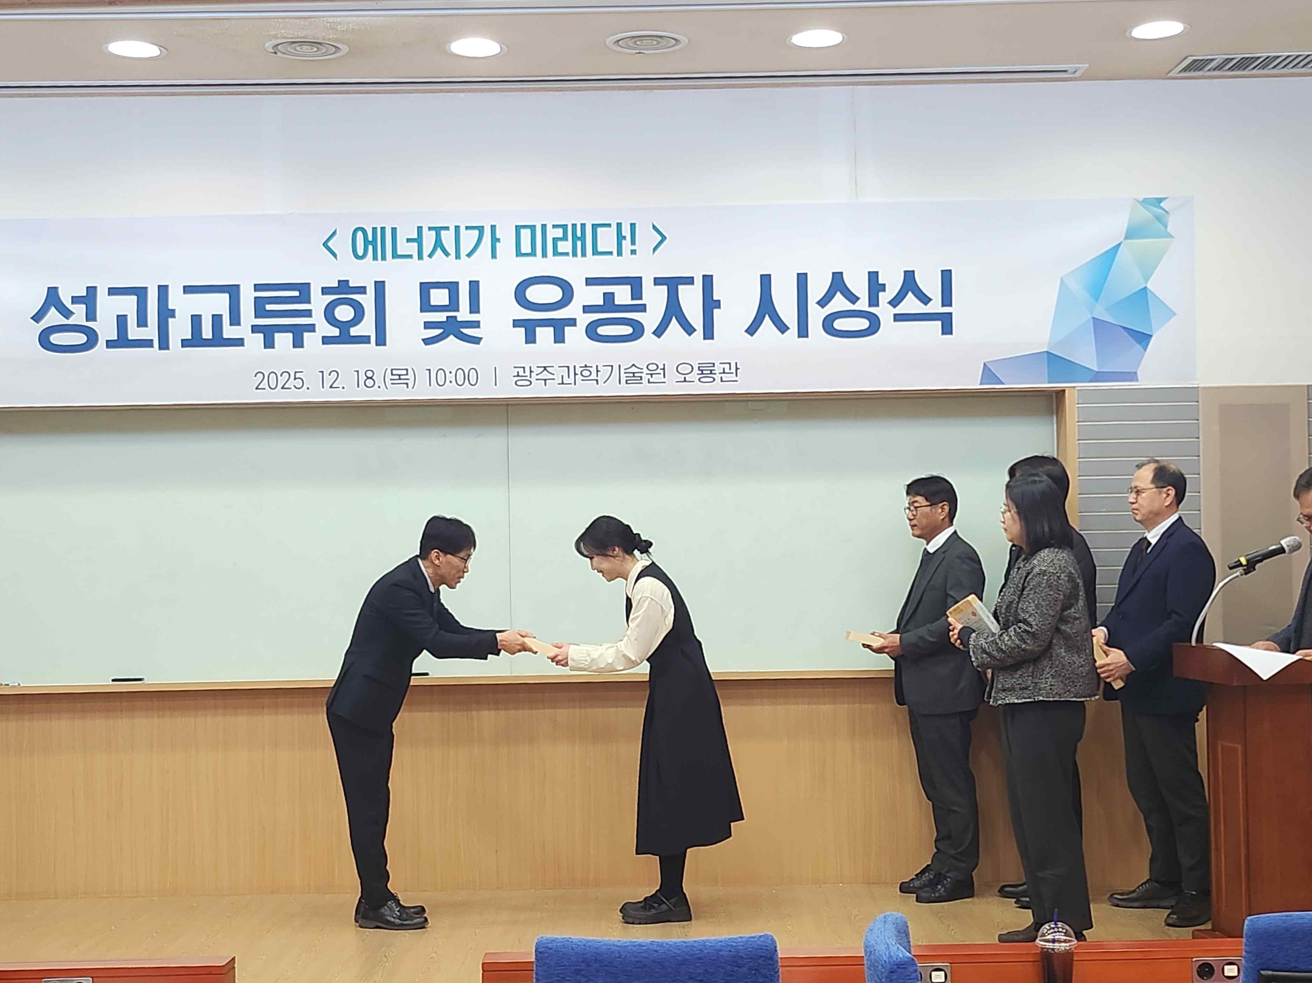

▲ Researcher Jeong-yoon Hwang of the GIST Energy Valley Institute of Technology receives the Gwangju Mayor's Award for Contribution to Energy Promotion.



