GIST undergraduate team wins grand prize at the DIC2025 startup competition

- Six first and second year undergraduate students participating in GIST's flagship extracurricular program, the "Infinite Challenge Project," developed a startup idea and developed a hyper-personalized home gardening app that provides customized care solutions for companion plants

- Winning the Excellence Award at the "1st NAMUHX Hackathon," hosted by SK Intelix, further validates their competitiveness... Preparations are underway for commercialization, with submissions to the Ministry of SMEs and Startups and the Korea Innovation Promotion Agency's 2026 Preliminary Startup Package

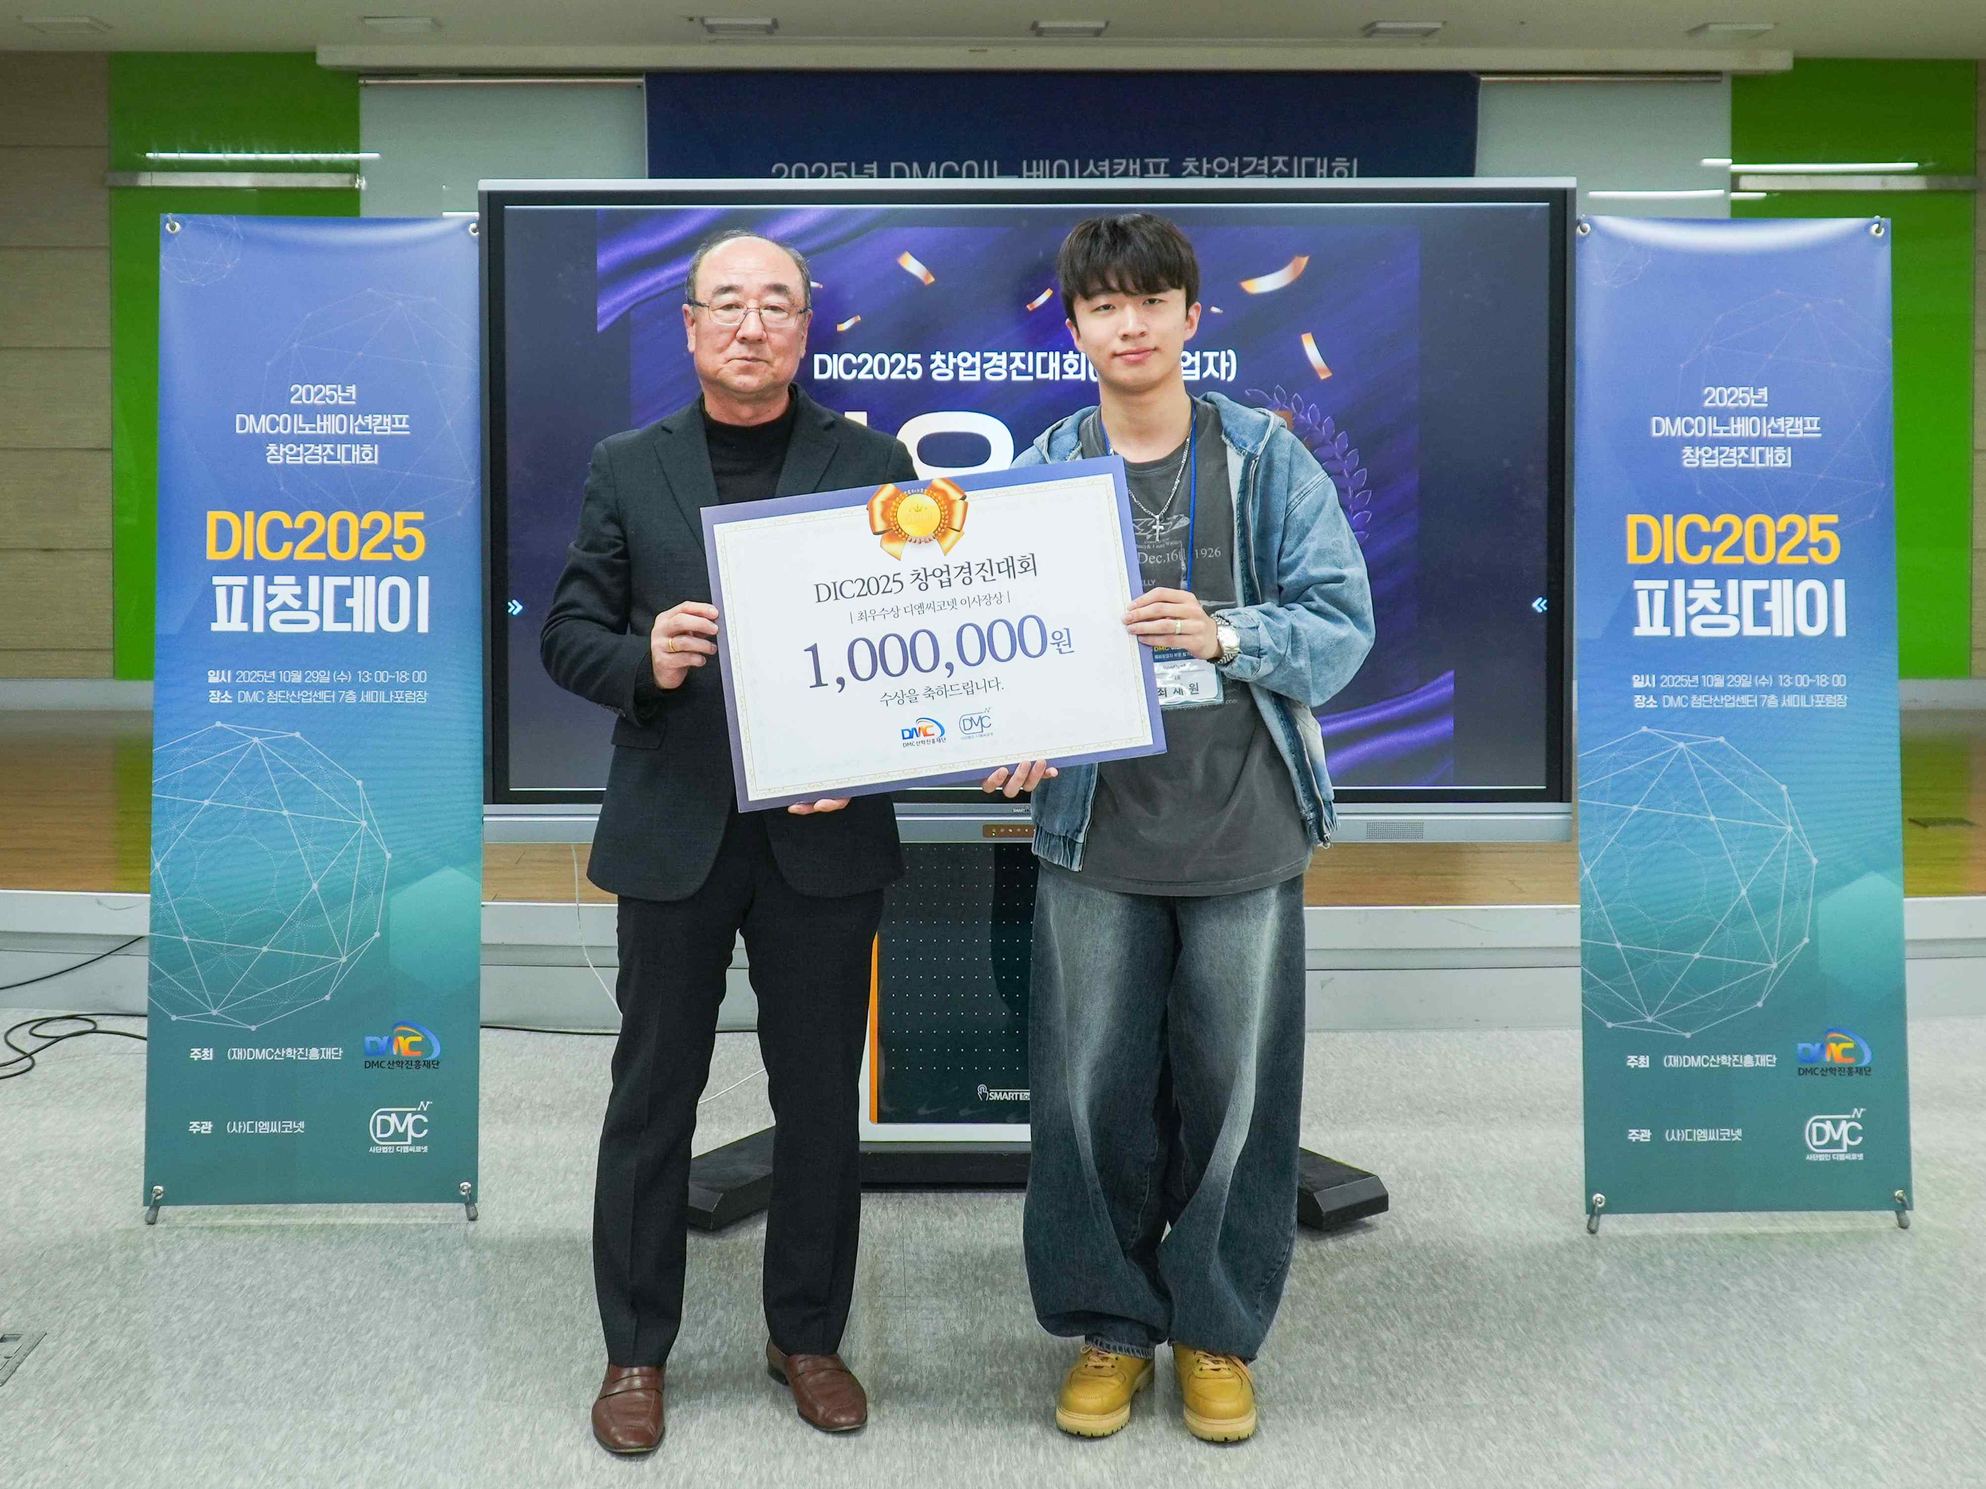

▲ Jaewon Choi, a freshman in the Challenge Exploration Program and the representative of the "Rootive" team comprised of GIST undergraduate students, poses for a commemorative photo after winning the grand prize (second place) in the preliminary entrepreneur track of the "2025 DMC Innovation Camp Entrepreneurship Competition (DIC2025).

The Gwangju Institute of Science and Technology (GIST, President Kichul Lim) announced that the "Rootive" team (CEO: Jaewon Choi, freshman in the Challenge Exploration Program), comprised of first- and second-year undergraduate students, won the grand prize (second place) in the preliminary entrepreneur track of the "2025 DMC Innovation Camp Entrepreneurship Competition (DIC2025)," hosted by the DMC Industry-Academic Cooperation Foundation and DMC Co.Net and operated by The Innovators.

DIC2025 is a nationwide startup competition that discovers and nurtures innovative ideas from aspiring and early-stage entrepreneurs, supporting their commercialization and practical experience.

The awards ceremony was held in Sangam-dong, Mapo-gu, Seoul on the 29th of last month. One grand prize winner and seven top prize winners were selected from the aspiring entrepreneur track, while one grand prize winner, two top prize winners, and four excellence prize winners were selected from the early-stage entrepreneur track. The Rootive team won the grand prize among 73 aspiring entrepreneur teams, demonstrating their high startup potential.

The Rootive team is developing a hyper-personalized home gardening application that provides customized care solutions for companion plant owners. Using only photos taken by users, AI analyzes and diagnoses the growth status of companion plants, providing customized cultivation guidelines optimized for each plant.



▲ Demo image of the Rootive team's hyper-personalized home gardening application analysis. Currently, the team is receiving expert mentorship to refine their idea's commercial viability for submission to the "2026 Startup Package," operated by the Ministry of SMEs and Startups and the Korea Institute of Startups and Entrepreneurship Development. This program aims to discover and support aspiring entrepreneurs with innovative technologies and business models.

The Rootive team originated from the "G-Quarium" team, which participated in the "Infinite Challenge Project*," a representative extracurricular creative and challenging program at GIST that celebrates its 10th anniversary this year. They expanded their startup idea based on their experience in artificial ecosystem research and have since proven their mettle with consistent success at nationwide hackathons.

Notably, they showcased a service platform featuring interactive care features that allow companion plants to interact with users, earning an Excellence Award at the "1st NAMUHX Hackathon*" hosted by SK Intelix on December 5th, further demonstrating their competitiveness.

* GIST Infinite Challenge Project: This autonomous and experimental program fosters students' creativity and spirit of challenge. Regardless of their major, students form teams to implement their ideas and undertake diverse projects, including research, technology development, and solving social problems. The university provides mentoring, space, and material support, and encourages experimental attempts without fear of failure.

* NAMUHX Hackathon: Hosted by SK Intelix, this AI- and data-based creative idea competition aims to improve human-environment interaction (HX). Participants compete in various tracks to develop innovative solutions. "NAMUHX" is an SK Intelix brand that combines nature (Namu) and user experience (HX).

Jaewon Choi, CEO of the Rootive team, stated, "We were able to achieve such great results thanks to GIST's unique Infinite Challenge Project, the Startup Promotion Center, and the meticulous feedback from our advisors. We will continue to lead the way in creating an ecosystem where even college students can start businesses."



