A GIST graduate student team placed second in an international competition where AI competed using Pokémon game strategy

- The "4thLesson" team, comprised of four graduate students in the Department of AI Convergence (advisor: Professor KyungJoong Kim), placed second in the Pokémon Gen 1 battle category of the "PokéAgent Challenge," an AI strategy competition based on Pokémon game battle environments

- The team presented an effective methodology for AI to learn independently even in limited data and uncertain environments... The final results were announced on December 7th at the "NeurIPS 2025 Conference," the world's most prestigious AI academic conference

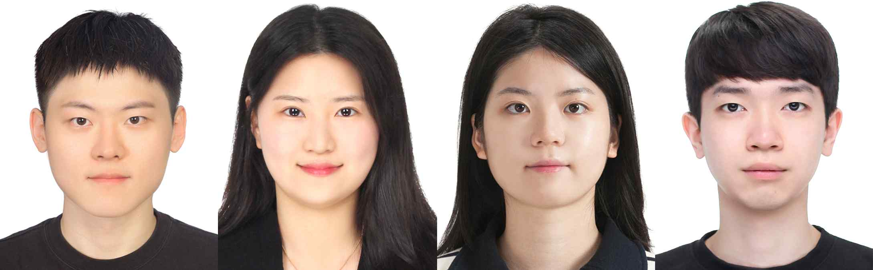

▲ Team "4thLesson," which placed second in the "PokeAgent Challenge." (From left) GIST master's students Gyung-Bo Kim, Eunju Kwon, Yujin Kim, and Sangyeon Park

The Gwangju Institute of Science and Technology (GIST, President Kichul Lim) announced that the "4thLesson" team (master's students Gyung-Bo Kim, Eunju Kwon, Yujin Kim, and Sangyeon Park, and their advisor, Professor KyungJoong Kim), comprised of graduate students in the Department of AI Convergence, placed second in the "Battle Track: Pokémon Gen 1 OU*" category at the "2025 PokeAgent Challenge," an international AI competition hosted by NeurIPS, the world's most prestigious artificial intelligence (AI) conference.

Both the preliminaries and finals were held online, and the final results were announced at the NeurIPS 2025 conference in San Diego, California, on December 7th.

* OU (Overused): These Pokémon are the most frequently selected in Pokémon battles. Their high stats, effective moves, and advantageous characteristics make them a key strategic asset. Due to these characteristics, some tournaments and formats may impose restrictions on their use for balance purposes. They are also used for various purposes, such as strategic research and analysis of opponent strategies in AI learning environments.

The PokeAgent Challenge is an international competition that pits AI against AI in an environment that replicates the battle mechanics of Pokémon games (Pokémon selection, move use, and switching strategies). It evaluates the AI's ability to make intelligent decisions and formulate strategies under uncertain circumstances.

Participating teams train models using self-play* and data expansion strategies within limited data and computational resources, and experiment with various strategies according to rules (Gen 1 OU, Gen 9 OU*) that reflect the structure of Pokémon types, skills, and abilities that vary depending on the version of the Pokémon game.

The competition consists of two tracks: Battling and Speedrunning. The Battling track, in particular, is a key event that evaluates AI's comprehensive capabilities, including predicting opponent strategies, long-term planning, and the ability to respond to incomplete information.

* self-play: In reinforcement learning, this refers to a method in which a model learns by acting as its own opponent. In other words, without using external data, the model repeatedly competes against itself or other models in training, exploring and improving its strategies. This enhances decision-making capabilities in various situations, increases data efficiency, and improves generalization performance.

* Gen 1 OU, Gen 9 OU: Generational battle formats in Pokémon games. Each generation has different available Pokémon, moves, abilities, game rules, and balance, significantly altering the strategic environment. Gen 1 OU features a simple strategy structure that incorporates the initial 151 Pokémon and the calculation methods and bugs unique to Generation 1, favoring certain OP Pokémon (e.g., Mewtwo and Kentaros). While Gen 9 OU includes Pokémon up to the latest generation, with moves, abilities, and item effects adjusted to the latest rules, offering a much greater variety of strategies and combinations.

To maximize performance even with limited resources, the GIST "4thLesson" team adopted a fine-tuning strategy*, starting with an AI model that had already learned basic abilities and adding only the necessary additional training.

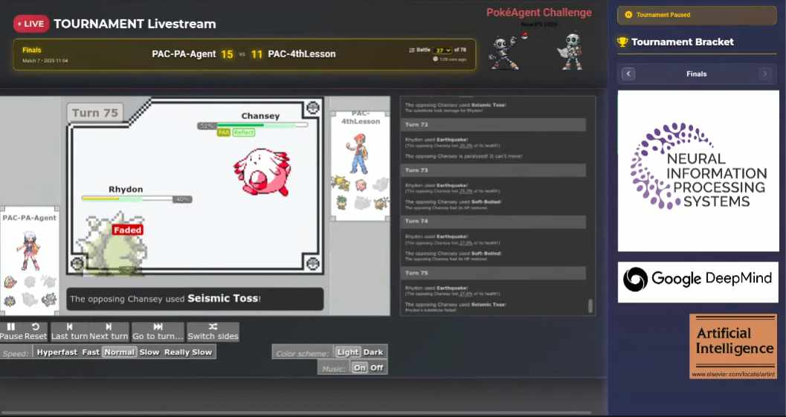

▲ PokeAgent Challenge finals

To ensure more stable learning, the team adopted a new learning technique called the "Kron Optimizer*," which helps the AI ​​learn more efficiently on its own. This technique replaces existing methods.

Furthermore, to prevent "plasticity loss," where the AI ​​struggles to learn new information over time, the team applied AID* technology to continuously maintain learning capabilities.

* fine-tuning strategy: This strategy involves performing additional training based on a pre-trained model, tailored to new data or specific tasks. This allows the model to quickly adapt and improve performance even in environments with limited data and computational resources, and enables more efficient and stable learning than training the model from scratch.

* Kron Optimizer: This is a secondary optimization algorithm that utilizes secondary information (such as the Hessian matrix) to efficiently update parameters in neural network learning. Unlike existing primary optimizers (e.g., SGD, Adam), which only use gradient information, the Kron optimizer incorporates model curvature information to simultaneously increase learning speed and stability. It is particularly effective in improving performance in environments with limited data and computational resources.

* AID (Activation by Interval-wise Dropout): This technique was developed to address the problem of model plasticity loss (the inability to properly learn new information) during reinforcement learning. It adjusts the model's internal signal flow to prevent learning loss, ensuring the model learns stably and maintains performance even in reinforcement learning environments.

The "4thLesson" team's greatest strength is its ability to self-extend its data. They determined that a basic dataset of approximately 190,000 items would not be sufficient for sufficient strategic learning. Therefore, they built a self-developed experimental environment (Local Ladder Setup*) that pitted 19 AI models of varying sizes against each other repeatedly, thereby generating a large amount of additional training data.

Through this process, they secured approximately 1.35 million high-quality additional data items, significantly enhancing the strategic completeness of the model.

This achievement is significant not only for improving the winning rate of game AI, but also for presenting a methodology that enables reinforcement learning (the process by which AI learns through trial and error) to operate effectively even in situations with limited data or high uncertainty.

* Local Ladder Setup: This strategy utilizes multiple AI models simultaneously to perform self-play and expand the data set. By generating diverse strategic data through model-to-model competition and utilizing this data for learning, it effectively enhances the model's generalization ability and strategic completeness even in environments with limited original datasets.

Professor KyungJoong Kim, the advisor, said, "Despite limited resources, the students achieved internationally recognized results based on creative strategies and meticulous experimental design." He added, "This second-place finish demonstrates the international competitiveness of the GIST AI Convergence Department's research and education."

He continued, "The bold application of new optimization algorithms and activation techniques to overcome the limitations of reinforcement learning has borne fruit." He added, "We will continue to actively support the students' challenging research."

Student Gyung-Bo Kim said, "Thanks to Professor KyungJoong Kim's passionate guidance and the support of the Department of AI Convergence, we were able to confirm the technical feasibility of efficiently optimizing AI models even with limited resources. I will continue my research to apply this technology to solve real-world industrial problems."



