GIST Professor Youngjune Park appointed Special Professor of Super-Gap Technology by POSCO Group

- GIST will play a key role in securing fundamental technologies for strategic minerals and energy materials, conducting joint research and technical consulting until September 2028... New collaborations based on international industry-academia-research achievements are expected to expand

- Strengthening cooperation in sustainable technology research and resource circulation, ranging from lithium and rare earth separation and recovery to CCUS convergence processes... Industry-academia joint research will be fully launched, linking GIST's research capabilities with POSCO Group's industrial infrastructure

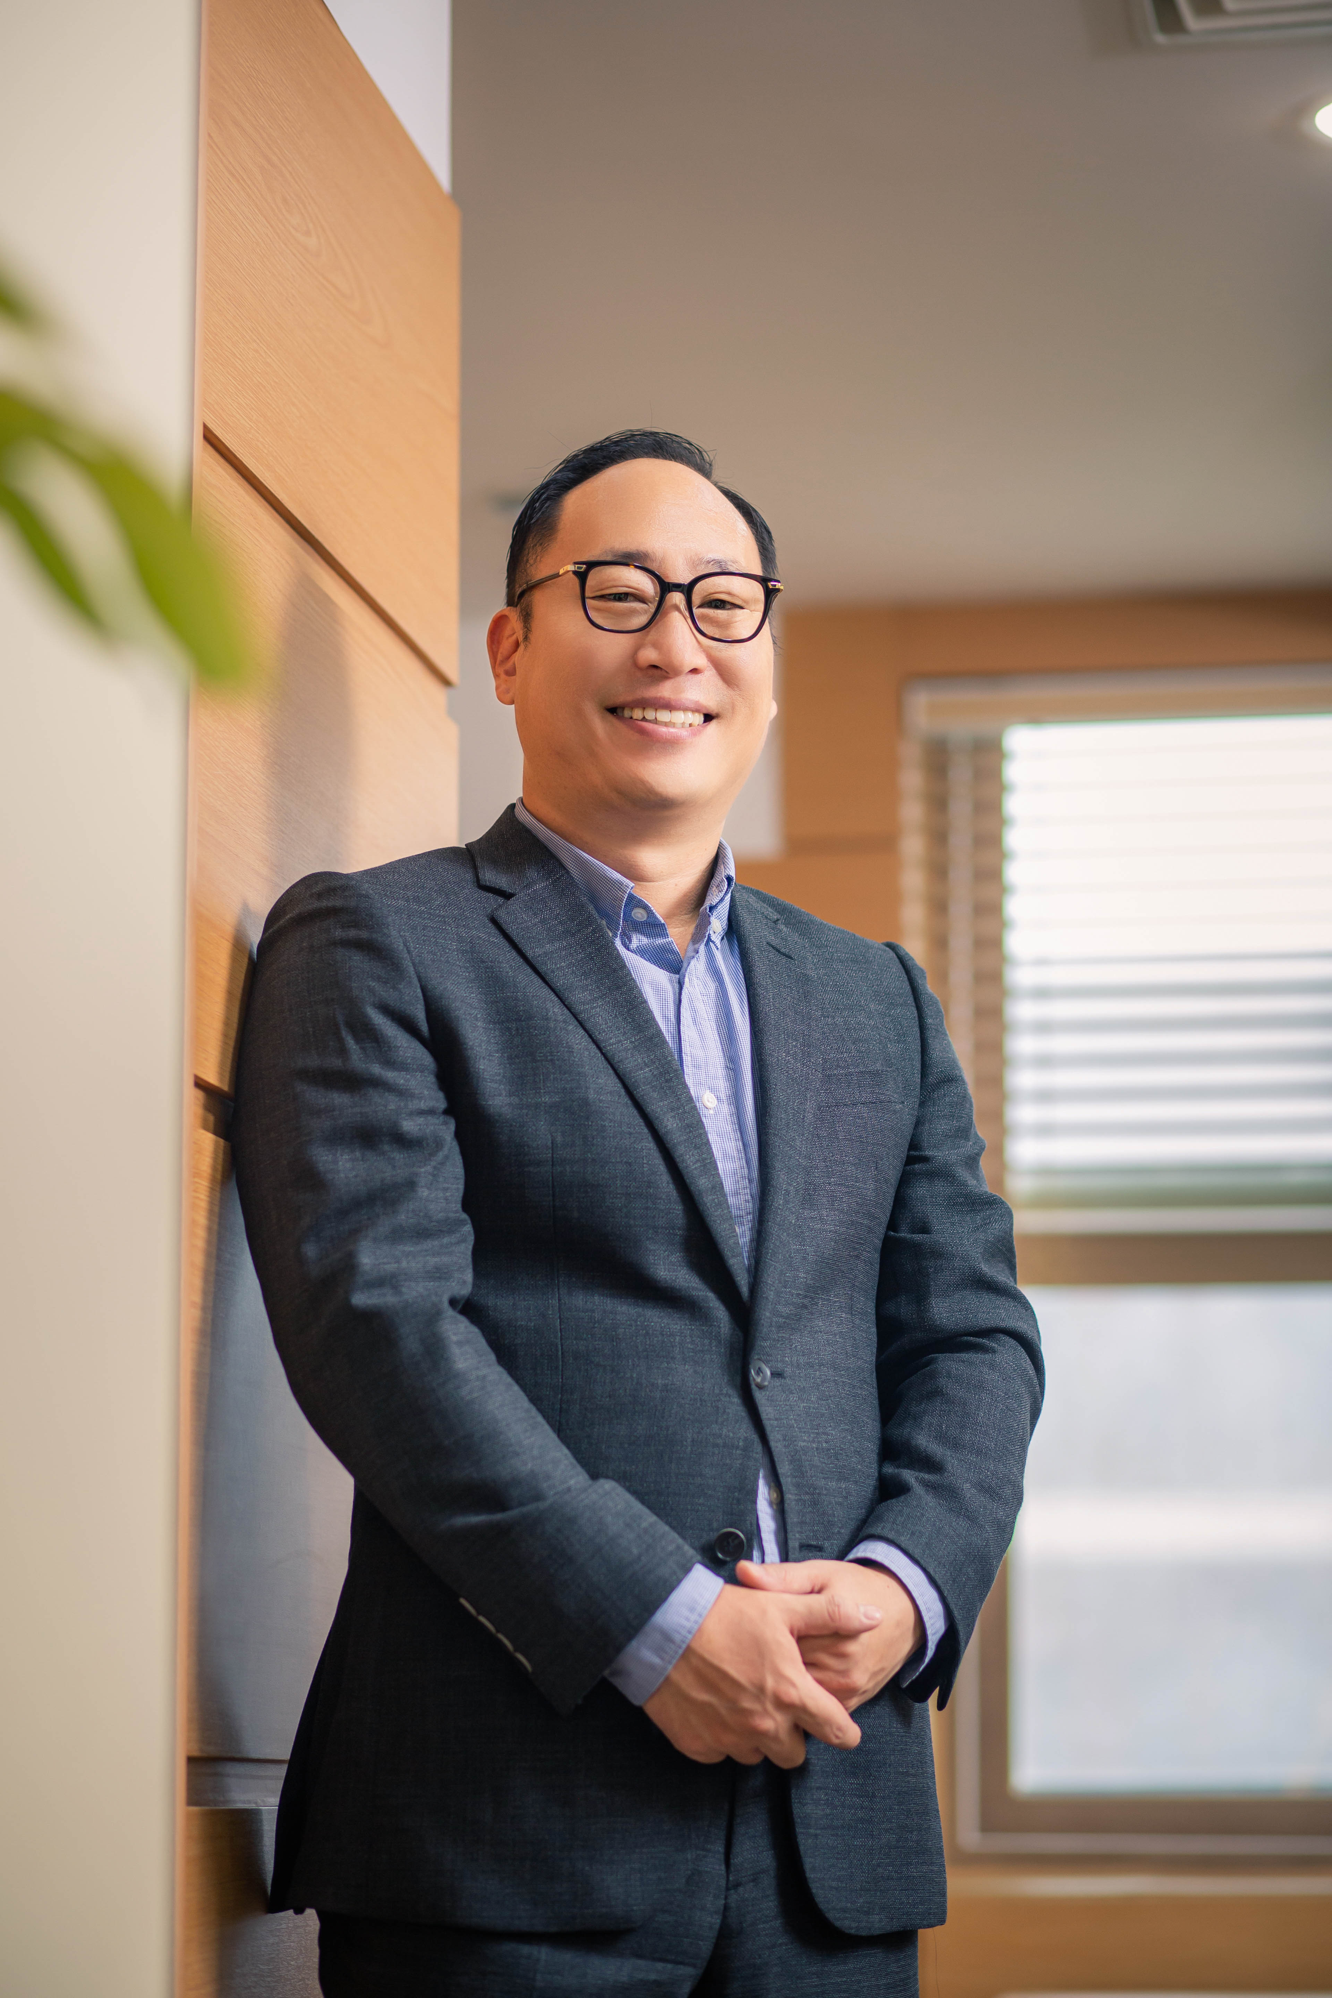

▲ Professor Youngjune Park, Department of Environment and Energy Engineering, GIST

The Gwangju Institute of Science and Technology (GIST, President Kichul Lim) announced that Professor Youngjune Park of the Department of Environment and Energy Engineering has been appointed as a "POSCO Group Distinguished Professor for Super-Gap Technology," hosted by POSCO Holdings.

The POSCO Group Distinguished Professor for Super-Gap Technology program is a program designed to strengthen basic and fundamental research in the steel and energy materials fields, secure core technologies, and cultivate specialized talent. The Distinguished Professor will perform various roles to enhance the Group's core technological capabilities, including joint research with POSCO Holdings, technical consulting, and research achievement exchange. His term will run from October of this year to September 2028.

Through this appointment, Professor Park plans to actively pursue technological development in key strategic minerals, such as lithium and rare earth elements, foster talented individuals, and conduct joint industry-academia research in collaboration with POSCO Holdings.

Professor Park has been conducting research based on industry-academia-research collaboration, including international joint research, in areas such as ▴ eco-friendly separation and recovery of lithium and rare earth resources, ▴ recycling of steel slag and industrial byproducts into valuable metal resources, and ▴ carbon capture, storage, and utilization (CCUS) convergence processes. He also leads the "AI-Circular Economy Clustering Graduate School," hosted by the Ministry of Climate, Energy, and Environment, spearheading the development of circular economy and sustainable technologies and talent development.

Professor Youngjune Park stated, "Securing stable supplies of strategic energy minerals and resource circulation are the core pillars of a carbon-neutral society. Through cooperation with POSCO, we will further solidify the technological foundation for a sustainable circular economy."



