GIST Professor Minjae Lee wins Academic Award at the 5th Haedong Semiconductor Engineering Award

- Professor Minjae Lee of the Department of Electrical Engineering and Computer Science was recognized for his academic excellence and industrial practicality in research on core semiconductor circuit technology... The award, presented by the Korean Society of Semiconductor Engineers, is given to mid-career scientists under the age of 49 who have contributed to the advancement of semiconductor technology

- Proven global research influence, with over 100 published research papers, over 3,000 citations, and ranking among the world's top 2% of researchers... Contributing to strengthening the nation's semiconductor competitiveness through creative research and industry-academia collaboration

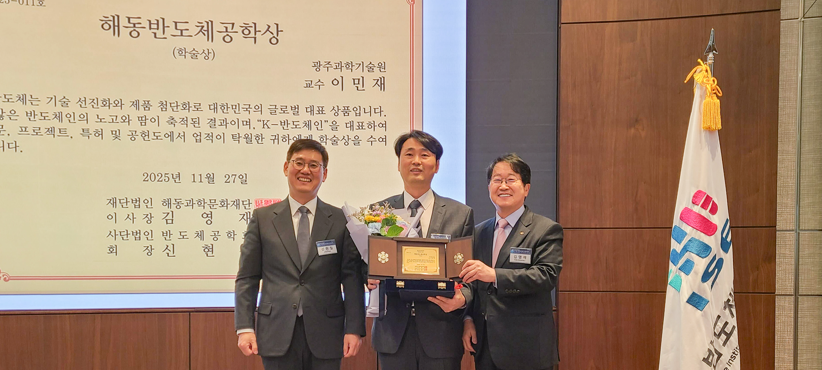

▲ Professor Minjae Lee of the Department of Electrical Engineering and Computer Science at GIST poses for a commemorative photo after receiving the Haedong Semiconductor Engineering Award (Academic Award) at the Park Hyatt Seoul in Gangnam-gu, Seoul on November 27th. (From left) Hyun-chul Shin, President of the Korean Society of Semiconductor Engineering; Professor Minjae Lee of GIST; and Young-jae Kim, Chairman of the Haedong Science and Culture Foundation.

The Gwangju Institute of Science and Technology (GIST, President Kichul Lim) announced that Professor Minjae Lee of the Department of Electrical Engineering and Computer Science received the Academic Award at the 5th Haedong Semiconductor Engineering Award ceremony hosted by the Korean Society of Semiconductor Engineering.

The Haedong Semiconductor Engineering Award was established by the Haedong Science and Culture Foundation in accordance with the will of the late Jung-sik Kim, Chairman of Daedeok Electronics. It is presented by the Korean Society of Semiconductor Engineering to a mid-career scientist (engineer) under the age of 49 who has made significant contributions to the advancement of semiconductor-related academics and technology. Considered one of the most prestigious awards in the semiconductor field, each year one individual is selected for the Academic Award and one for the Technology Award. This year's Technology Award went to Jun-ho Baek, CEO of FuriosaAI.

The Korean Society of Semiconductor Engineers (KSSE), launched in 2017, is Korea's first semiconductor-specific academic society. It focuses on technological exchange, global joint research, and the development of specialized talent through collaboration between industry, academia, and research.

This year's awards ceremony took place following the "2025 KSSE Annual General Meeting," held at the Park Hyatt Seoul in Gangnam-gu, Seoul on Thursday, November 27th.

Since joining GIST in 2012, Professor Minjae Lee has accumulated creative and sustained research achievements in the field of semiconductor design.

He was selected as the recipient of this academic award for his academic excellence and industrial practicality in key semiconductor circuit areas, including time-frequency conversion circuits, analog-to-digital conversion circuits, and display and interface circuits.

Professor Lee has published over 100 research papers, including presentations at international conferences and journals, and domestic and international patents, earning over 3,000 cumulative citations. Furthermore, he has proven his international influence by being included in the Stanford-Elsevier World's Top 2% Scientists list for two consecutive years (2023 and 2024), jointly published by Stanford University and the global academic information analytics company Elsevier.

Professor Minjae Lee said, “Winning the Haedong Semiconductor Engineering Award is a great honor for me as a semiconductor researcher, and it is a meaningful recognition of my efforts,” and added, “I will continue to contribute to strengthening the nation’s semiconductor competitiveness through creative research and expansion of industry-academia cooperation.”



