GIST Professor Yousoo Kim wins the 21st Gyeong-Am Prize in natural sciences: Leading the world in basic science through research that measures and actively controls the quantum state within a single molecule

- An awards ceremony was held at Gyeongam Hall in Busan on Friday the 7th… Pioneered single-molecule spectroscopy, established real-time control technology for intramolecular quantum phenomena, and demonstrated world-class research capabilities with numerous publications in 《Science》 and《Nature》

- Laid the foundation for next-generation quantum devices and precision measurement… “We will strive to enrich human lives through understanding the microscopic world and ensure that the next generation of scientists can conduct research in a better environment.”

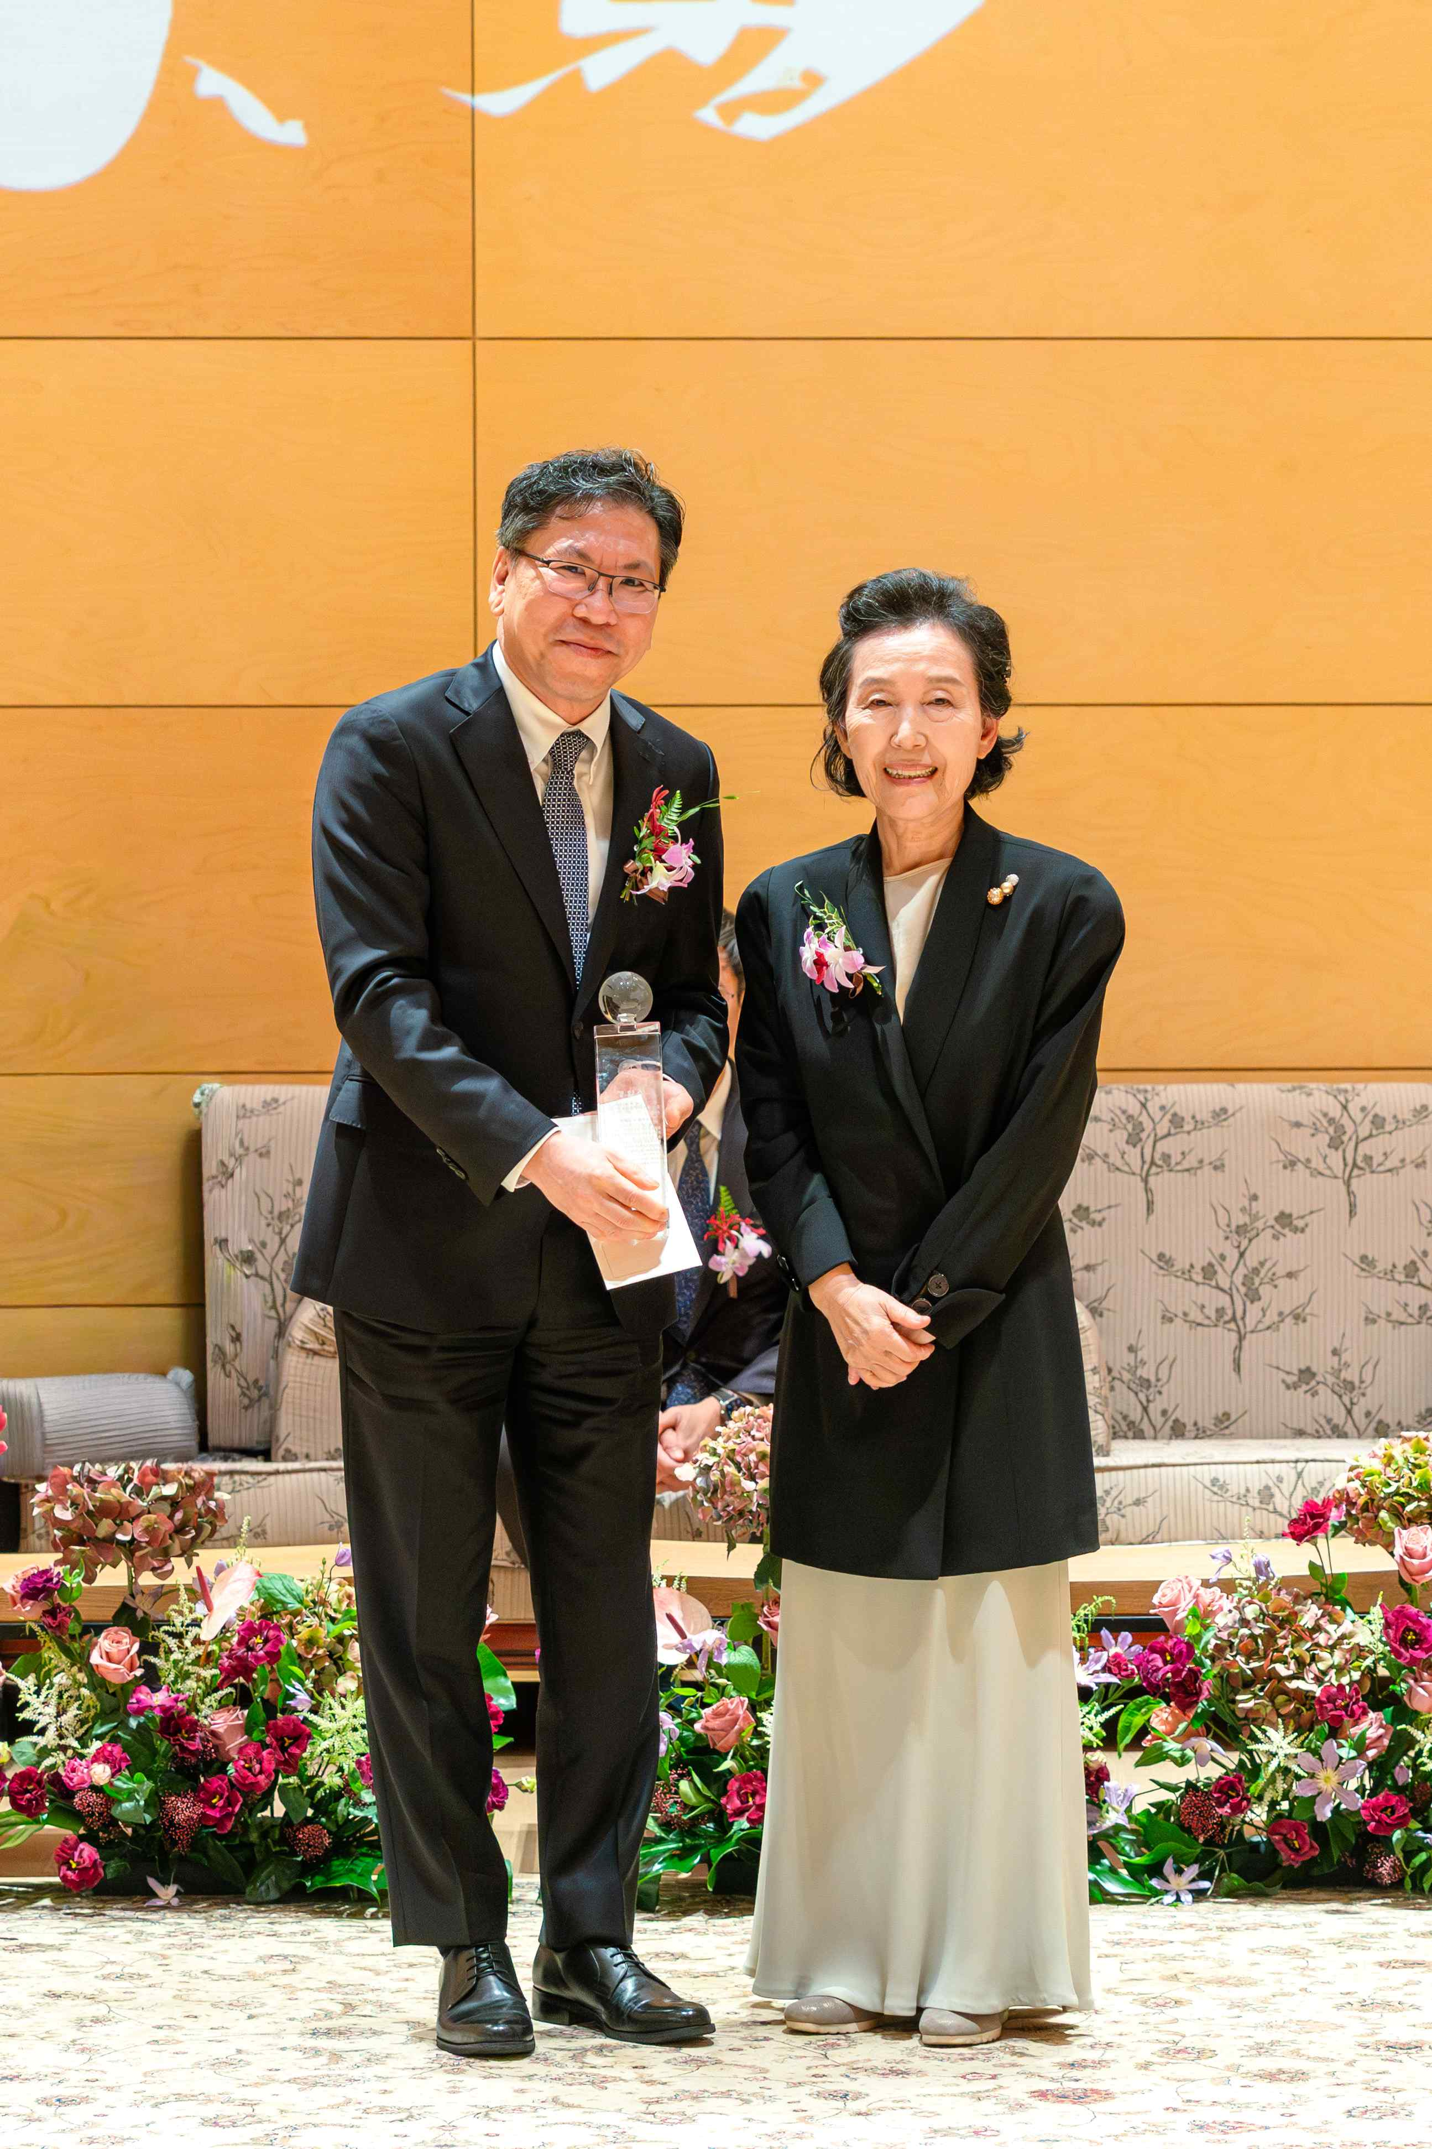

▲ Professor Yousoo Kim of the Department of Chemistry at GIST (Director of the Center for Quantum Conversion Research at the Institute for Basic Science) poses for a commemorative photo after receiving his award plaque at the 21st Kyungam Prize Awards Ceremony held at Gyeongam Hall in Seomyeon, Busan on November 7th. (From left) Professor Yousoo Kim and Ae-eon Jin, Chairman of the Kyungam Education and Cultural Foundation

The Gwangju Institute of Science and Technology (GIST, President Kichul Lim) announced that Professor Yousoo Kim of the Department of Chemistry (Director of the Center for Quantum Conversion Research at the Institute for Basic Science (IBS)) has been awarded the 21st Kyungam Prize in the Natural Sciences category, one of Korea's most prestigious academic awards.

The awards ceremony was held at Gyeongam Hall in Seomyeon, Busan on Friday, November 7th. Past recipients, the Kyungam Prize Committee, judges, and prominent figures from the academic and artistic communities were in attendance to congratulate the recipients.

The Gyeongam Prize is awarded annually by the Gyeongam Education and Culture Foundation (Chairman Ae-eon Jin), which was established in 2004 with the late Song Geum-jo, Chairman of the Taeyang Group, donating all of his assets accumulated through his lifelong frugality. It is awarded to scholars who have made outstanding achievements in various fields, including ▴ humanities and social sciences, ▴ natural sciences, ▴ life sciences, and ▴ engineering.

This year, the prize money for each category has been increased to 300 million won, further solidifying the Gyeong-Am Prize's status as a global academic award, extending beyond Korea. Furthermore, the inclusion of scholars working abroad and expanding the scope of Korean scholarship has further enhanced its prestige and symbolism.

This year's 21st recipients include Professor Yousoo Kim in the Natural Sciences category, Professor Jun-yeol Heo (Harvard University School of Medicine) in the Life Sciences category, Professor Ho-young Kim (Seoul National University, Department of Mechanical Engineering) in the Engineering category, and Professor Sang-bae Kim (Massachusetts Institute of Technology (MIT), Department of Mechanical Engineering) in the Special Award category.

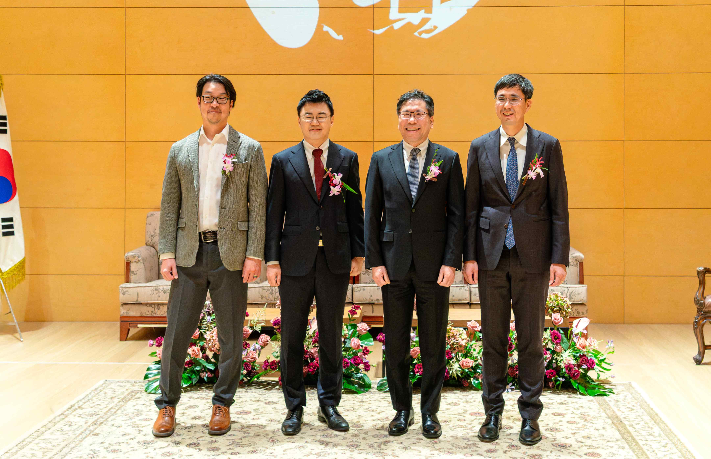

▲ At the 21st Gyeong-Am Prize Awards Ceremony held at Gyeongam Hall Hall in Seomyeon, Busan on November 7th, the recipients, including Professor Yousoo Kim of the Department of Chemistry at GIST (second from the right), pose for a commemorative photo.

Professor Yousoo Kim is recognized as a world-renowned scholar who pioneered a new research field that precisely measures and actively controls quantum states at the single-molecule level.

He developed a unique "single-molecule spectroscopy" method that combines scanning tunneling microscopy (STM) and optical technology, establishing an experimental foundation for real-time observation and manipulation of the electronic and vibrational states of individual molecules.

This research has dramatically expanded our understanding of core fundamental scientific phenomena such as quantum energy conversion, molecular dynamics, and interface functional control. Furthermore, it has opened up potential applications in diverse future convergence technologies, including high-efficiency optoelectronic devices, single-molecule-based quantum information processing devices, artificial photosynthesis, and nanophotocatalysis.

To date, Professor Kim has published over 200 papers in renowned international journals, with key findings appearing in top-tier journals such as five in 《Science》 and three in 《Nature》.

Representative research includes: ▴ visualization of intermolecular energy transfer and quantum coherence dynamics (Nature, 2016); ▴ elucidation of single-molecule near-field reaction mechanisms (Science, 2018); ▴ real-time spectroscopy of triplet excited states (Nature, 2019); ▴ development of single-molecule nanospectroscopy (Science, 2021); ▴ elucidation of photocurrent generation mechanisms (Nature, 2022).

In particular, the study titled "Picosecond-scale Formation and Control of Excitons in Single Molecules Using Phase-Controlled Terahertz Pulses" (Science, 2025), announced in March of this year, is a groundbreaking achievement that enables ultra-precise time, space, and energy measurement and control at the picosecond (one trillionth of a second) level, a feat unattainable by conventional spectroscopy or electron microscopy. It is recognized as a key foundation for next-generation quantum devices and precision measurement technology.

Professor Kim received his bachelor's and master's degrees from Seoul National University and his doctorate from the University of Tokyo. He then led single-molecule spectroscopy research at the Physical and Chemical Research Institute (RIKEN) for over 20 years.

In 2013, he was elected as the first foreign chairman of the RIKEN Research Council, spearheading the protection of researcher rights and the internationalization of the research environment. Since 2022, he has been a professor in the Department of Applied Chemistry at the University of Tokyo, where he has been engaged in both teaching and research.

After returning to Korea in 2024, he served as Director of the Center for Quantum Conversion Research at the Institute for Basic Science (IBS), building a world-class research center based at GIST. He has played a pivotal role in strengthening Korea's global standing in basic science by fostering an international collaborative research system linking IBS, GIST, RIKEN, and the University of Tokyo.

He has also served as Vice President of Academic Affairs at the Japan Society of Scientists and Engineers for over a decade, actively contributing to society through support for Korean and Japanese students and postdoctoral researchers, as well as providing science lectures to young people.

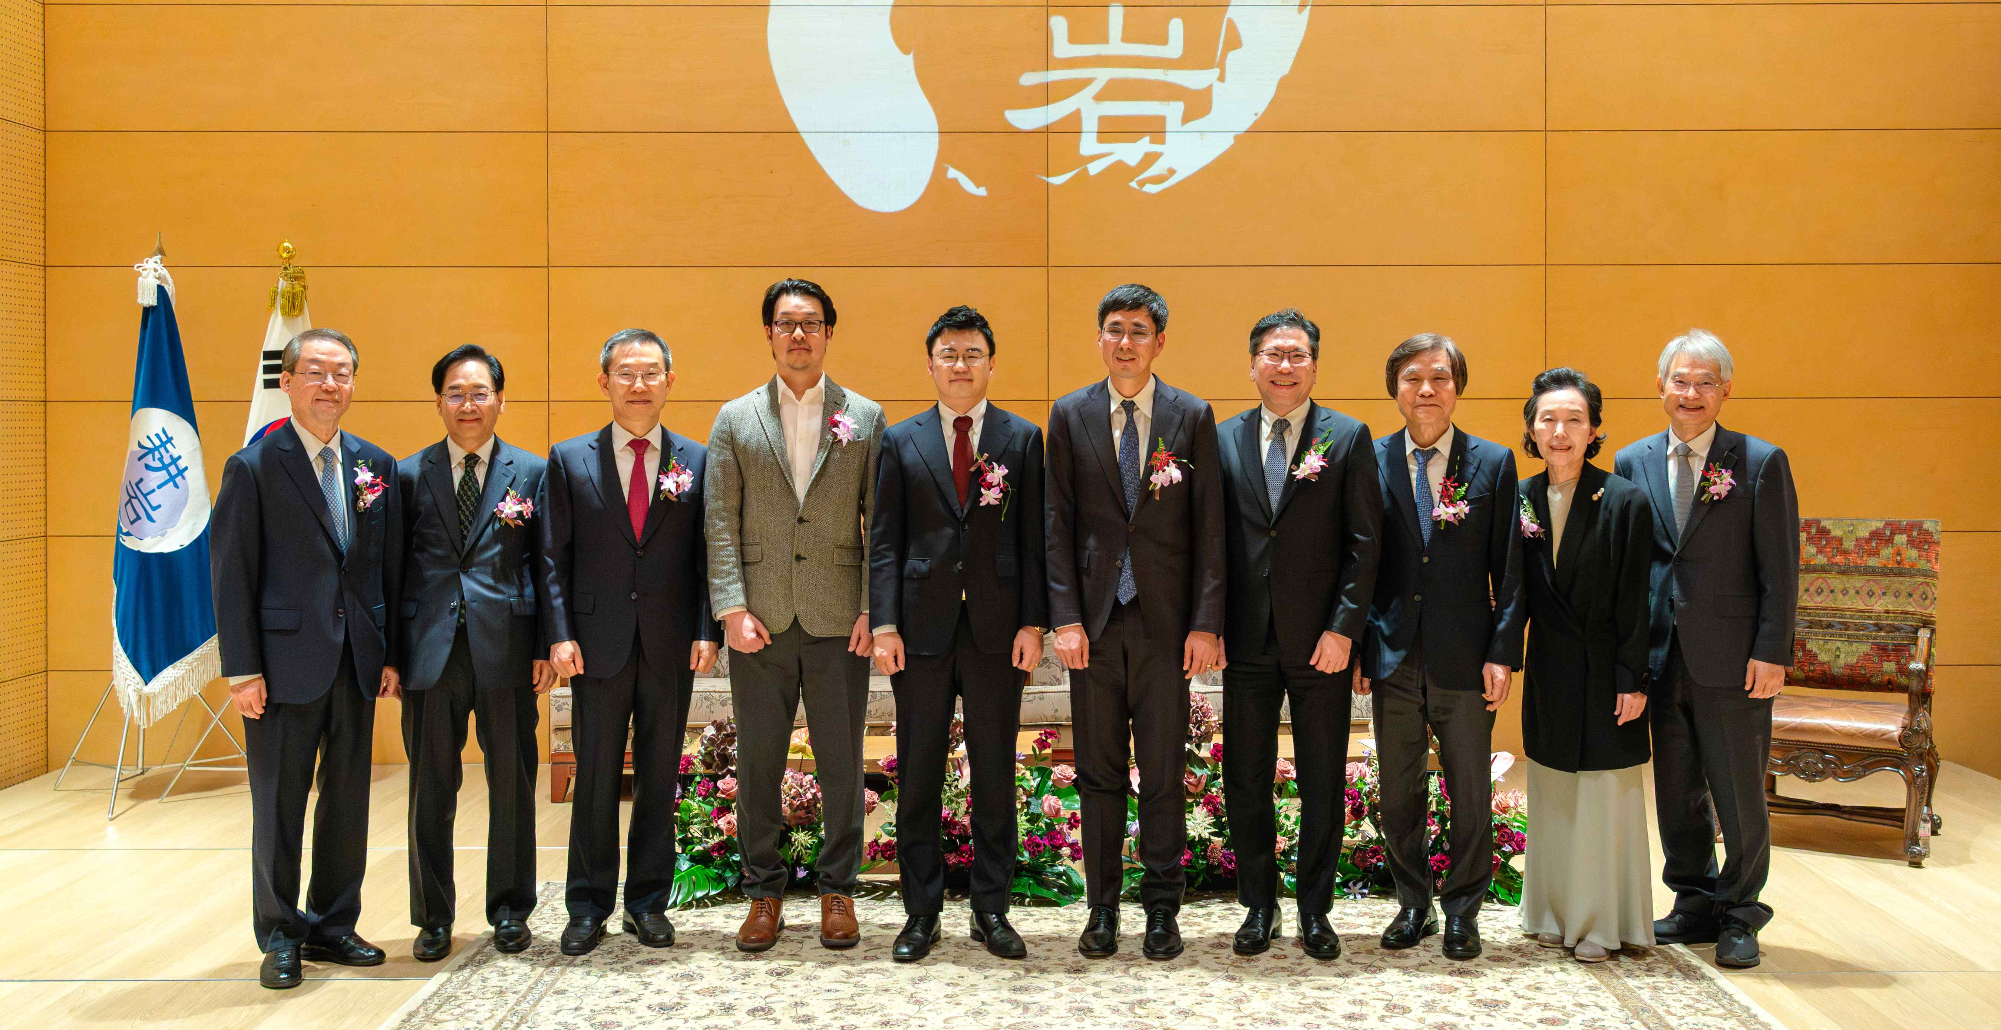

▲ At the 21st Gyeong-Am Prize Awards Ceremony held at Gyeongam Hall in Seomyeon, Busan on November 7th, winners of the Natural Sciences category, including Professor Yousoo Kim of the Department of Chemistry at GIST (fourth from the right), pose for a commemorative photo with the event staff.

Professor Yousoo Kim said, "The Gyeong-Am Prize is all the more meaningful because it recognizes not only academic achievement but also the social responsibility of researchers." He added, "This award is not just my personal honor, but the dedication of my students and fellow researchers with whom I have worked for many years, as well as my family who have always supported me."

Professor Kim continued, "My research involves observing and controlling the quantum state changes occurring within a single molecule. I believe that understanding this microscopic world will ultimately lead to technology and knowledge that enrich human lives."

He added, "Now that I have returned to Korea and am taking on new challenges in this new environment, this award has given me great courage and excitement. I will strive to ensure that the next generation of scientists have more options and better environments to conduct their research."

Meanwhile, the awards ceremony was followed by a tribute performance honoring each recipient's achievements, following the presentation of the awards and the recipients' acceptance speeches. For Professor Yousoo Kim, Mozart's String Quartet No. 14 (K. 387), 1st Movement, was performed to pay tribute to his academic journey and achievements.



