GIST Professor Donghyuk Kim publishes translation of the science history masterpiece "Lonely Ideas": Revealing the causes of Russia's ‘innovation failure’ in science and technology through its institutions and social structure

- Professor Donghyuk Kim of GIST and Professor Seung-chul Heo of Korea University co-translate the renowned book by American historian of science Lauren Graham, published by MIT Press… "The Sociology of Innovation": A Look at the Successes and Failures of Russian Science and Technology

- Exploring "Why Did Russian Science's 'World-First' Inventions Fail to Transform into Industry?"… Illuminating the relationship between science and technology policy and social innovation with the insight that "there can be no technological innovation without national innovation"

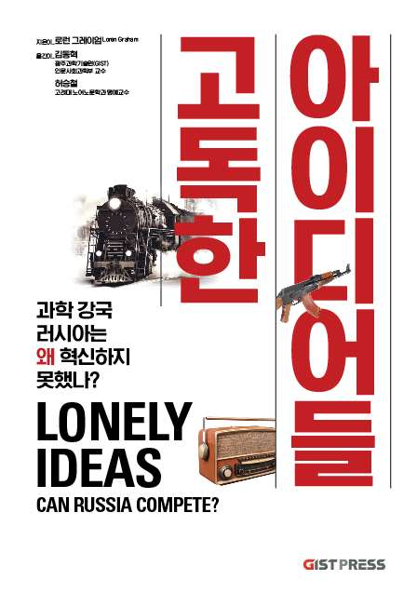

▲ Book cover for "Lonely Ideas: Why Did Russia, a Scientific Powerhouse, Fail to Innovate?"

The Gwangju Institute of Science and Technology (GIST, President Kichul Lim) announced that Professor Donghyuk Kim (Director of the Center for Convergence Education and Research) in the School of Humanities and Social Sciences and Professor Emeritus Seung-chul Heo of the Department of Russian Language and Literature at Korea University have jointly translated and published "Lonely Ideas: Can Russia Compete?" (MIT Press, 2013), a renowned book by American historian of science Loren Graham.

The translation was published on Thursday, October 30th by GIST's university press, GIST Press, under the title "Lonely Ideas: Why Did Russia, a Scientific Powerhouse, Fail to Innovate?"

This book delves into why, despite Russia's numerous "world firsts," technologies and inventions, it failed to translate these achievements into industrial success. The title, "Lonely Ideas," symbolizes the paradox of Russia's 300-year history of overflowing creative inventions and innovations, yet failing to translate them into industrialization.

The author emphasizes that scientific and technological advancement is not simply a matter of individual creativity or technological prowess, but rather a product of the social and institutional environment, conveying the message that "there can be no technological innovation without national innovation."

Lauren Graham analyzes the history of Russian technological development as a "discontinuous cycle of success and stagnation." He attributes the failure of innovation not to individual limitations, but to structural factors such as bureaucracy, institutional inefficiency, and social attitudes.

Her insight that "innovation is not achieved with brilliant ideas alone" highlights the importance of technological advancement, which is only possible through social and economic environmental innovation and institutional reform.

This book goes beyond a simple study of the history of science, demonstrating that the essence of innovation lies not in the "idea" itself, but in the "social foundation" that enables its realization.

The history of Russian science and technology serves as a testament to the fact that "innovation is not achieved through brilliant ideas alone," and its lessons offer profound implications for science and technology policies in Korea and around the world today.

"Lonely Ideas" is divided into three parts. Through a variety of inventions, including the light bulb, the steam locomotive, semiconductors, and computers, it traces the history of Russian science and technology successes and setbacks, leading readers to reflect on the direction modern science and technology policy and research ecosystem should take.

▴ Part 1 explores the question, "Why has Russian innovation repeatedly been frustrated?" through examples from representative fields such as railways, electricity, aerospace, semiconductors, genetics, computers, and lasers. ▴ Part 2 analyzes the structural causes that hinder innovation, including political order, legal systems, educational systems, corruption, and social attitudes, revealing institutional limitations that cannot be overcome through individual creativity alone. ▴ Part 3 examines Russia's attempts to overcome these limitations, including the establishment of research foundations, the creation of new technology complexes, and the establishment of innovative universities. The book concludes with the author's conclusion that "technological innovation without social reform is impossible."

Professor Donghyuk Kim of GIST is a historian specializing in Cold War history, contemporary Russian and Eastern European history, and the history of scientific and technological exchange. Focusing on Soviet mathematical economics, science policy, and international knowledge exchange, he has reexamined the structural limitations of Russian science from the perspective of the Cold War knowledge system.



▲ (From left) Professor Donghyuk Kim of the School of Humanities and Social Sciences at GIST and Professor Seung-chul Heo of the Department of Russian Language and Literature at Korea University

He explores the interplay between science, technology, and society through interdisciplinary research that transcends the boundaries of history, economics, and science. In this translation, he faithfully interprets the context of Russian science and technology history from a modern perspective, deeply conveying the content of the original book.

Professor Seung-chul Heo of the Department of Russian Language and Literature at Korea University is a pioneer in Korean Slavic and Ukrainian studies, a leading scholar with both academic depth and diplomatic experience in Russian and Eastern European studies.

After conducting research at the Harvard Russian Institute and the Institute of Ukrainian Studies, he led Russian and Slavic studies at Korea University and served as Ambassador to Ukraine (with concurrent appointments to Georgia and Moldova).

During his time at Harvard, he had the opportunity to spend two years closely interacting with Professor Lauren Graham, author of "Lonely Ideas," who was also a professor at both MIT and Harvard. This close relationship led to his later translation of this book, he writes in his postscript.

Through his books and translations, including "A Modern History of Ukraine" and "Chernobyl History," he has introduced the complex context of modern Eastern European history to Korea. This translation, too, meticulously interprets the historical context of Russian society and institutions, faithfully conveying the cultural depth of the original work.



