"Korea-Swiss joint research begins demonstration of long-distance quantum communication in the atmosphere" The GIST Advanced Photonics Research Institute, in collaboration with Swiss universities including the University of Bern, is conducting a next-generation quantum communication experiment that extends to space

- GIST selected for the "QFREE" project under the Korea-Swiss Joint Quantum Science and Technology Research Program… Establishing a fixed link across the 57km Zimmerwald-Jung Fraujoch route to verify the feasibility of quantum communication and explore the impact of the space environment

- Quantum light, containing energy and time information, was transmitted over long distances, providing the world's first demonstration of the distribution and interference characteristics of quantum light... Expected to lead the way in defense, space, and security applications and future global quantum internet technology

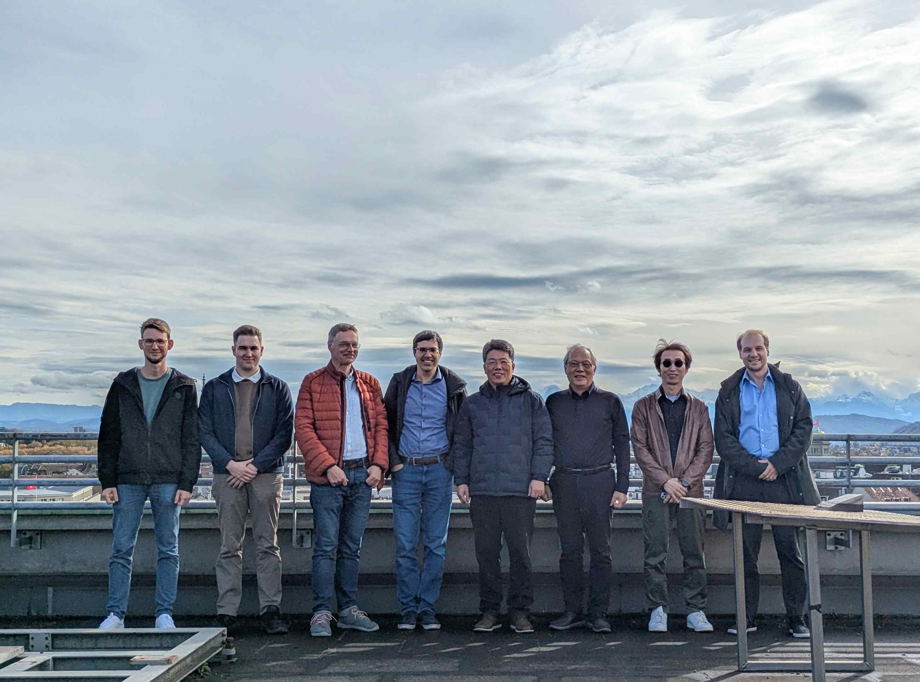

▲ The GIST Advanced Photonics Research Institute (APRI), along with the University of Bern, the University of Geneva, and the Northwestern University of Applied Sciences (FHNW), held a kickoff meeting in Bern, Switzerland, and took a commemorative photo after being selected for the new project "QFREE" under the "2025 Korea-Switzerland Quantum Science and Technology Joint Research Program." (Bern, Switzerland, October 21, 2025)

The Gwangju Institute of Science and Technology (GIST) Advanced Photonics Research Institute (APRI, Director Yeung Lak Lee) announced that it held a project kickoff meeting in Bern, Switzerland for "QFREE (Entanglement Distribution via Free-Space Optical Links: From High-Altitude Balloons to Space-Time Curvature Tests)," a project selected for the new "2025 Korea-Switzerland Quantum Science and Technology Joint Research Program*.

This project, co-led by GIST APRI Senior Researcher Woojin Shin and Professor André Stefanov of the University of Bern in Switzerland, includes the University of Geneva (UNIGE) and the Fachhochschule Nordwestschweiz (FHNW) as collaborating institutions.

* The Korea-Switzerland Quantum Science and Technology Programme: This international quantum cooperation project, jointly promoted by the Korean Ministry of Science and ICT and the Swiss Federal Office for Education, Research and Innovation (SERI), aims to strengthen bilateral research collaboration and global quantum technology competitiveness by supporting joint research and human resource exchanges in next-generation core technologies such as quantum communications, quantum computing, and quantum sensing.

QFREE is a joint quantum communication demonstration project conducted by Korea and Switzerland. It experimentally verifies the reliability of quantum information transmission from the ground to distant locations by exchanging quantum entangled light (entangled photons) in free space using high-altitude balloons (stratospheric platforms) and drones. Furthermore, the research aims to explore how the Earth's gravitational field and the curvature of space-time affect this quantum entanglement state, thereby elucidating the principles of reliable quantum communication in space environments.

This research aims to build a free-space quantum network extending from the ground through the stratosphere into space. This challenging project will lay the foundation for future quantum repeater and quantum satellite technologies and lay the groundwork for a future global quantum internet.

This research is significant in that it marks the world's first attempt to encode energy and time information into quantum light (energy-time encoded entangled photons) and transmit them over long distances using drones and high-altitude aerial balloons (HAPS). Furthermore, it compares the interference characteristics of quantum light (light with quantum properties) and classical light (ordinary light) on the same platform.

The research team will utilize Switzerland's high-altitude research infrastructure to establish a fixed link across the Zimmerwald-Jungfraujoch section (approximately 57 km, with an altitude difference of approximately 2.5 km) and conduct long-term measurements. To achieve this, advanced experimental equipment, including a mobile SNSPD (Superconducting Nanowire Single Photon Detector)*, a mobile tracking ground station, and a vehicle-mounted interferometer payload, will be gradually deployed.

The Korean research budget is a total of 1.2 billion KRW (approximately 300 million KRW per year), while the Swiss budget is approximately 799,899 Swiss francs (approximately 1.447 billion KRW). The research period is four years.

* high altitude pseudo-satellite (HAPS): An unmanned aerial vehicle (UAV) that performs satellite-like functions while remaining in the stratosphere for extended periods of time, approximately 18-25 km above sea level. Powered by renewable energy such as solar energy, it can fly for weeks or even months and is used in a variety of fields, including communication relay, ground observation, weather monitoring, disaster response, and quantum communication demonstrations. With lower operating costs than satellites and less communication delay with ground stations, it is attracting attention as a next-generation high-altitude platform.

* SNSPD (Superconducting Nanowire Single Photon Detector): This highly sensitive sensor utilizes superconducting nanowires to detect single photons. It features extremely fast response times and low noise. This allows for the accurate measurement of even extremely weak light in precision optical experiments such as quantum communication, quantum cryptography, and astronomical observations. In particular, mobile SNSPDs feature a miniaturized and portable cooling system, enabling single photon detection in a variety of environments, including field experiments, satellite installations, and aircraft operations.

The project kickoff meeting held in Bern, Switzerland, on October 21st discussed detailed objectives, role allocation, schedule confirmation, risk and quality management plans, and initial experimental environment setup.

Key agenda items included: ▴ a 57km fixed-link long-term measurement roadmap and observation window analysis; ▴ interferometer payload system design for drones and the High Altitude Area Platform (HAP); ▴ mobile SNSPD and ground station tracking system configuration; ▴ scenario review for integration of the two-axis gimbal* and fine targeting (FSM) module developed by the Swiss University of Applied Sciences Northwestern (FHNW); ▴ experimental data management, research results publication, international standardization activities, and intellectual property strategies.

* HAP interferometer payload: In space, aviation, and experimental equipment, a "payload" refers to the device or equipment that performs the primary mission. For the HAP interferometer, the payload includes the core components of the interferometer, sensors, and the entire optical system that transmits and receives light.

* FHNW-developed 2-axis gimbal: Developed by the Northwestern University of Applied Sciences (FHNW), this device is primarily designed to stably control and precisely position optical sensors, cameras, and detection equipment.

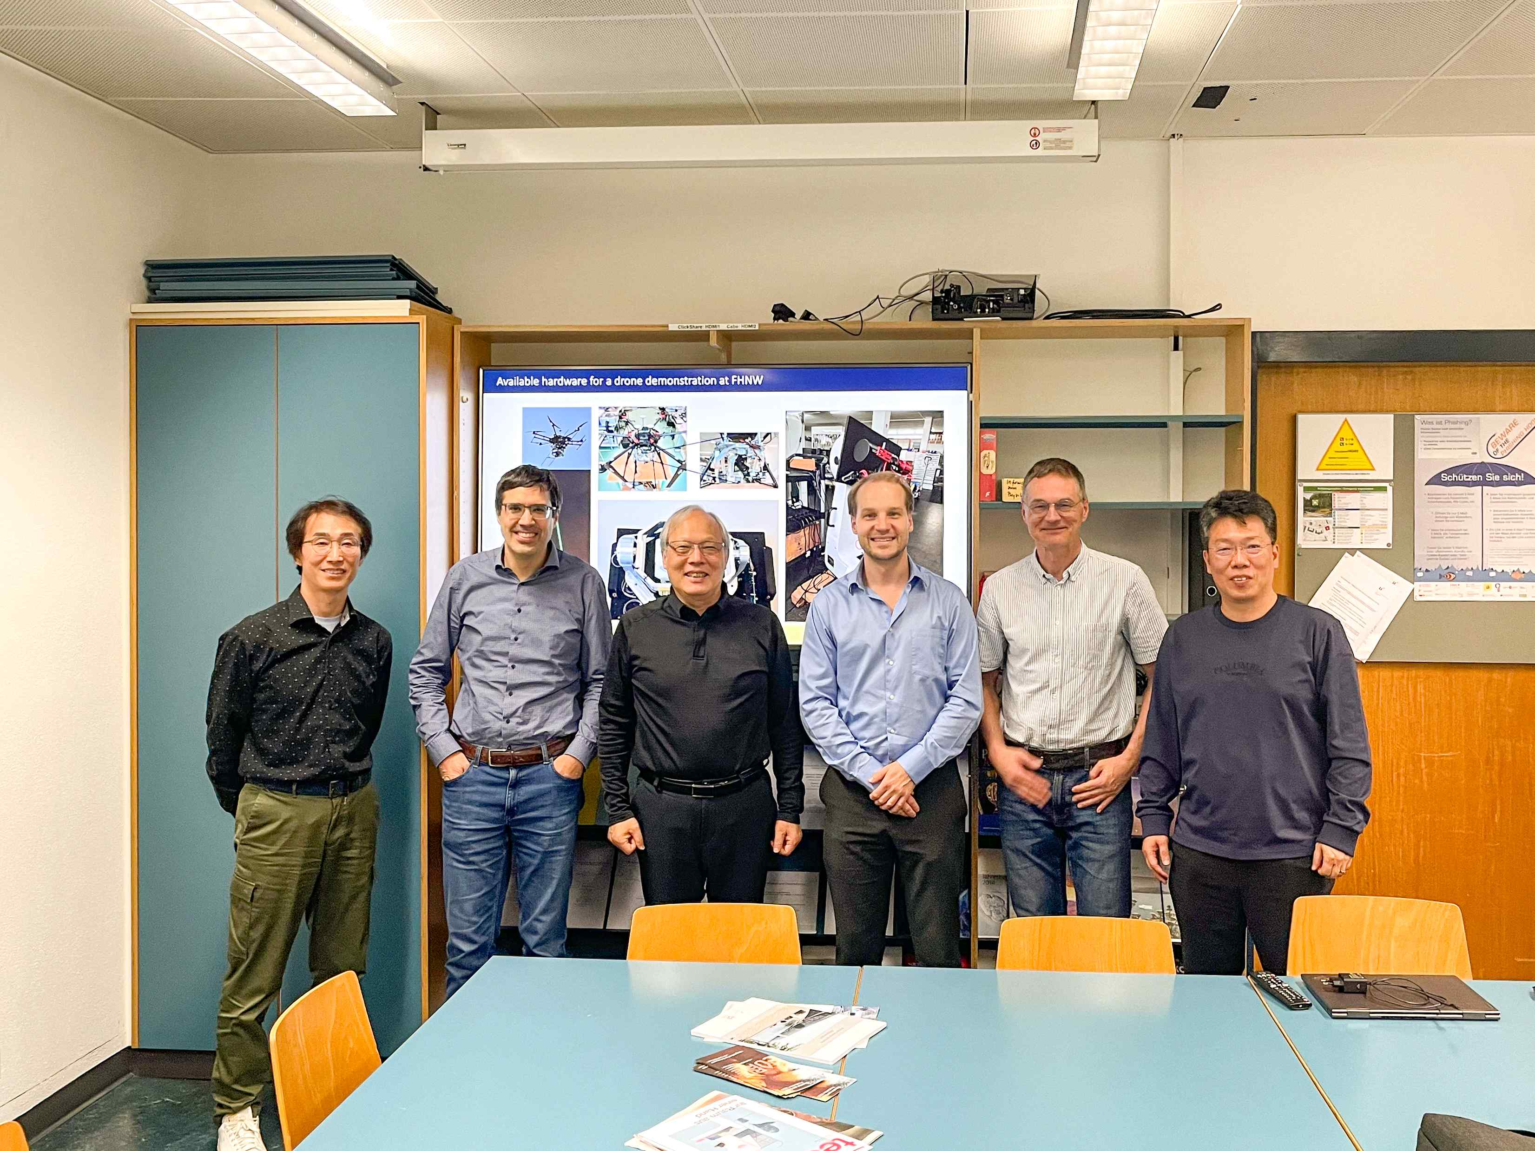

▲ (From left) Chul Kang, Director of the Space and Defense Convergence Division at GIST; Professor Andre Stefanov, Institute of Applied Physics, University of Bern, Switzerland; Professor Do-Kyung Ko, Department of Physics and Photonics, GIST; Professor Boris Korzh, Department of Physics, University of Geneva, Switzerland; Professor Christoph Wildfeurer, Department of Applied Physics, Northwestern University of Applied Sciences, Switzerland; and Woojin Shin, Senior Researcher at GIST APRI.

Through this project, the research team expects to verify a hybrid quantum network backbone that connects the ground, high-altitude, and stratosphere, and to confirm the scalability of quantum networks.

Furthermore, the goal is to leverage energy-time coding technology to increase communication channel capacity and stability, while ensuring reproducible performance even in long-distance, high-altitude links.

The mobile quantum communication, high-precision tracking, and high-sensitivity detection technologies developed in this study have significant potential for application in diverse fields, including defense, space, security, and safety. Based on the Swiss-Korean joint demonstration data, QFREE is expected to contribute to international standardization efforts and subsequent large-scale projects.

GIST APRI Senior Researcher Woojin Shin stated, "QFREE is a globally unique attempt in that it actually distributes entangled photons from drones and stratospheric platforms and directly compares and measures the difference in quantum optical interference compared to classical light under identical conditions. Combining Swiss high-altitude infrastructure with APRI's optical and tracking technologies will lay a key foundation for the future construction of a quantum internet."

Professor Andre Stepanov of the University of Bern stated, "This experimental platform includes a mobile ground station and a high-sensitivity single photon detector (SNSPD) system, which will simultaneously increase the data transmission rate and reliability of free-space quantum communication." He added, "This collaboration will further strengthen the connection between quantum and space technologies between Switzerland and Korea."

Meanwhile, GIST APRI is a leader in all fields of advanced photonics, including ultra-precision light sources, optical measurement, optical communications, and quantum optics. It also has research foundations and infrastructure in free-space laser communication, adaptive optics, high-sensitivity detection, and optical quantum information.

The University of Bern, the University of Geneva, and Northwestern University of Applied Sciences in Switzerland are leading research institutions with capabilities in free-space quantum communication, single photon detection, high-altitude experimental infrastructure, and payload development. Through this project, they will jointly conduct ground-altitude-stratospheric demonstration research.



