GIST Professor Chang Hee Nam wins the ISUILS Medal at the International Symposium on Ultra-Intense and Ultra-Fast Lasers

- ISUILS 2025, held in Italy from September 14th to 19th… A prestigious academic event featuring world-renowned scholars, including 2023 Nobel Prize in Physics winner Professor Pier Agostini, recognized internationally for academic achievements and research results

- The opening ceremony featured a tribute ceremony honoring the academic achievements of Professor Chang Hee Nam and Professor Gaetano Ferrante of the University of Palermo, Italy... Professor Nam stated, “We will further actively pursue the development of next-generation ultra-fast laser technology and convergence research.”

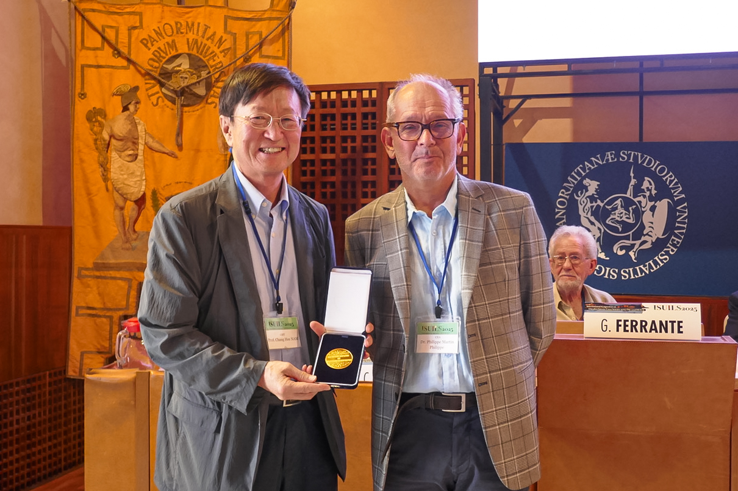

▲ Professor Chang Hee Nam of the Department of Physics and Photon Science at GIST poses for a commemorative photo after receiving the ISUILS Medal at ISUILS 2025, held in Palermo, Italy, from September 14 to 19. (From left) Professor Chang Hee Nam of the Department of Physics and Photon Science at GIST; Dr. Phillipe Martin (CEA, French Institute of Atomic Energy), co-chair of the ISUILS conference.

The Gwangju Institute of Science and Technology (GIST, President Kichul Lim) announced that Professor Chang Hee Nam of the Department of Physics and Photon Science received the ISUILS Medal at the International Symposium on Ultrafast Intense Laser Science (ISUILS 2025), held in Palermo, Sicily, Italy, from September 14 to 19.

The ISUILS Medal is awarded to researchers who have made outstanding research achievements and academic contributions in the field of ultrafast and intense laser science.

The awards ceremony took place during the symposium's opening ceremony. The medal was presented at a special tribute ceremony honoring the academic achievements of Professor Gaetano Ferrante of the University of Palermo, Italy, along with Professor Chang Hee Nam, Honorary Co-Chair of ISUILS, adding to its significance.

The symposium was attended by world-renowned scholars, including Professor Pierre Agostini of Ohio State University, the 2023 Nobel Prize in Physics. Researchers from various fields, including physics, chemistry, biology, and engineering, gathered to discuss the latest research achievements and future directions in ultra-intense, ultra-fast laser science.

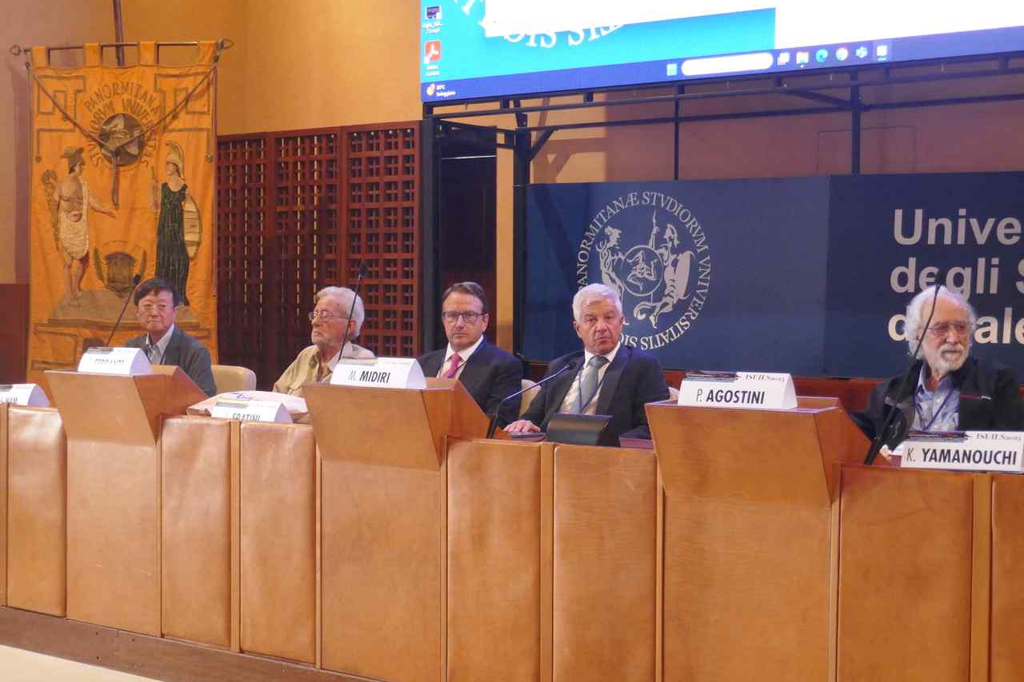

▲ The opening ceremony of the symposium held at the University of Palermo. (From left) Professor Chang Hee Nam of the Department of Physics and Photonics at GIST; Professor Gaetano Ferrante, recipient of the ISUILS Medal; Dean Livan Fratini of the University of Palermo; President Massimo Midiri of the University of Palermo; and Professor Pierre Agostini, winner of the 2023 Nobel Prize in Physics.

Professor Chang Hee Nam said, "I believe this award is international recognition for the achievements of our research on ultra-high-intensity, ultra-fast lasers, which we have consistently pursued. We will continue to actively pursue the development of next-generation ultra-fast laser technology and diverse convergence research."



