"K-DeepTech Starting in a GIST Lab" GIST student startup goes beyond KOSDAQ listing to take on the global stage

- Neurophet, Inc., which secured a full-cycle AI solution for brain disease diagnosis and treatment, successfully listed on the KOSDAQ in July... SOS Lab, Inc., a leader in the autonomous vehicle core component market with high-precision lidar sensors, also listed on the KOSDAQ last year

- Icarus, a startup building an "aerospace communications network" by launching unmanned airships into the stratosphere, is making a mark in diverse fields such as AI, bio, advanced sensors, and aerospace... K-DeepTech startups are continuing their success through systematic startup support and investment connections



▲ (From left) Neurophet Co-CEOs Jun-gil Bin and Dong-hyun Kim

Companies founded and growing by students at the Gwangju Institute of Science and Technology (GIST, President Kichul Lim) are gaining recognition as successful examples of "K-DeepTech Startups," excelling in diverse fields such as artificial intelligence (AI), biotechnology, advanced sensors, and aerospace.

A prime example is Neurophet, Inc. (Co-CEOs Jun-gil Bin and Dong-hyun Kim), a brain disease diagnosis and treatment AI company that made headlines with its successful KOSDAQ listing last July.

Neurophet was founded in 2016 by CEO Jun-gil Bin, then a master's student in the Department of Electrical Engineering and Computer Science at GIST, and CEO Dong-hyun Kim, a doctoral student in the same department. Based on AI technology, Neurophet is developing solutions for the entire brain disease cycle—diagnosis, treatment guidance, and treatment—as well as therapeutic medical devices.

Neurophet has achieved a significant market share in the domestic brain imaging AI market and expanded collaborations with global pharmaceutical companies. Furthermore, its KOSDAQ listing in July 2025 has proven the potential of student startups in the global market.

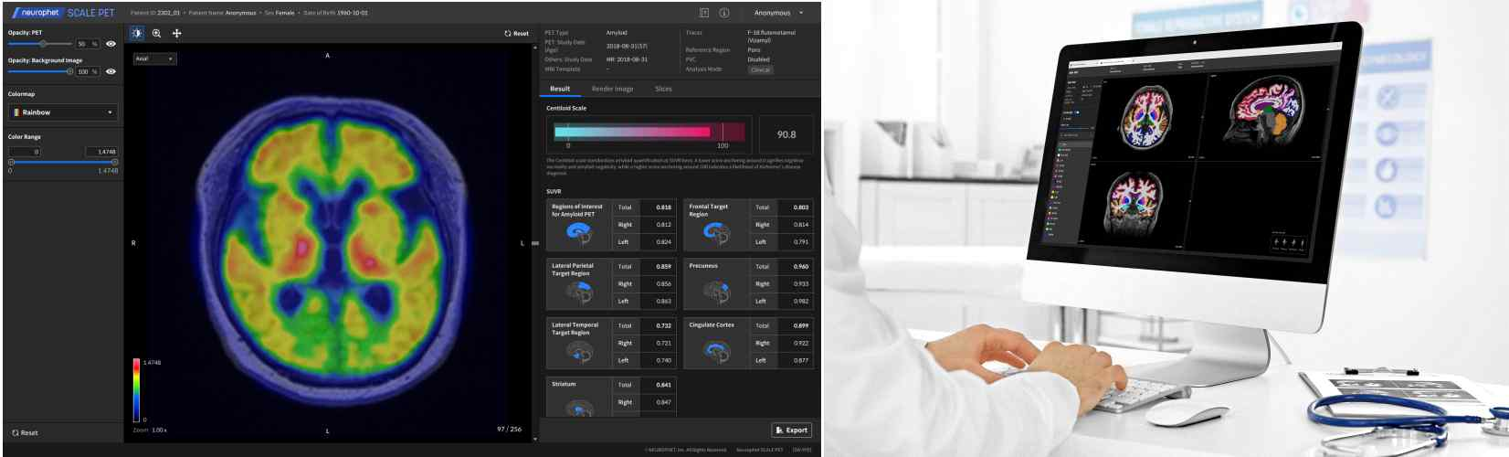

▲ (Left) Neurophet SCALE PET: PET (positron emission tomography) image quantitative analysis software and (Right) Neurophet AQUA: Neurophet AQUA: Neurodegeneration imaging analysis software

Neurophet's growth is closely linked to GIST's systematic entrepreneurship support program.

CEO Jun-gil Bin was able to systematically prepare for entrepreneurship while still in graduate school through the "GIST Sprint for Startup (GSS)" program, which supports aspiring entrepreneurs to validate their ideas and explore their feasibility, as well as entrepreneurship education and competitions.

Notably, in 2015, he won the grand prize at the 2nd Science and Technology Specialized Universities Joint Entrepreneurship Competition, which provided him with the opportunity to participate in an overseas entrepreneurship training program at the Korea Innovation Center Washington, D.C. (KIC). During this training, he engaged in investment attraction activities, which helped him secure early-stage investment immediately after launching his business.

The "Next-Generation Neuronavigation System," developed based on the research results from the GIST Science, Technology, and Innovation (GTI) Innovation Commercialization Project, was commercialized as the company's first product after receiving technology transfer from the university following its incorporation.

CEO Jun-gil Bin reflected, "We were able to pursue both our research and product development simultaneously. The university, taking into account the current student entrepreneurship situation, provided a reasonable technology transfer, which was a crucial aid in the early stages of our business."

Furthermore, Neurophet's first office was located within the GIST Startup Incubation Center, providing an optimal environment for simultaneous research and entrepreneurial activities. Following this, the company collaborated closely with the Gwangju Center for Creative Economy and Innovation, securing a total of 8 billion won in Series A and B funding, leading to rapid growth.

The success of GIST student startups extends beyond Neurophet.

SOSLAB, a company in the autonomous driving field, was founded in 2016 by CEO Ji-Seong Jeong, who was a doctoral student at GIST, along with fellow researchers. The company has grown into a core component company for autonomous vehicles and smart cities by developing world-class compact, high-precision LiDAR sensors.

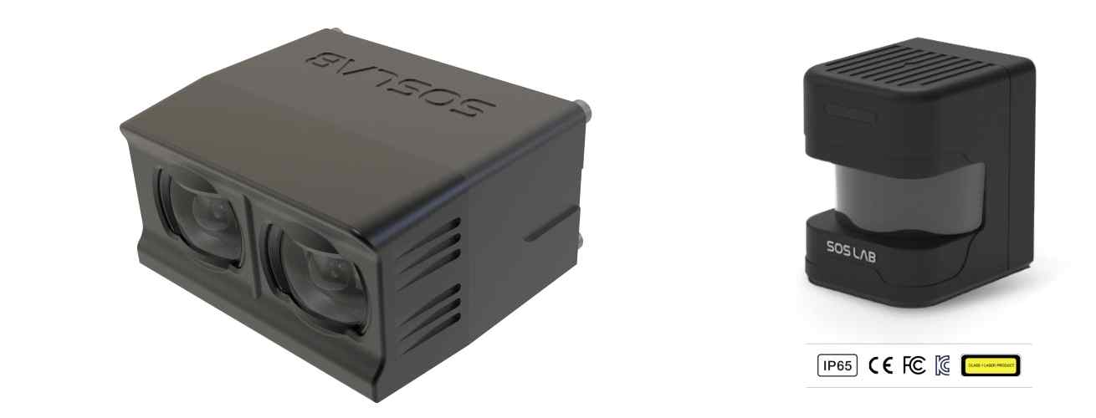

▲ (Left) SOSLAB ML (Mobility LiDAR), a next-generation fixed-mount 3D LiDAR, and (right) SOSLAB GL (General LiDAR), a compact, wide-angle scanning 2D LiDAR.

By expanding collaborations with global automakers, SOSLAB is increasing its overseas market presence and, with its technological competitiveness recognized globally, successfully listing on the KOSDAQ in June of last year.

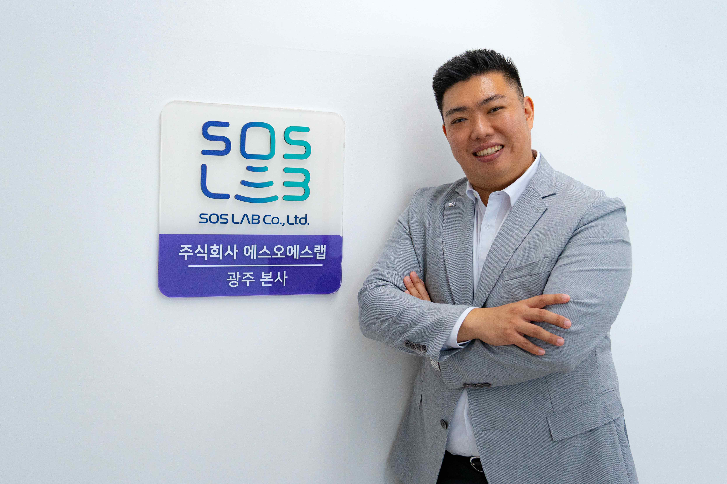

▲ CEO Ji-Seong Jeong of SOSLAB

SOSLAB recently successfully secured 43 billion won in investment. It is expanding its fabless business for high-performance semiconductor chips, "SPAD (Single Photon Avalanche Diode)," for autonomous driving and robotics, and its mass production of lidar for robotics. Furthermore, it has been selected as an official partner for the lidar sensor division of NVIDIA's autonomous driving and robotics software platform, "NVIDIA DRIVE AGX Orin." Based on its world-class technological prowess in autonomous driving and smart mobility, the company is expanding its influence in the global market.

ICARUS, an aerospace startup developing a stratospheric communication platform based on unmanned airships, was founded in 2024 by CEO Jong-won Lee, a graduate of the Department of Mechanical and Robotics Engineering at GIST. Lee is a graduate of the "Distributed Control and Automation Systems Laboratory," led by Professor Hyo Sung Ahn, an authority on control theory and unmanned autonomous systems.

ICARUS aims to establish an "aerospace communications network" connecting the world by launching unmanned airships capable of sustaining flight for over 10 years into the stratosphere. This network will provide ultra-high-speed communication services at a cost that is one-tenth that of existing satellites or ground-based base stations.

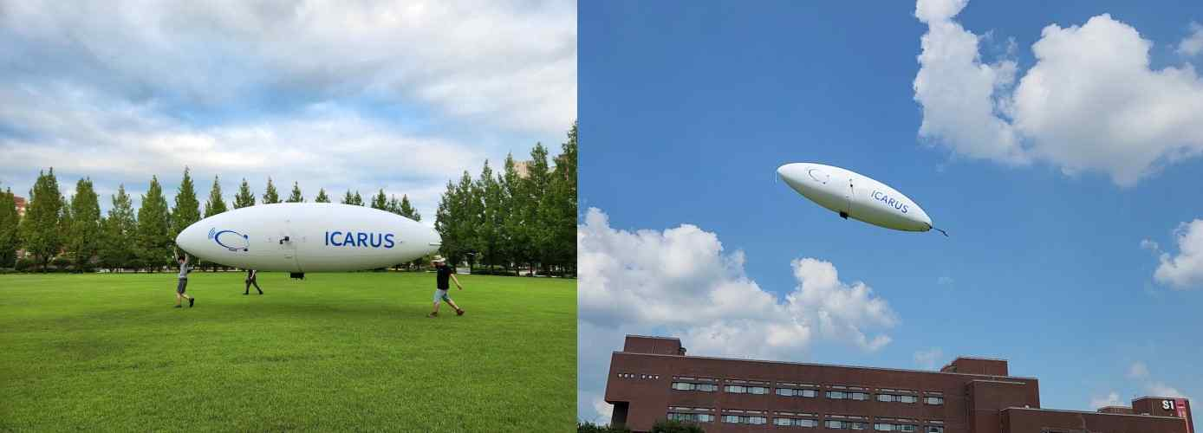

▲ ICARUS, an aerospace startup developing unmanned airships for stratospheric communication relay, is demonstrating its research results on the GIST campus.

ICARUS is developing an autonomous airship for maritime surveillance as its initial entry point. Currently, maritime surveillance only covers about 16% of the total ocean, and existing manned surveillance systems and drones struggle to monitor large areas due to cost and flight time limitations. ICARUS aims to fill this gap with its low-cost, long-endurance unmanned airships and is actively pursuing market entry, including signing an MOU with a specialized supplier to the Korea Coast Guard.

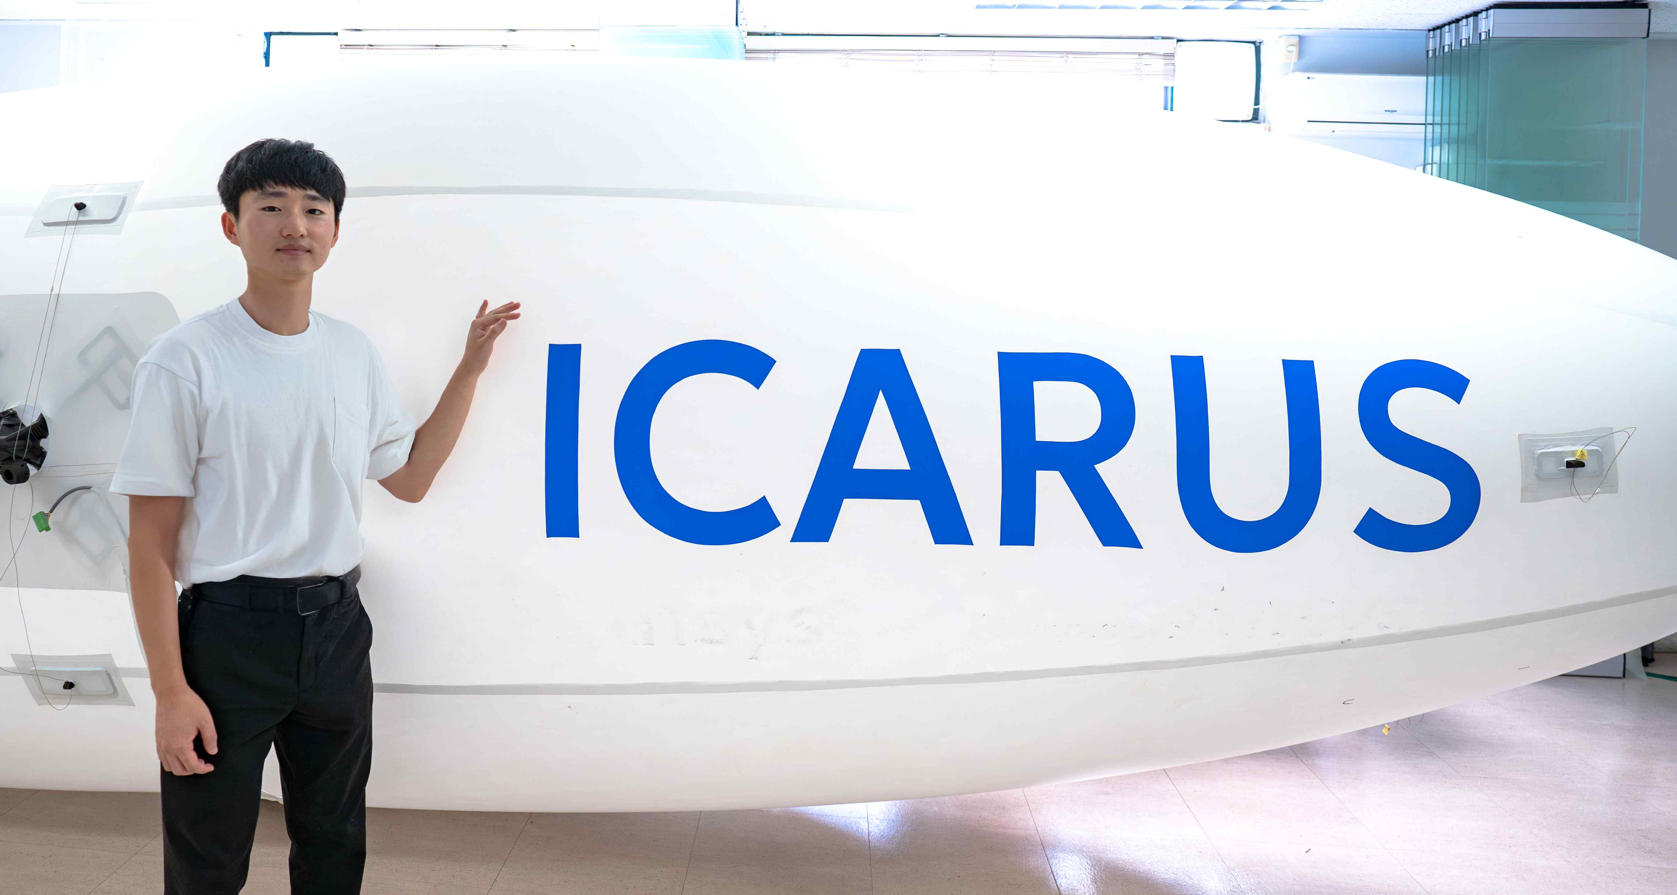

▲ ICARUS CEO Jong-won Lee

In 2025, ICARUS was selected for the Ministry of SMEs and Startups' Global Corporate Collaboration Program, receiving KRW 140 million in support.

Furthermore, ICARUS is collaborating with Ansys, a leading US engineering simulation company, to strengthen its international competitiveness. Utilizing drone control technology, ICARUS is developing control software that can withstand strong winds. Furthermore, ICARUS is jointly developing an airship using ultra-lightweight, ultra-strong materials with the Korea Textile Development Institute, steadily growing into a next-generation aerospace communications platform company.

These achievements are backed by GIST's systematic support.

GIST's Science, Technology, and Innovation Initiative (GTI), which originated from the Startup Technology Support Center, which opened in 2000, has actively supported the entrepreneurship of students and researchers through various programs aimed at supporting startups and disseminating their achievements, including: ▴ Korea's I-Corps (a research-based startup support program hosted by the Ministry of Science and ICT), ▴ Fostering aspiring entrepreneurs, ▴ Innopolis Campus (a university-based youth startup support program hosted by the Ministry of Science and ICT), and ▴ Customized commercialization of startups.

In particular, the Entrepreneurship Promotion Center under GTI leverages its expertise and experience in leading various government startup support programs to support the growth of campus startups. GIST actively supports fundraising and early-stage growth through the "Global Corporate Collaboration Program," a startup program under the Ministry of SMEs and Startups' innovation sector, investment linkages through the TIPS (Tech Incubator Program for Startups) network, a joint government-private partnership that supports promising startups, and collaborations with approximately 30 major domestic investment consortia.

Inchan Kwon , Director of the Science and Technology Innovation Center, stated, "The success of GIST student startups, including Neurofit, demonstrates that student startups can directly lead to technological innovation and industrial growth. We will continue to foster student startups that can compete in the global market by creating startup-friendly campuses and supporting investment."



