GIST faculty startup LEECELL Co., Ltd. receives the Minister of Trade, Industry and Energy Award for its innovative solar cell technology

- At the 2nd Climate Energy Innovation Awards hosted by the Ministry of Trade, Industry and Energy... Developed next-generation solar cell film technology that boasts ultra-lightness, flexibility, and transparency, enabling installation on building walls, windows, and even car roofs

- Secured price competitiveness and productivity through roll-to-roll wet processing... CEO Kwanghee Lee stated, "We will lead the transition to eco-friendly energy and contribute to the establishment of a domestic climate industry ecosystem"

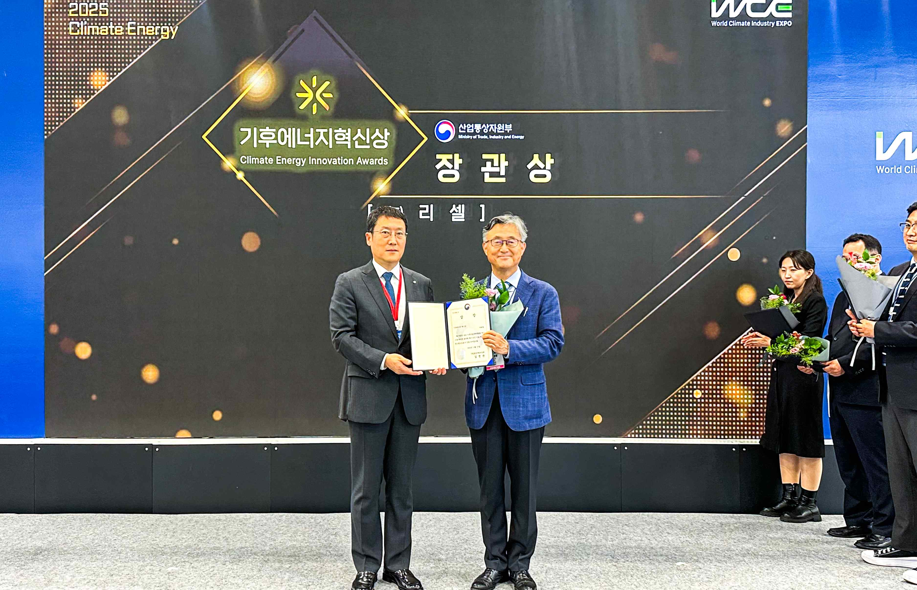

▲ Kwanghee Lee (right), CEO of LEECELL Co., Ltd., a GIST faculty-run startup, poses for a commemorative photo after receiving the Minister of Trade, Industry and Energy Award at the ‘Climate Energy Innovation Awards’ hosted by the Korea Energy Agency.

The Gwangju Institute of Science and Technology (GIST, President Kichul Lim) announced on the 28th that LEECELL, founded by Professor Kwanghee Lee of the Department of Materials Science and Engineering, won the Minister of Trade, Industry and Energy Award at the 2nd Climate Energy Innovation Awards.

The Climate Energy Innovation Awards, established last year, aim to discover and support promising domestic companies with innovative technologies and products in the climate technology field and revitalize the new energy industry ecosystem. Hosted by the Ministry of Trade, Industry and Energy and organized by the Korea Energy Agency, the awards are presented by the Korea Energy Agency.

This year's awards ceremony was held in conjunction with the 2025 Climate Industry International Expo held at BEXCO in Busan. Among the eight awardees, LEECELL was selected as one of the top four companies for its technological innovation and business potential, receiving the Minister of Trade, Industry and Energy Award.

LEECELL received particularly high marks for its "organic-inorganic hybrid solar cell film" technology, which overcomes the limitations of conventional silicon solar cells.

The "organic-inorganic hybrid solar cell film" is ultra-lightweight, flexible, and transparent, allowing it to be attached to a variety of surfaces, including building walls and windows (BIPV, building integrated photovoltaics) and car roofs (MIPV, mobility integrated photovoltaics), where conventional solar cells were difficult to apply.

Furthermore, the liquid-based process, which involves rolling the material into rolls and continuously processing it, facilitates large-scale production, ensuring cost competitiveness and productivity. It can also be expanded into diverse fields, such as indoor photovoltaics (LPV, light photovoltaics) and agricultural photovoltaics (APV, agrivoltaics photovoltaics).

Kwanghee Lee, CEO of LEECELL, stated, "This award is official recognition of LEECELL unrivaled technological prowess and growth potential. Building on this achievement, we will accelerate technology commercialization, lead the global eco-friendly energy market, and contribute to the development of the domestic climate industry ecosystem."

Meanwhile, the technologies and products of the Innovation Award-winning companies leading global climate and energy innovation technologies can be seen in person at the 'Climate Energy Innovation Award Special Exhibition Hall' set up in BEXCO Exhibition Hall 1 during the exhibition period (August 27-29).



