GIST-MIT launches global R&D collaboration hub to drive human-centered physical AI innovation: Investing 7.7 billion won over six years to create AI that coexists with humans

- Professor SeungJun Kim's team in the Department of AI Convergence was selected as the sole lead institution for the Ministry of Science and ICT's "Overseas Excellent Research Institute Collaboration Hub Construction Project (Type 2)"... Establishment and operation of the "GIST-MIT Human-Centered Physical AI Interaction Research Center"

- Global collaboration to accelerate the development of next-generation physical AI core technologies based on human-computer interaction (HCI) and extended reality (XR)... Establishment of a global research cooperation hub in conjunction with the Gwangju AI Complex

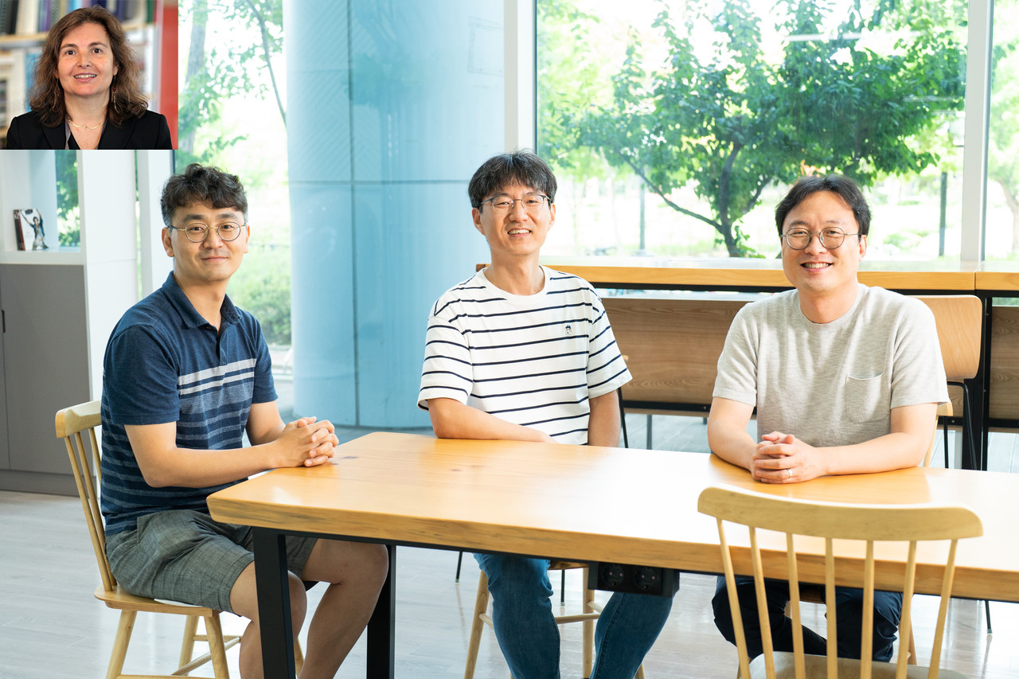

▲ (From right) Principal Investigators: Professor SeungJun Kim of GIST, Professor KyungJoong Kim, and Professor Jin Hyuk Hong; Principal Investigator: Professor Daniela Rus of MIT (top left)

The Gwangju Institute of Science and Technology (GIST, President Ki-Chul Lim) announced on Tuesday, the 19th, that Professor Seung-Jun Kim's research team in the Department of AI Convergence has been selected as the lead institution for the "Overseas Excellent Research Institution Collaboration Hub Construction Project," hosted by the Ministry of Science and ICT and the National Research Foundation of Korea.

The project (Type 2: Collaboration Network Enhancement) for which the research team was selected is a program designed to further develop domestic research institutions' existing overseas networks, foster continued excellence through international collaboration, and actively leverage outstanding overseas research capabilities for domestic research and industry. This year, GIST was the only recipient nationwide.

The research team plans to establish and operate the ‘GIST-MIT Human-Centered Physical AI Interaction Research Center’ with a total of 7.7 billion won in support over six years (2025-2030), and Professor Daniela Rus, director of the Computer Science and Artificial Intelligence Laboratory (CSAIL) at the Massachusetts Institute of Technology (MIT), will participate as the overseas research director.

Professor Rus is a world-renowned authority on robotics, and her first popular book, "MIT Robotics Class with Daniela Rus," published in 2024, recently became widely known in Korea with its translation and introduction.

In Korea, leading experts in each field will be joining the research center, including Professor Seung-Jun Kim (Director), Professor Jin Hyuk Hong (GIST, Robotics and Accessibility), Professor KyungJoong Kim (GIST, Reinforcement Learning and Tactile Robotics), Professor Young Min Song (Korea Advanced Institute of Science and Technology (KAIST), Optoelectronics and Physical AI Sensors), and Director Kyungtaek Lee (Korea Electronics and Technology Institute (KETI), Edge Computing and Realistic Media).

Through the newly established research center, GIST and MIT will develop physical AI technologies that feature realistic interaction, inclusiveness, and understandability, with the goal of realizing "human-centered AI." To this end, the two universities will jointly research human-computer interaction (HCI) technologies and technologies utilizing extended reality (XR).

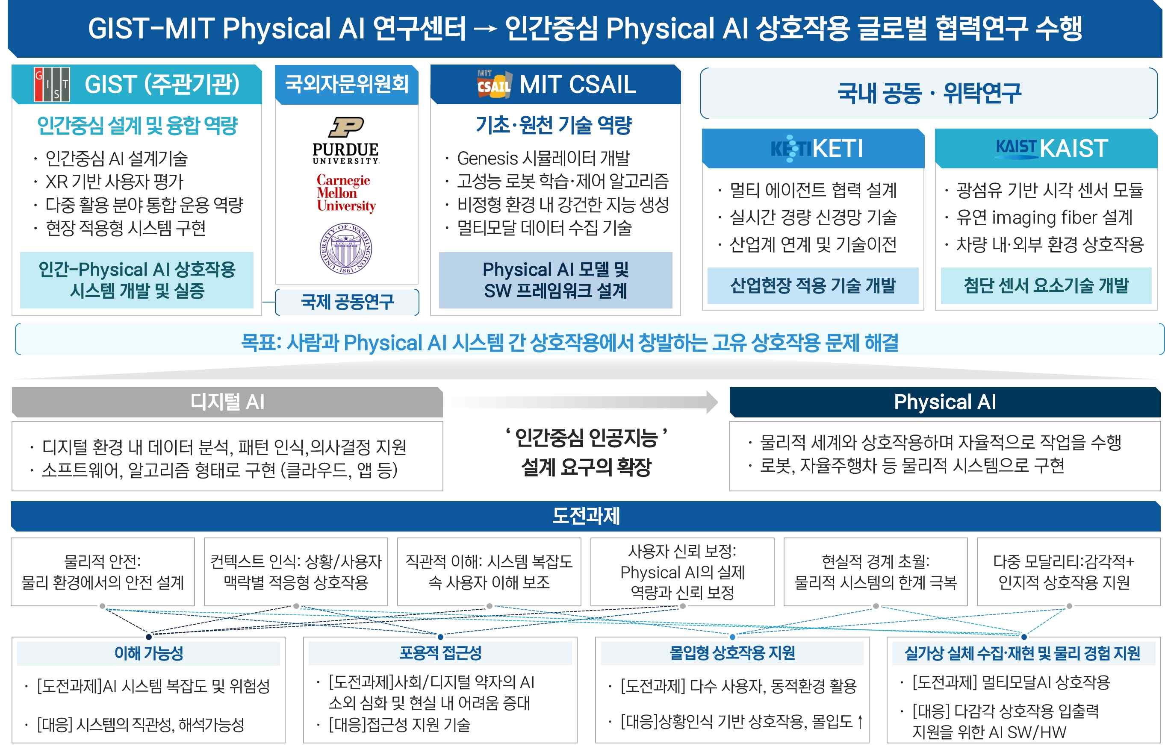

▲ Overview of the GIST-MIT "Human-Centered Physical AI Interaction Research Center"

Physical AI refers to next-generation artificial intelligence technology that goes beyond mere virtual environments and directly interacts with the real physical world. The key is to create an environment where humans and machines can naturally collaborate by combining AI with physical devices such as sensors, robots, self-driving cars, and smart manufacturing equipment.

It can be integrated with various cutting-edge technologies, such as humanoid robots, autonomous vehicles, and smart factories, and is attracting attention as a future innovation with broad applicability across healthcare, education, industry, and services.

The research team will combine the collaborative experience with MIT, previously accumulated through the "GIST-MIT International Joint Research (2021-25)" project, with the expertise of participating institutions to conduct full-cycle research, from core technology development to commercialization. Furthermore, the team plans to strengthen personnel exchanges and expand its role as a hub for international research collaboration.

Professor SeungJun Kim, the principal investigator, is an expert in the convergence of HCI, XR, and AI. He has led the development of numerous technologies for interacting with physical AI in future computing environments, including virtual reality interfaces, autonomous vehicles, and the construction of real-virtual environments based on generative AI.

Notably, since 2021, he has been conducting "HCI+AI Convergence Research for Human-Centered Physical Systems Design" with MIT. Through his collaboration with MIT's Professor Daniela Rus and Professor Wojciech Matusik, the team has achieved world-class results, including the publication of 18 joint papers and six awards for the best international conference paper.

Professor SeungJun Kim expressed his aspirations, saying, "Building on the international collaboration network and experience built through the GIST-MIT joint research project over the past five years, we will produce world-class research results. We will also take the lead in fostering the next generation of global AI talent through active exchanges between researchers."

Through this project, GIST plans to: ▴ expand joint research with MIT CSAIL; ▴ establish a multilateral HCI+AI research collaboration network with leading universities in North America, Europe, and Asia; ▴ facilitate two-way talent exchanges between universities; ▴ host international workshops in physical AI; and ▴ accelerate the commercialization of technology through industry-academia collaboration.

In particular, he presented a vision to become a global research collaboration hub in the field of physical AI interaction in conjunction with the Gwangju AI Complex. To this end, he plans to dispatch Korean researchers to MIT and invite MIT researchers to GIST to expand practical research collaborations.



