GIST Energy Valley Technology Institute Director Kwanghee Lee receives Gwangju Metropolitan City Mayor's Award

- Active field-oriented activities from policy, planning, and corporate support to industry-academia cooperation... Contributing to establishing Gwangju's energy industry strategy and strengthening the ecosystem

- Taking the lead in creating a sustainable energy ecosystem and establishing a cooperation platform

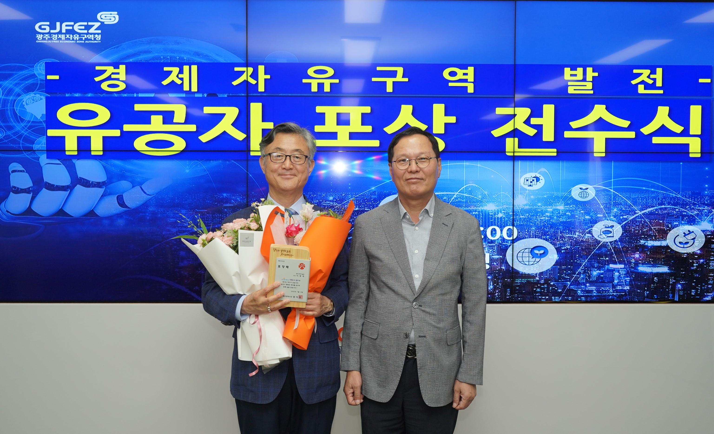

▲ GIST Energy Valley Technology Institute Director Kwanghee Lee (left) is taking a commemorative photo after receiving the Gwangju Metropolitan City Mayor’s Award on July 10 (Thursday) in recognition of his continued contributions to the creation and development of the energy industry ecosystem.

The Gwangju Institute of Science and Technology (GIST, President Kichul Lim) announced that Energy Valley Technology Institute Director Kwanghee Lee received the Gwangju Metropolitan City Mayor’s Award on July 10 (Thursday) in recognition of his contributions to the creation and development of the energy industry ecosystem in the Gwangju region.

Director Kwanghee Lee has played a leading role in strengthening the Gwangju-type energy transition and industrial ecosystem through various activities such as ▴ energy industry policy planning ▴ discovering and supporting promising companies ▴ operating an industry-academia-research cooperation platform centered around the GIST Energy Valley Technology Institute.

In particular, by forming and operating expert committees in major fields such as hydrogen, batteries, and distributed energy, he established customized strategies that reflect regional characteristics and industrial bases and linked them to central government R&D projects to enhance execution capabilities. In addition, he established a practical cooperation network among research institutes, universities, companies, and local governments in the region, and regularized policy seminars and technology exchange meetings to solidify our foundation as an energy industry hub.

Recently, he has been actively working with the Gwangju Free Economic Zone Authority to discover promising local companies and support customized investment attraction.

At the ‘G.E.T. & ReBorn Gwangju Energy Industry Technology Exchange’ held on June 11, he planned and supported IR presentations by promising companies and created a venue for mutual cooperation through networking between policy agencies, companies, and investors.

Director Kwanghee Lee said, “From energy policy establishment to industry planning, company support, and cooperation networks, we are taking responsibility for laying the foundation for Gwangju’s future energy industry,” and added, “We will do our best to build a sustainable ecosystem so that Gwangju can establish itself as a key city leading the national energy transition.”



