GIST graduate Dr. Young Hwan Jung appointed as assistant professor at the University of Texas at Austin (UTMB)

- Obtained master's and doctoral degrees from GIST Department of Life Sciences (Advisor: Professor Yong-Chul Kim)... After NIH and St. Jude, appointed as an assistant professor at the Department of Neurobiology and the Silicine Drug Development Institute at the University of Texas Medical Branch (UTMB) in September 2024

- A researcher developing a fusion new drug combining small molecule drugs, target protein degradation, and epigenetics "GIST is a turning point in my life as a researcher... I want to leave a distinct mark in the field of new drug development"

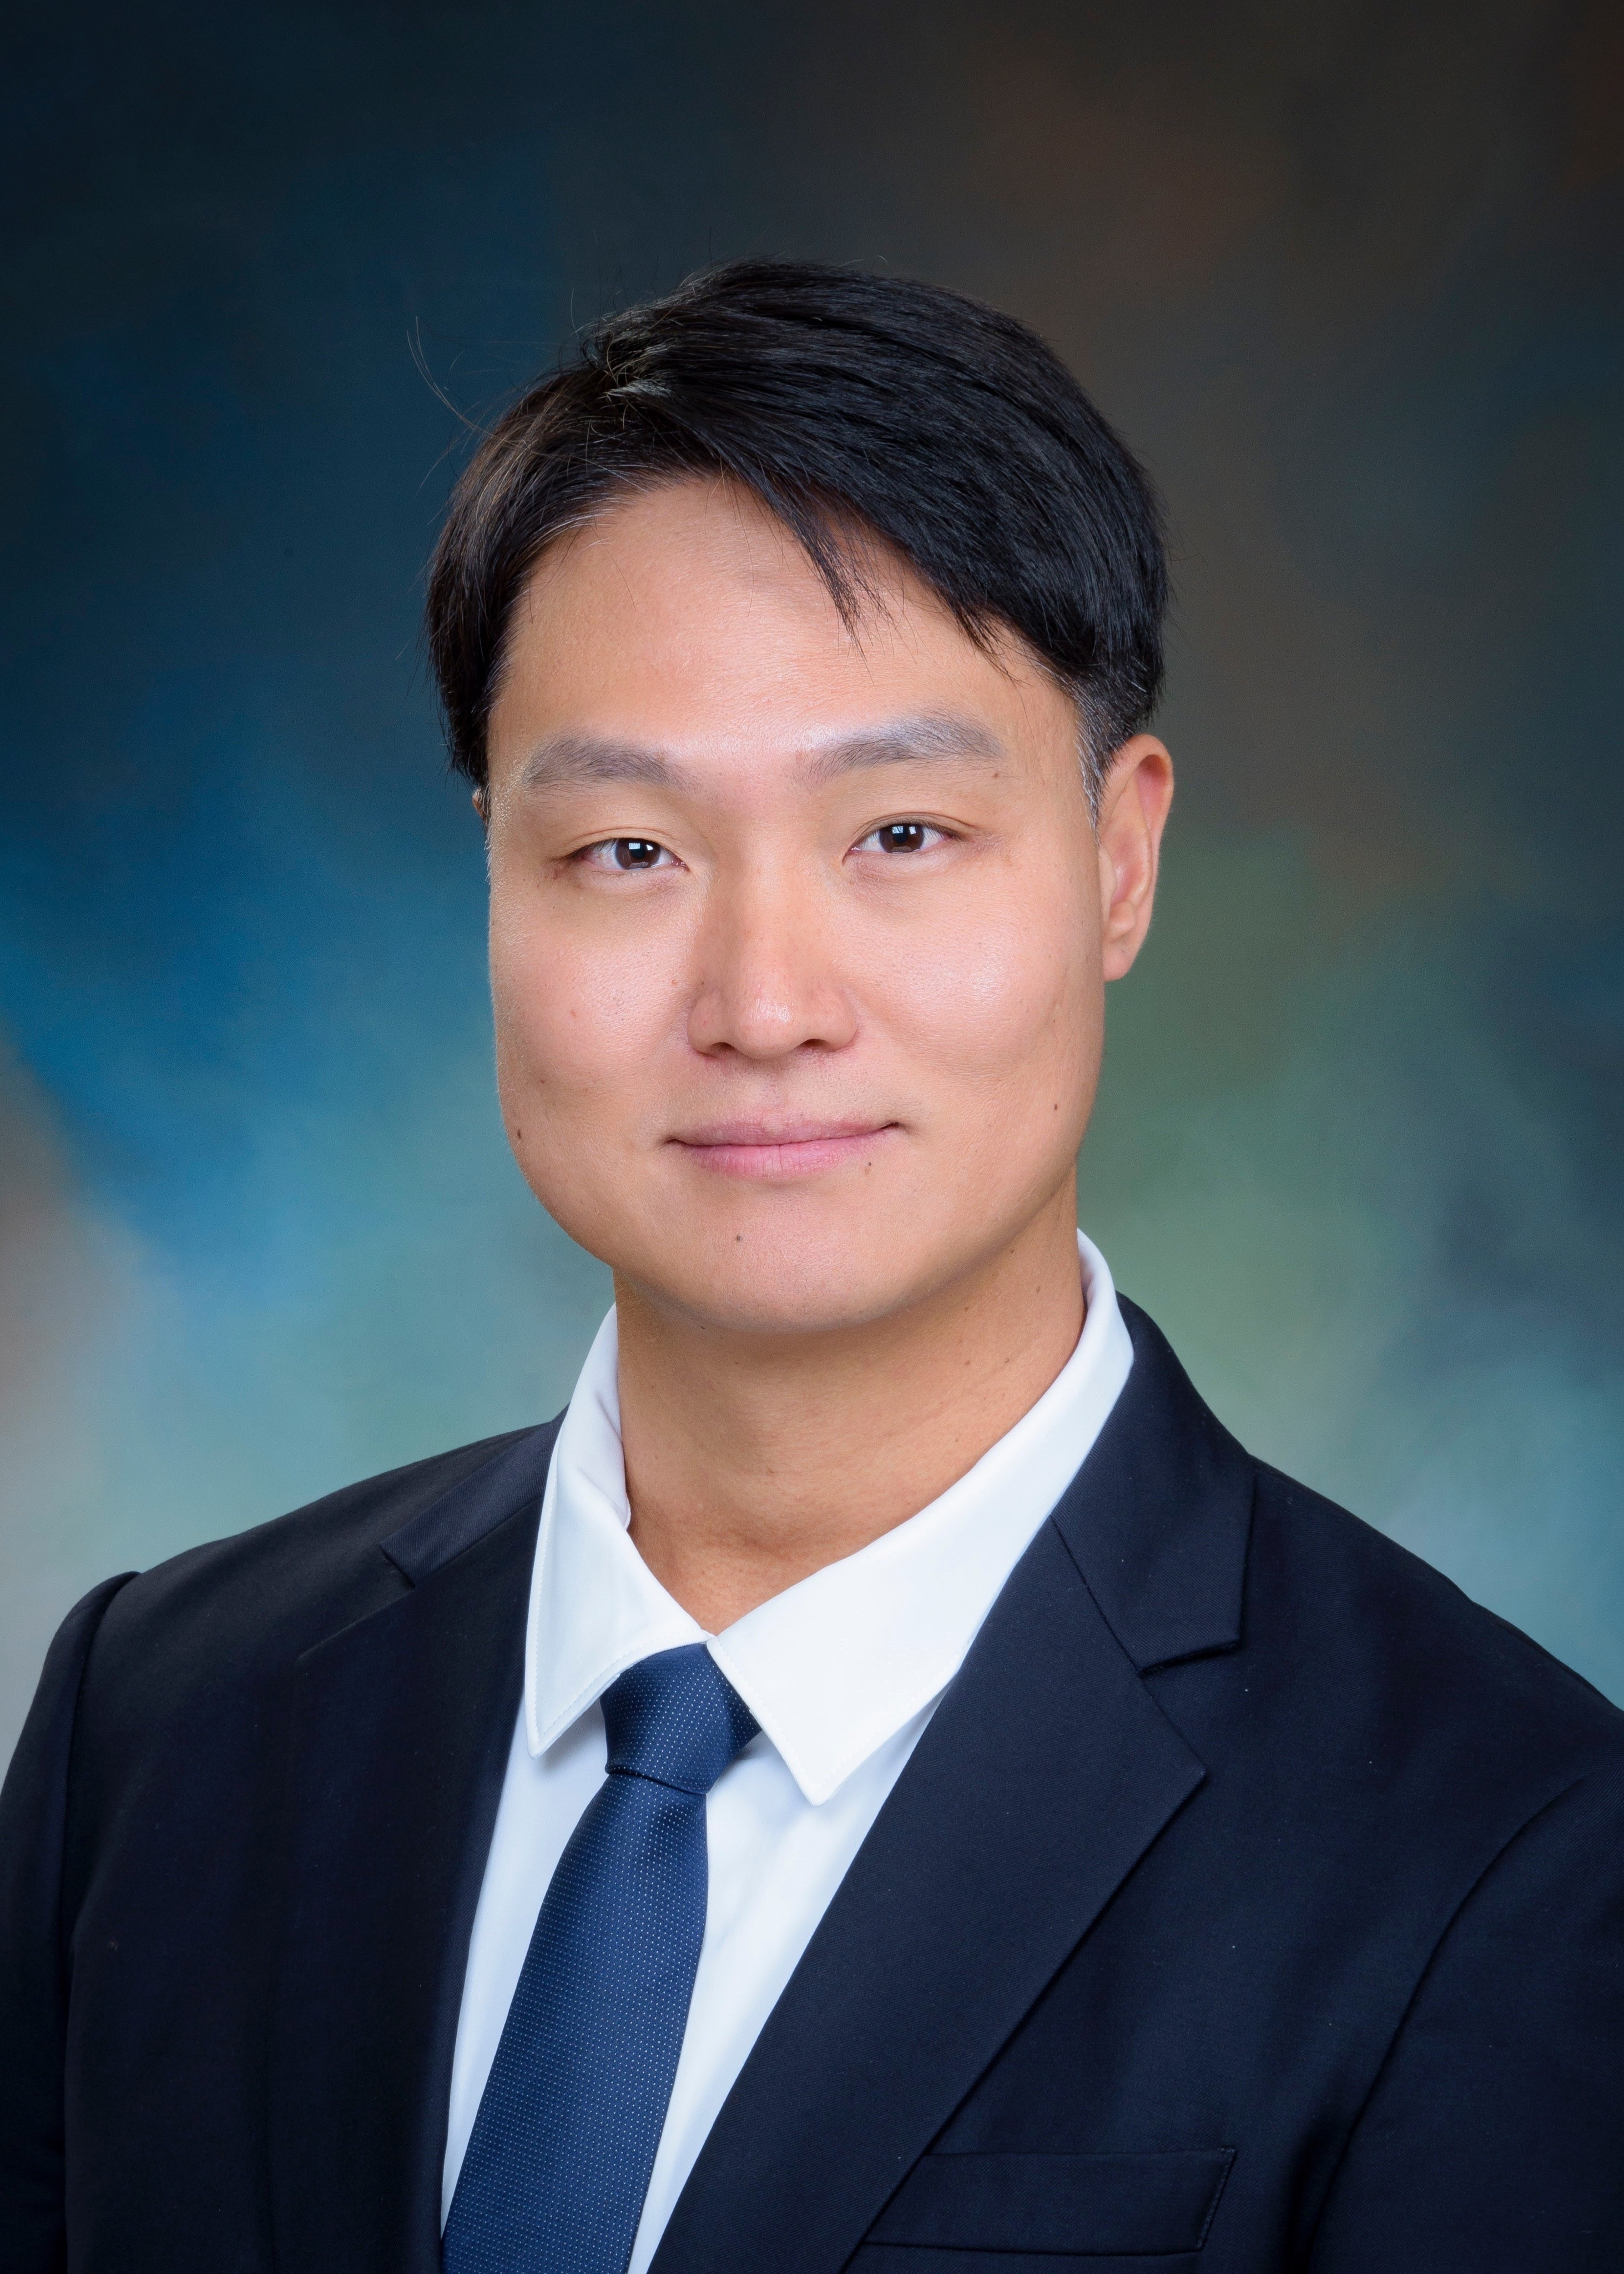

▲ Dr. Young Hwan Jung, a Ph.D. graduate of the Department of Life Sciences at GIST, was appointed as an Assistant Professor at the Department of Neurobiology at the University of Texas Medical Branch (UTMB) in September 2024

□ The Gwangju Institute of Science and Technology (GIST, President Kishul Lim) announced that Dr. Young Hwan Jung (Advisor: Yong-Chul Kim), a graduate of the Department of Life Sciences, was appointed as an Assistant Professor at the Department of Neurobiology and the Sealy Institute for Drug Discovery at the University of Texas Medical Branch (UTMB) in the United States as of September 1, 2024.

∘ Dr. Young Hwan Jung completed his master's and doctoral studies in the laboratory of Professor Yong-Chul Kim of the Department of Life Sciences at GIST and received his doctorate in August 2017. After that, he worked as a postdoctoral researcher (2018. 2. ~ 2022. 11.) at the National Institute of Diabetes and Digestive and Kidney Diseases (NIDDK) under the National Institutes of Health (NIH)* in the United States, focusing on the discovery of new drug candidates targeting G Protein-Coupled Receptors (GPCRs). Through this, he laid the foundation for research to develop treatments for chronic diseases.

* National Institutes of Health: The National Institutes of Health is an administrative agency in the United States that oversees medical and health-related policies, and is one of the world's top medical science research funding organizations, supporting tens of trillions of won in research funds to domestic and foreign researchers annually. A total of 144 Nobel Prize winners have been produced here so far.

□ While working as a principal investigator at St. Jude Children’s Research Hospital in the United States (November 2022 - August 2024), he led the development of innovative small molecule compounds such as PROTACs (Proteolysis Targeting Chimeras) for cancer treatment. In particular, he devoted himself to new drug development research utilizing targeted protein degradation technology and the latest drug exploration platform.

□ Currently, Dr. Jung is conducting research with the goal of developing advanced treatments for various diseases such as chronic pain, premature birth, neurodegenerative diseases, cancer, and infectious diseases.

∘ His main research areas include ▴ design and synthesis of bioavailable small molecule chemicals ▴ targeted protein degradation technology for regulating disease-related protein expression ▴ development of multi-regulators based on epigenetic drugs, etc., and he is approaching new drug development by integrating technologies from various fields such as medicinal chemistry, chemical biology, and computational science.

□ Dr. Jung said, “Through research at the US NIH and St. Jude Children’s Hospital, I was able to deeply experience the entire process of new drug development, from the design of cutting-edge new drug candidates such as GPCR agonists and PROTACs,” and “Above all, my studies and research at GIST were a decisive turning point in my life that laid the foundation for me as a researcher, and I hope to leave a distinct mark in the field of new drug development through meaningful achievements in the future.” <End>



