GIST Professor Kihong Park's team wins the Ahn Kang-ho Award for real-time analysis technology of aerosol components

- Professor Kihong Park's research team from the Department of Environment and Energy Engineering won an award at the 2025 Korean Association for Particle and Aerosol Research regular conference... Taking domestic measurement technology to the next level with real-time aerosol analysis technology

- Recognition of creative research results that overcome the limitations of non-real-time and expensive equipment... Expected to contribute to indoor and outdoor air quality analysis and health policy "We will develop real-time analysis technology to a world-class level"

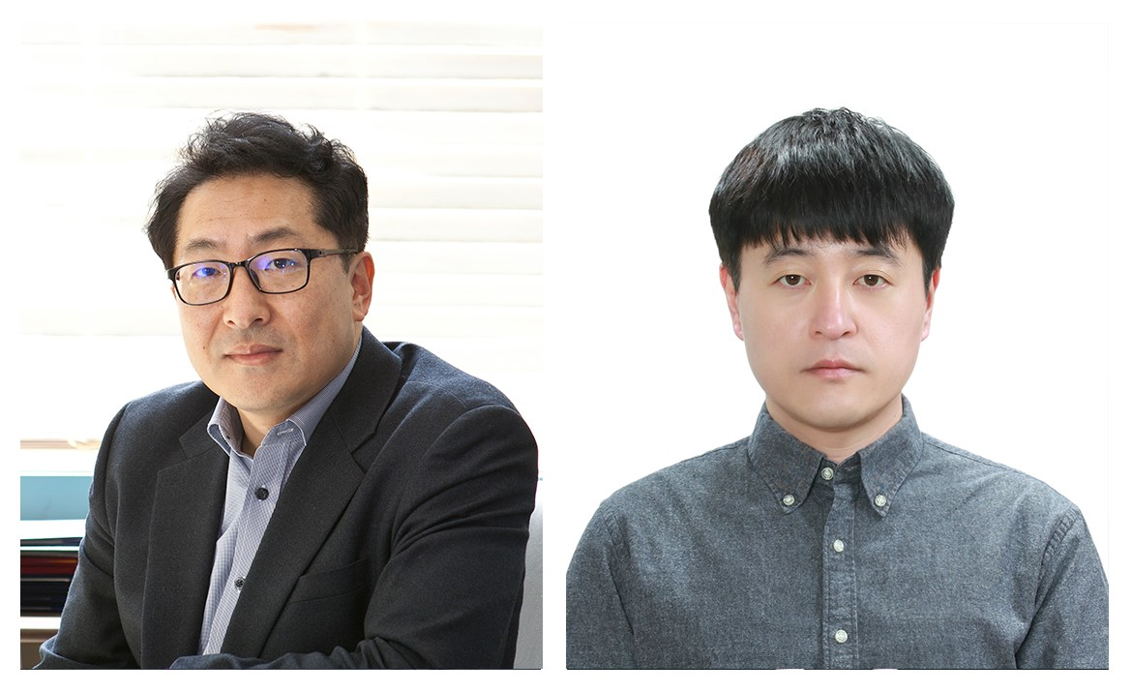
▲ (From left) Professor Kihong Park of the Department of Environment and Energy Engineering, and Dr. Ki-Baek Kim, alumnus (Korea Institute of Science and Technology Evaluation and Planning (KISTEP) researcher)

□ The Gwangju Institute of Science and Technology (GIST, President Kichul Lim) announced that Professor Kihong Park of the Department of Environment and Energy Engineering won the 'Ahn Kang-Ho Award Grand Prize' at the 2025 regular academic conference of the Korean Association for Particle and Aerosol Research.

□ The 'Ahn Kang-Ho Award' is an award given to researchers who have made outstanding academic contributions in the field of particles and aerosols, and was established with funds donated by ALT Plus Co., Ltd. to the Korean Society for Particle and Aerosol Studies to honor the achievements of Professor Emeritus Kang-Ho Ahn of Hanyang University.

∘ The Korean Association for Particle and Aerosol Research selects the best paper among the papers published in its journal every year and presents the 'Ahn Kang-Ho Award', and strives to discover and encourage creative and influential research results in the field of aerosols.

* Korean Association for Particle and Aerosol Research: The Korean Association for Particle and Aerosol Research was founded in 1994 as a leading domestic academic society specializing in aerosols. It has led basic and applied convergence research in various fields such as atmospheric fine particles, semiconductor process contaminant particles, nanomaterial particles, bioaerosols, and nuclear power-related aerosols. Recently, it has been contributing to solving social problems such as resolving the fine dust problem and identifying the airborne infection route of COVID-19, and has been striving to provide a scientific basis for policy decisions.

□ The paper awarded to Professor Kihong Park's research team is a study that developed a technology that can measure the elemental composition ratio of carbonaceous aerosols in real time, and was evaluated to have overcome the limitations of existing non-real-time analysis methods or expensive equipment, and raised the level of domestic aerosol measurement technology to the next level.

∘ This technology is expected to be of great help in establishing air quality management and environmental and health policies as it can quickly analyze the cause of generation, emission path, and health effects of various aerosols generated indoors and outdoors.

□ Professor Kihong Park said, "With this award as an opportunity, I will continue to conduct research with students and researchers so that Korea's real-time aerosol composition analysis technology can reach a world-class level."

□ Meanwhile, the awards ceremony was held at the '2025 Korean Association for Particle and Aerosol Research Society Regular Academic Conference' held in Yongpyeong, Gangwon-do on Thursday, July 3. <End>



