GIST Professor Dongryeol Ryu receives the 'Sasuk Award', the highest recognition in biochemistry and molecular biology

- Leading Korea and international industry-academia cooperation based on precise analysis of life phenomena and leading the development of practical treatment strategies... Achieving outstanding results from molecular identification of life phenomena to commercialization of treatment technologies

- Publishing over 150 SCIE-level papers (average citations per paper of over 100 times)... Proving international status by being listed as the world's most influential researchers (HCR) and selected as one of the world's top 2% scientists for 3 consecutive years

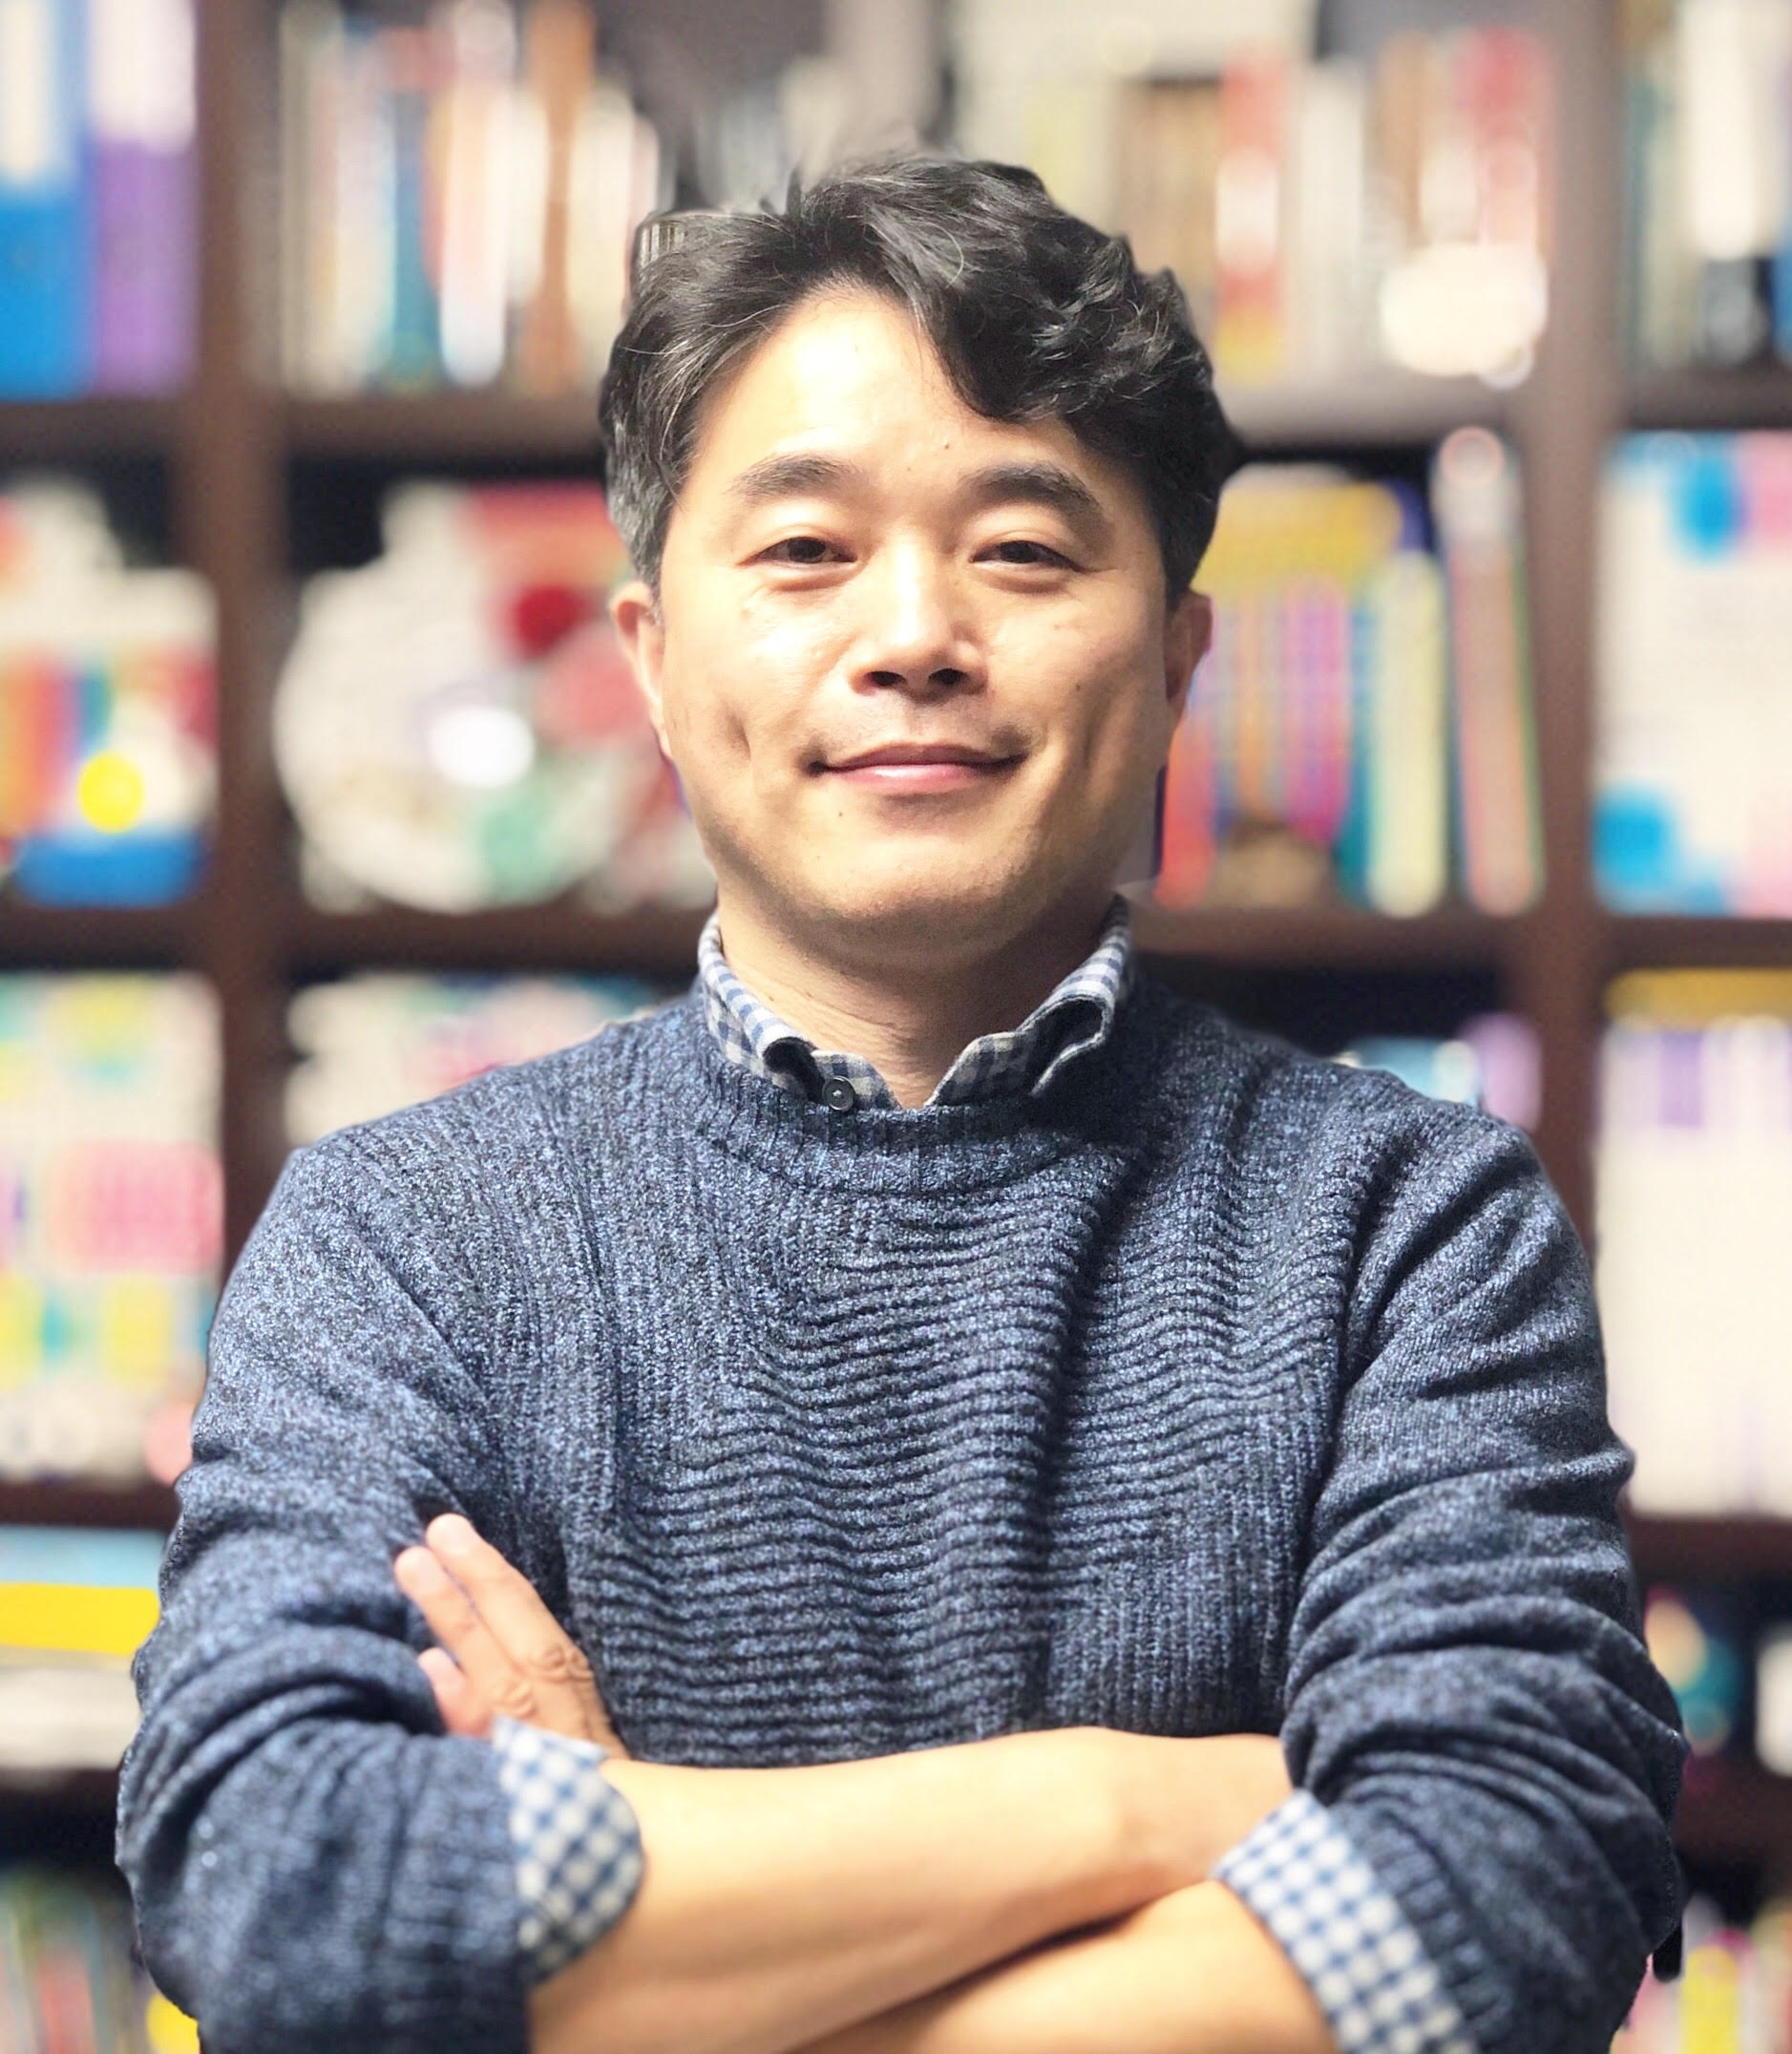

▲ Professor Dongryeol Ryu of GIST Department of Biomedical Science and Engineering

The Gwangju Institute of Science and Technology (GIST, President Kichul Lim) announced that Professor Dongryeol Ryu of the Department of Biomedical Science and Engineering won the 2025 Sasuk Award at the ‘2025 Asia-Oceania Federation of Biochemistry and Molecular Biology (FAOBMB) Conference’ and the ‘Korean Society for Biochemistry and Molecular Biology (KSBMB) Annual Conference’ held at BEXCO in Busan from May 20 to 23.

The Sasuk Award was established in 2019 according to the wishes of former Chairman Kyung-soo Ham, and was created to encourage young life scientists with outstanding creative research capabilities and to inspire research motivation. It is currently considered the most traditional and prestigious award among the awards presented by the Korean Society for Biochemistry and Molecular Biology.

Professor Ryu has been recognized for his outstanding research achievements in both academic and practical aspects through his elucidation of the molecular pathophysiology of aging biology and metabolic diseases, development of indicators of healthy aging, and application to sarcopenia treatment and healthy aging induction technology.

He has published about 150 papers in SCIE-level international academic journals so far, and the average number of citations per paper is about 100 or more (as of May 2025).

He also holds about 10 technology patents, so he is highly regarded for his potential for practical application beyond his academic contributions in terms of basic research.

Based on these research achievements, Professor Ryu was listed as one of the ‘Highly Cited Researchers (HCR)’ in the world by Clarivate Analytics in the United States in 2022, and was also recognized for his research influence worldwide by being listed in the ‘Top 2% Scientists in the World’ by Stanford University in the United States and Elsevier, a global academic information analysis company, for three consecutive years from 2022 to 2024.

Currently, Professor Ryu is the general manager of the first phase of the ‘Korean ARPA-H’ project hosted by the Ministry of Health and Welfare and the Korea Health Industry Development Institute, and is leading a multimodal integrated research consortium for the development of a treatment for sarcopenia.

The research is attracting attention as a new treatment strategy for sarcopenia, a major disease in the aging society, and is considered a representative example of successful domestic and international industry-academia-research cooperation.

Professor Ryu said, “This award is thanks to the dedicated efforts of the excellent members of the GIST laboratory and domestic and international collaborating researchers,” and added, “I will continue to devote myself to research that precisely elucidates life phenomena at the molecular level and connects them to the development of practical treatment strategies.”



