Professor Hobeom Kim, receives ‘Young Scientist Award’… at PIERS 2025, a world-class academic conference in the fields of electromagnetism and optical science

- Professor Hobeom Kim of the Department of Materials Science and Engineering, greatly increases the possibility of commercializing high-efficiency and high-stability optoelectronic devices with perovskite defect control technology



▲ Professor Hobeom Kim of the GIST Department of Materials Science and Engineering

The Gwangju Institute of Science and Technology (GIST, President Kichul Lim) announced that Professor Hobeom Kim of the GIST Department of Materials Science and Engineering won the Young Scientist Award at the ‘PIERS 2025 (PhotonIcs and Electromagnetics Research Symposium)’ held in Abu Dhabi, United Arab Emirates on Wednesday, May 7.

The PIERS Young Scientist Award (YSA) is awarded to a young scientist under the age of 40 who has been recognized for his outstanding potential and research achievements in the fields of electromagnetics and photonics. The recipient is selected through a rigorous screening process targeting researchers from around the world. The recipient is highly recognized for his potential to grow into a key researcher at the leadership level in the field.

Professor Hobeom Kim was recognized for his unique and innovative development of defect control technology for perovskite, which is attracting attention as a next-generation optical semiconductor material, and for greatly increasing the possibility of commercializing high-efficiency and high-stability optoelectronic devices. This technology has high potential for use in various optoelectronic applications such as solar cells, light-emitting diodes (LEDs), and photodetectors.

Meanwhile, the PhotonIcs and Electromagnetics Research Symposium (PIERS) is a world-renowned international academic conference in the field of electromagnetic theory and application and has been held annually since 1989 under the auspices of The Electromagnetics Academy (TEA).

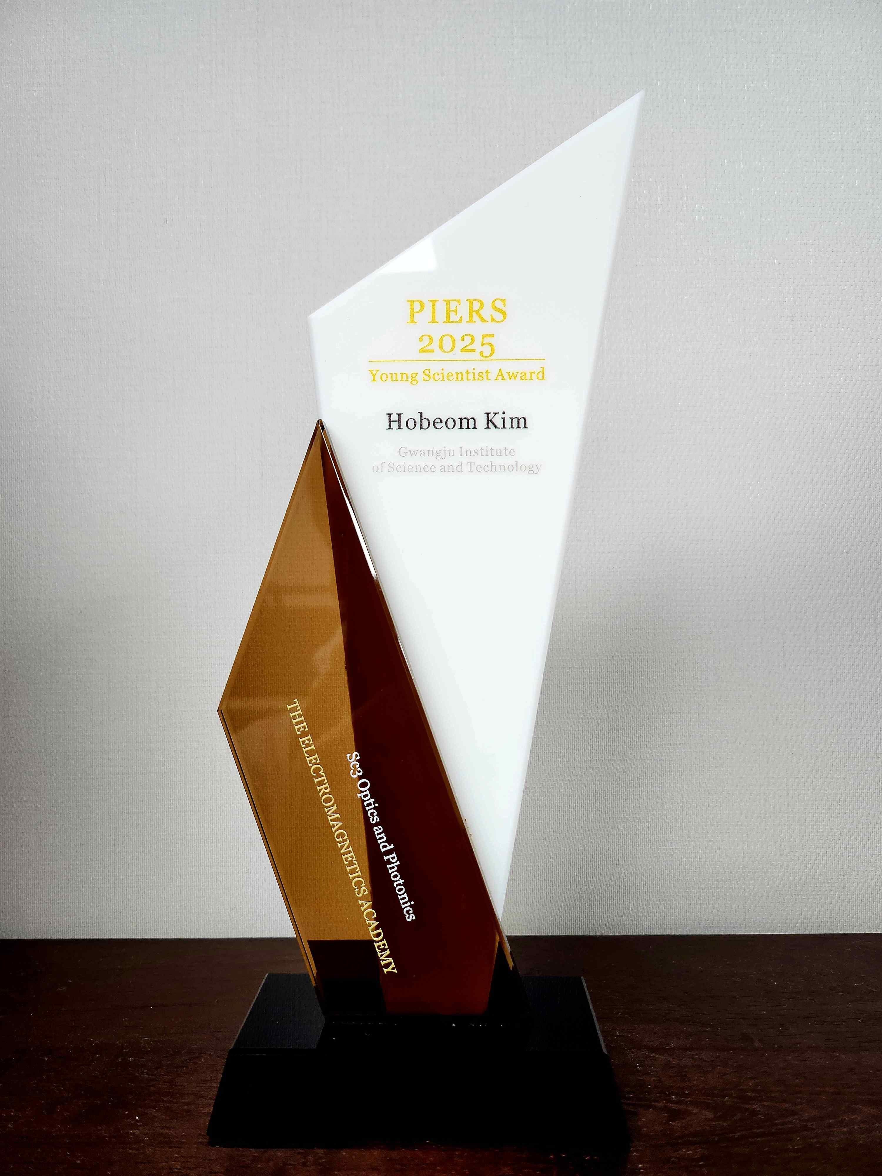

▲ PIERS 2025 YSA (Young Scientist Award) Plaque

PIERS is held in major cities in the U.S., Europe, and Asia, and is a venue for sharing the latest research results in various fields such as optics, photonics, electromagnetic theory, metamaterials, and nano-optics. This conference serves as a platform for knowledge exchange and global collaboration among researchers, and is evaluated as an authoritative academic event in which leading scholars in related fields participate.



