Five GIST faculty members receive government awards and ministerial commendations for their contributions to the advancement of science and technology

- Commemorating the 25th Science and Information Communication Day... Achievements in each field, innovation in science education, etc.

- Awarded the Medal of Science and Technology (Professor Do-Young Noh), Presidential Citation (Professor Bong-Joong Kim), etc.

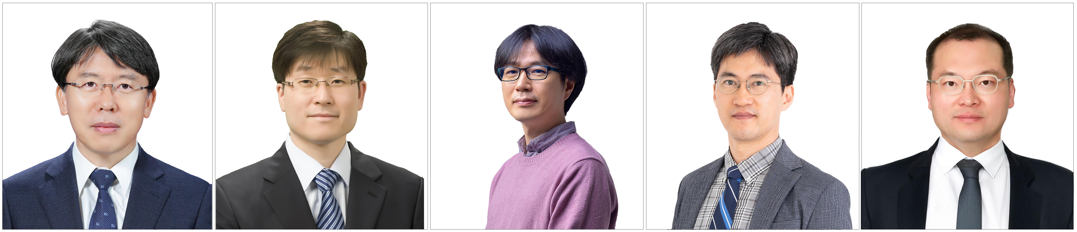

▲ (From left) (Medal of Innovation) Professor Do-Young Noh of the Department of Physics and Photon Science, (Presidential Citation) Professor Bong-Joong Kim of the School of Materials Science and Engineering, (Prime Minister's Citation) Professor Jongseok Lee of the Department of Physics and Photon Science, (Minister's Citation) Professor Jongho Lee of the School of Mechanical and Robotics Engineering, Team Leader of the Future Strategy Office

The Gwangju Institute of Science and Technology (GIST, President Kichul Lim) announced on the 21st that Professor Do-Young Noh and four other faculty members received the Science and Technology Promotion Government Award and Minister’s Commendation for their contributions to creating excellent research results and promoting science and technology at the ‘2025 Science and Information and Communication Day Commendation Ceremony’ held at the Korea Science and Technology Hall.

Professor Do-Young Noh (Department of Physics and Photon Science), who received the Medal of Science and Technology Innovation, has contributed to creating world-class research results while serving as the president of the Institute for Basic Science (IBS) and a member of the National Science and Technology Advisory Council.

Based on his academic excellence and outstanding leadership, Professor Noh established and operated the ‘Ultrafine Ultra-High-Speed X-ray Science Research Center,’ a leading research center in the field of X-ray science in Korea, and contributed to the development of national science and technology by publishing over 200 SCI papers and fostering 22 doctoral and 45 master’s degree holders.

The Presidential Citation went to Professor Bong-Joong Kim (School of Materials Science and Engineering), who has devoted himself to education and research for 23 years as a leading scholar in the field of nanomaterials and has contributed to the development of future advanced materials in the fields of nano, electronics, and energy through real-time electron microscopy technology.

Professor Kim quantified the characteristics of nanomaterials/devices and suggested the potential for application in various fields such as next-generation semiconductors, renewable energy, catalysts, and sensors, and played a major role in raising the level of domestic nanomaterials research to the world-class level through training of future researchers and international joint research.

The Prime Minister's Citation went to Professor Jongseok Lee (Department of Physics and Photon Science), who has led the development of linear/nonlinear and ultrafast spectroscopy research in the field of condensed matter physics and has greatly contributed to the activation of infrared/terahertz spectroscopy research using synchrotron radiation.

Professor Lee has published over 100 SCI-level academic papers, and is expected to make a significant contribution to solving the problem of heat generation in the semiconductor industry, especially through innovative research on nanoscale heat transport.

The Minister’s Award was awarded to individuals who have contributed to the development of science and technology and the educational environment through innovative research and institutional improvement.

Professor Jongho Lee (School of Mechanical and Robotics Engineering) has created achievements that have garnered much attention from academia and industry by developing the world’s first flexible solar cell and power transmission technology inside the human body. He has also continuously conducted research that is interesting and easy for the general public to understand, thereby increasing national interest and understanding of science and technology and widely publicizing its social value.

Team Leader Seung-jae Lee of the Future Strategy Office, who also received the award, has made a significant contribution to the practical improvement of the education and welfare infrastructure, such as the establishment of the GIST undergraduate program, modernization of student dormitories, and improvement of employee treatment. In addition, he was selected as the recipient in recognition of his contribution to strengthening the external competitiveness of the institution through the establishment of the GIST Innovation Vision and operation of the Joint Secretariat.

GIST President Kichul Lim said, “In today’s world where global competition centered on science and technology is becoming fiercer by the day, the role of scientists and engineers is becoming more important in strengthening our country’s competitiveness,” and added, “On Science Day and Information and Communications Day, I would like to express my deepest gratitude and respect to the award recipients who have devoted themselves to the development of national science and technology.”



