GIST Professor Hobeom Kim of the Department of Materials Science and Engineering receives the ‘New Academic Award’ from the Polymer Society of Korea

- Professor Hobeom Kim of the Department of Materials Science and Engineering, recognized for outstanding research achievements in the field of next-generation optical semiconductor materials and devices

- Last year, he was selected as the recipient of the ‘7th Korea Toray Fellowship’ and received attention from academic circles at home and abroad for his creative research achievements

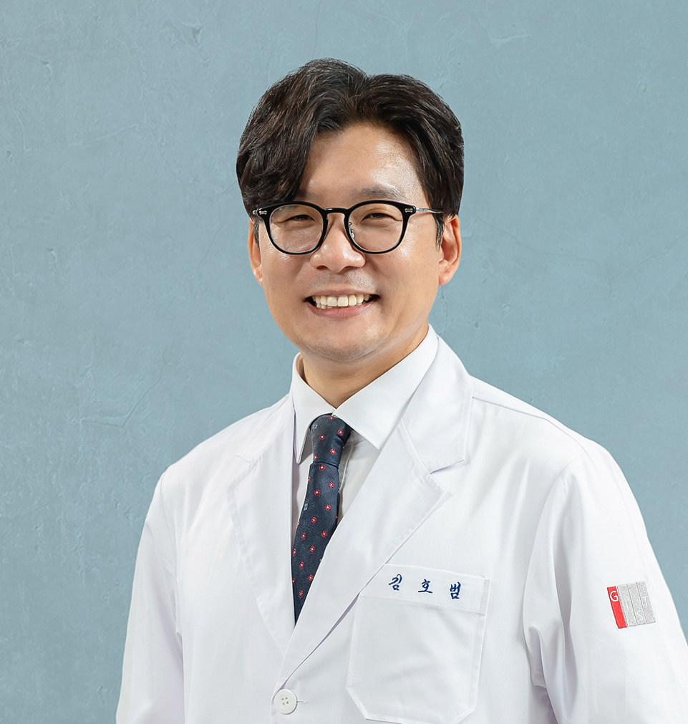

▲ Department of Materials Science and Engineering Professor Hobeom Kim

The Gwangju Institute of Science and Technology (GIST, President Kichul Lim) announced that Professor Hobeom Kim of the Department of Materials Science and Engineering won the Young Scientist Award at the 2025 Spring Conference of the Polymer Society of Korea.

The Polymer Society of Koreay Young Scientist Award is awarded to outstanding young scientists who stand out in the fields of polymer science and engineering, and to encourage them and to promote academic development and future research capabilities in the field.

In this award, Professor Hobeom Kim was highly recognized for his continuous and excellent research achievements in the cutting-edge field of next-generation optical semiconductor materials and devices development, as well as his active participation in academic activities and his efforts to contribute to the development of industry-academic cooperation.

In particular, Professor Kim's research achievements, which focus on developing core electronic devices such as light-emitting devices, solar cells, and neuromorphic devices using perovskite materials, are expected to be utilized as essential basic technologies for implementing high-performance, high-stability, and low-power devices in the future.

Professor Kim was previously selected as the recipient of the 7th Korea Toray Fellowship hosted by the Korea Toray Science Foundation last year, and was recognized for his unique and leading research capabilities.

The awards ceremony was held during the 2025 Spring General Meeting held at the Jeju International Convention Center on Thursday, April 17, and the recipients were awarded a plaque and a cash prize of 2 million won.

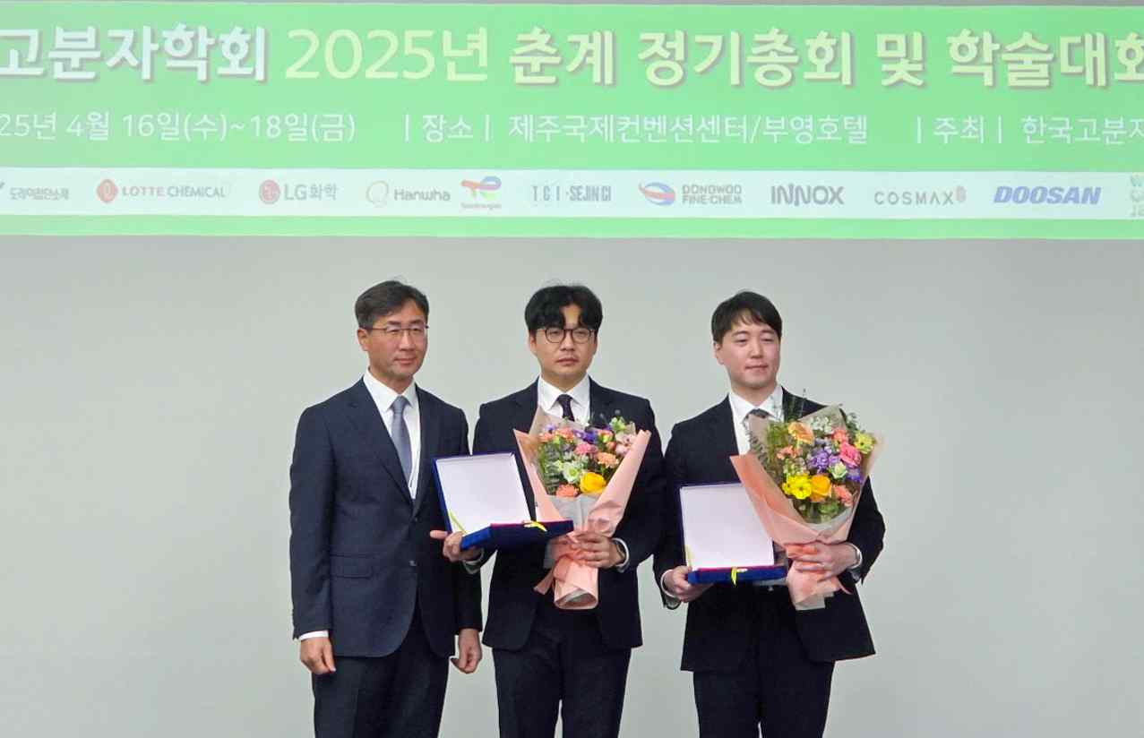

▲ (From left) Professor Yong-gu Kwon, Chairman of the Polymer Society of Korea, Professor Professor Hobeom Kim of the Department of Materials Science and Engineering at GIST, and Professor Ki-hoon Kang of the Department of Materials Science and Engineering at Seoul National University

Meanwhile, the Polymer Society of Korea is the largest polymer society in Korea that has led the academic development of polymer science and engineering and the dissemination of industrial technology since its establishment in 1976.

Currently, there are over 4,500 active members, and active research exchanges continue to the extent that approximately 2,500 academic presentations are made annually.



