GIST bachelor's, master's, and doctoral graduate Dr. Jiseung Kang appointed as youngest assistant professor at Korea University at age 27

- After graduating from the Department of Chemistry at GIST, she went on to pursue a combined master's and doctoral program in biomedical engineering and obtained a Ph.D. (advisor: Professor Tae Kim)... After working as a postdoc at Harvard Medical School and Massachusetts General Hospital in the U.S., she was appointed as the youngest professor at Korea University on March 1 of this year.

- Dr. Jiseung Kang, who has drawn attention in the academic world for her research on medical big data and brain neuroscience, has published more than 70 SCI-level papers and has also stood out at international academic conferences... "I want to contribute to the development of global medicine and health policies."

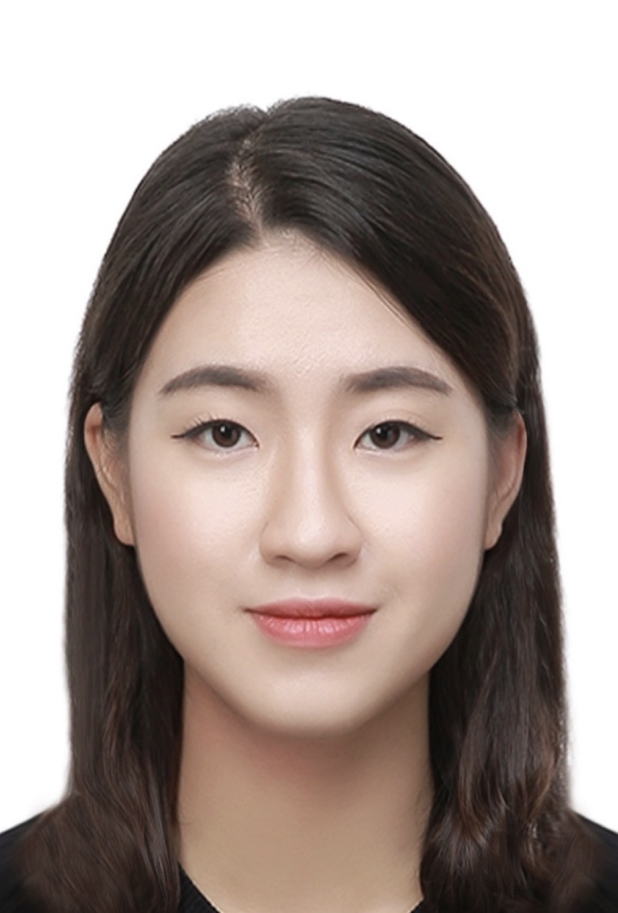

▲ Dr. Jiseung Kang, a GIST graduate, was appointed as an assistant professor in the Department of Health and Environmental Convergence Science at Korea University.

The Gwangju Institute of Science and Technology (GIST, President Kichul Lim) announced that Dr. Jiseung Kang (advisor: Professor Tae Kim), a graduate of the Department of Biomedical Science and Engineering, was appointed as an assistant professor at the Department of Health and Environmental Convergence Science at Korea University on March 1 of this year. Born in 1997, Dr. Kang set a record as the youngest person ever to be appointed at Korea University at the age of 27.

Dr. Kang received her bachelor's degree in neuroscience from the Department of Chemistry at GIST under the supervision of Professor Tae Kim (February 2019), and then entered the integrated master's and doctoral program in biomedical engineering at the same graduate school, where she received her doctorate in 4 years and 6 months (August 2023). She then worked as a postdoctoral researcher at Harvard Medical School and Massachusetts General Hospital* in Boston, USA, conducting research on medical big data and neuroscience.

* Harvard Medical School and Massachusetts General Hospital: Massachusetts General Hospital is the first and largest teaching hospital of Harvard Medical School and is a research-oriented hospital that leads the largest hospital-based research project in the United States. It has produced more than 14 Nobel Prize winners in medicine to date.

Dr. Jiseung Kang is an expert in medical big data research and brain neuroscience research, and has conducted translational brain science research that combines Alzheimer's disease research and medical big data.

The main research areas cover a wide range of fields from basic neuroscience research to epidemiology and medical big data, and the goal is to build an environment where mechanism research using mouse models and medical big data research can be conducted simultaneously.

Recently, in collaboration with Professor Yeon Dong-geon’s research team at Kyung Hee University Medical Center, they conducted a targeted test emulation study to analyze the effects of maternal exposure to narcotic analgesics, which are difficult to conduct clinical trials, on the development of mental disorders in children.

Dr. Kang has published more than 70 SCI-level papers in the past three years, including the world-renowned scientific journal BMJ (British Medical Journal, IF: 107.8) and the sister journal of 《Nature》, and has won excellent presentation awards at numerous international and domestic academic conferences.

Dr. Kang recalled, “I was able to establish my research foundation thanks to the organically connected research-centered curriculum at GIST from undergraduate to doctoral level, joint research experience with leading overseas universities and research institutes, and close guidance from professors.” She also expressed her ambition to “flexibly respond to the changing academic environment and contribute to the development of global medicine and health policies.”

In addition, she said, “Science demonstrates greater value when applied beyond the laboratory to actual medical environments and health policies. We will continue to conduct creative and challenging research while fostering future scientific talents and creating a research environment where academia and the medical community can cooperate.”



