GIST Department of Environment and Energy Engineering graduate appointed as a professor in the Department of Environmental Engineering at Seoul City University

- After receiving a doctorate in 2020 from the Environmental Systems Engineering Laboratory (Advisor Professor Joon Ha Kim) of the Department of Environment and Energy Engineering at GIST, he worked as a postdoctoral researcher at the Korea Institute of Science and Technology (KIST) and was appointed to Seoul City University on March 1

- Published numerous research results in the field of AI-based water treatment modeling in international academic journals in the field of environmental engineering, such as 《Water Research》... “We will strive to foster creative and challenging scientific talents who know how to communicate with society.”

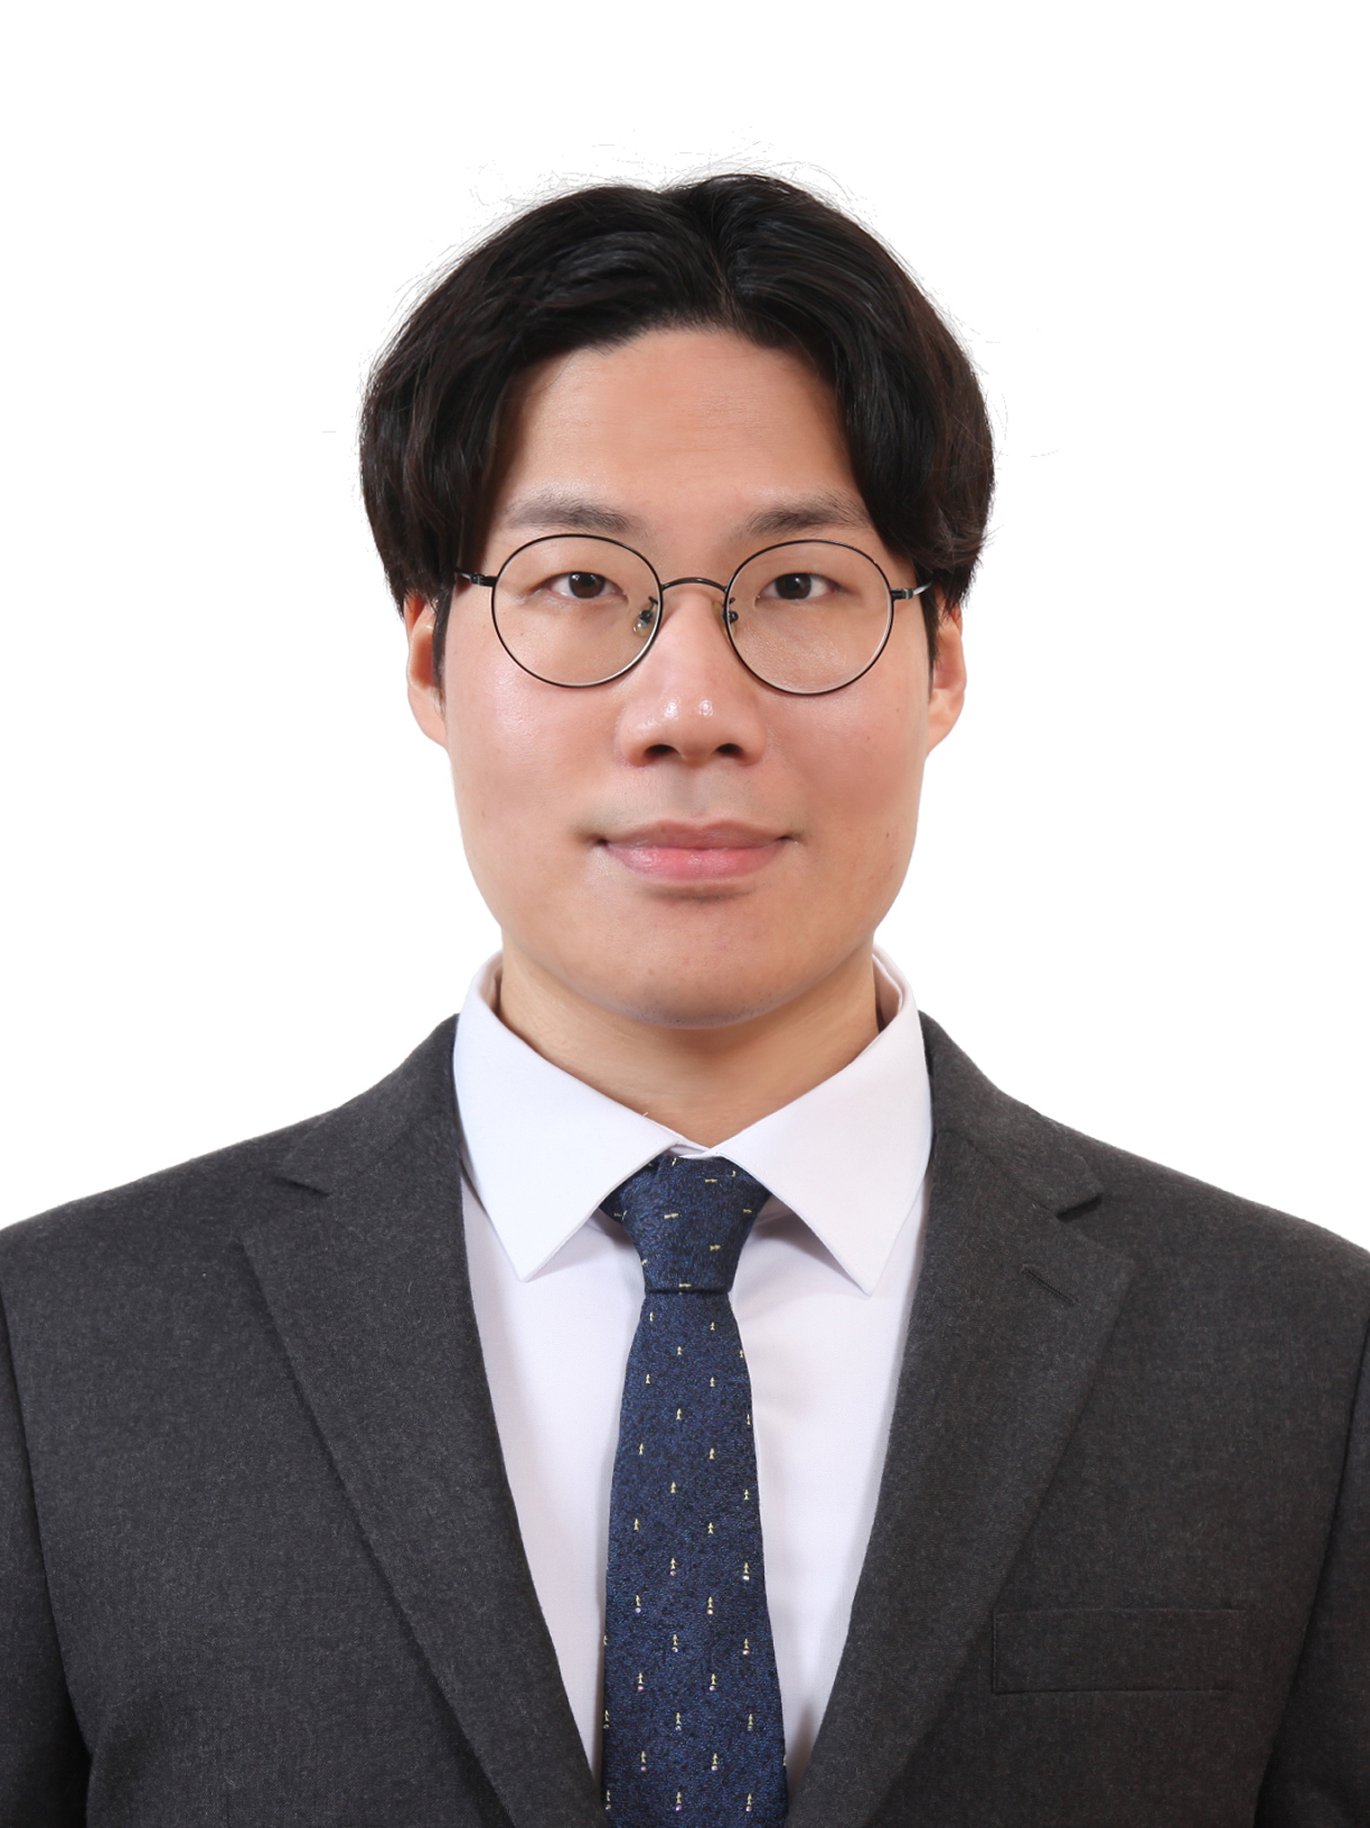

▲ Dr. Seong-ho Chae, who was appointed as an assistant professor in the Department of Environmental Engineering at Seoul City University on March 1st

The Gwangju Institute of Science and Technology (GIST, President Kichul Lim) announced that Dr. Seong-ho Chae (supervisor: Joon Ha Kim), a graduate of the Department of Environment and Energy Engineering, was appointed as an assistant professor in the Department of Environmental Engineering, College of Urban Science, Seoul City University, effective March 1 of this year.

Dr. Chae received his Ph.D. in environmental systems engineering under the supervision of Professor Joon Ha Kim in 2020, and has been conducting research as a post-doc researcher at the Korea Institute of Science and Technology (KIST) Water Resources Cycle Research Group since 2021.

At GIST and KIST, he is conducting research on improving the efficiency of seawater desalination and wastewater treatment processes using artificial intelligence (AI) and other optimization modeling, and has published numerous excellent research results as the main author in international academic journals such as 《Water Research》, 《Desalination》, and 《Journal of Water Process Engineering》. He also participated as a co-author in the academic book 《Pressure Retarded Osmosis: Renewable Energy Generation and Recovery》 on pressure-retarded osmosis technology.

In recognition of these research achievements, he received the Minister of Education Award in 2019 and the Young Researcher Award from the Korean Society of Environmental Engineers in 2023. Since September 2024, he has served as the research director for the National Research Foundation of Korea’s postdoctoral training program.

Dr. Dr. Seong-ho Chae said, “I will continue to devote myself to environmental engineering research, which is an essential discipline for a sustainable future, and become a researcher who develops technologies to reduce environmental pollution and suggests practical environmental management methods. I will do my best to conduct research that can effectively respond to an era of increasing uncertainty, as well as to foster creative and challenging scientific talents who know how to communicate with society about the value and meaning of research.”



