4 GIST papers win in the 31st Samsung Human Tech Paper Award

- 2 Bronze Medals (Jin-Hwi Park, Department of AI Convergence, Hyo-Eun Jeong, Department of Electrical Engineering and Computer Science), 2 Encouragement Awards (Hyun-Jun Jeong, Department of AI Convergence, Tae-Woong Kim, Department of Chemistry)

- Dr. Jin-Hwi Park, who developed a new technology that can accurately measure depth in various environments, said, “I am glad to confirm that research can be more than just academic.”

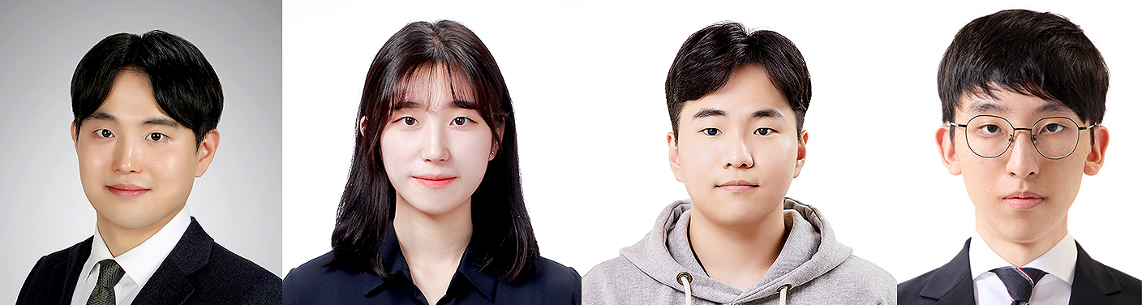

▲ (From left) GIST Department of AI Convergence, Jin-Hwi Park, a graduate of the combined master's and doctoral program (graduated in February 2025), Department of Electrical Engineering and Computer Science, Hyo-Eun Jeong, a student of the combined master's and doctoral program, Department of AI Convergence, Hyun-Jun Jeong, a student of the combined master's and doctoral program, and Department of Chemistry, Tae-Woong Kim, a student of the combined master's and doctoral program

The Gwangju Institute of Science and Technology (GIST, President Kichul Lim) announced that four graduate students won the Bronze and Encouragement Awards at the 31st Samsung Human Tech Paper Awards.

Jin-Hwi Park, a combined master's and doctoral program in the Department of AI Convergence, and Hyo-Eun Jeong, a combined master's and doctoral program in the Department of Electrical Engineering and Computer Science, won the Bronze Award, while Hyun-Jun Jeong, a combined master's and doctoral program in the Department of AI Convergence, and Tae-Woong Kim, a combined master's and doctoral program in the Department of Chemistry, won the Encouragement Award.

The Samsung Human Tech Paper Awards, an academic paper award established in 1994 with the aim of discovering future leaders in the field of science and technology, is hosted by Samsung Electronics and co-sponsored by the Ministry of Science and ICT and the JoongAng Ilbo.

A total of 3,152 papers were received for this year's competition, the largest number ever, and a total of 116 teams won awards. The awards ceremony was held at the Samsung Electronics Seocho Building in Seoul on the 12th.

Jin-Hwi Park, a student in the Department of AI Convergence, has developed a new technology that can accurately measure depth in various environments using sensors such as cameras and lidars. This technology is designed to learn a model that estimates depth information with only a small amount of data using the ‘Universal Depth Completion’ method and to apply it to various sensors and environments. This research is expected to greatly contribute to the development of autonomous vehicles, robotics, virtual and augmented reality in the future by overcoming the limitations of existing depth measurement models and expanding their scope of application.

Jin-Hwi Park, who received his doctorate from GIST on Friday, February 21 and was confirmed to be a professor at Chung-Ang University on March 1 of this year, said, “I am happy to have been able to confirm through this award that my research can have a positive impact on society beyond academic significance,” and added, “I will do my best to foster future generations of researchers and help them demonstrate their capabilities to the fullest.”

Hyo-Eun Jeong, a student in the Department of Electrical Engineering and Computer Science, proposed a reflective display technology that can implement full color without performance degradation in the micrometer-scale pixel range required for near-eye displays such as augmented reality (AR) and virtual reality (VR).

This technology can be manufactured in various pixel sizes from micrometers to several centimeters and can be utilized as a consumer-tailored display. In addition, it is a reflective monopixel display with excellent energy efficiency that provides stable memory characteristics at the pixel level, and has high potential in the next-generation display field.

Student Hyo-Eun Jeong said, “I want to continue to conduct in-depth research that can be meaningfully utilized in actual industrial settings, and I will continue to strive to become a researcher who leads innovation through constant challenges and creative attempts.”

Student Hyun-Jun Jeong of the Department of AI Convergence developed an AI model that identifies the location and direction from which light in a single photo is emitted, and implemented a technology to generate a light field. The light field enables novel view synthesis, which allows users to freely look around a space, and can be used to synthesize out-of-focus images or implement stereoscopic images and holograms.

Student Hyun-Jun Jeong said, “Novel view synthesis technology is one of the most notable research topics in the field of computer vision, and I am glad that my efforts have been recognized.” He added, “I will become a researcher who never stops discovering and exploring new problems.”

Chemistry student Tae-Woong Kim successfully synthesized covalent organic frameworks (COFs) using circularly polarized light for asymmetric synthesis, using a method that has never been reported before. In addition, he explored the mechanism by which chirality is induced based on the principle that circularly polarized light selectively stabilizes the potential energy by controlling the induced dipole moment of COF precursors.

* Chirality: A term referring to asymmetry, a molecular structure that cannot be superimposed on mirror images

Student Tae-Woong Kim said, “I hope that this research will provide a new direction for the design of chiral materials in the future, and I will continue to strive to continue meaningful research in the future.”



