GIST Department of Physics and Photon Science undergraduate students win the 5th miliTECH Challenge Grand Prize

- Department of Physics and Photon Science students Yu-seung Kim, Sang-woo Kim, and Tae-gyun Lee, Air Force Academy cadets Dong-min Lee and Hyeong-jun Park, together with quantum technology research... Development of phase-stabilized interferometer resistant to external perturbation and establishment of real-time PID control system

- Results achieved through 5 months of experiments and research... “I want to contribute to the development of quantum technologies such as quantum radar and quantum communications”



▲ (From left) GIST Department of Physics and Photon Science students Kim Yu-seung, Kim Sang-woo, and Lee Tae-gyun

The Gwangju Institute of Science and Technology (GIST, President Kichul Lim) announced that undergraduate students in the Department of Physics and Photon Science won first place in the 5th miliTECH Challenge, which aims to strengthen research capabilities and discover achievements in the field of defense science and technology, and received the Minister of Science and ICT Award.

The miliTECH Challenge is a program in which science and technology officer candidates and cadets work together as teams to conduct science and technology research in the field of defense.

GIST undergraduate students Yu-seung Kim (4th year), Sang-woo Kim (3rd year), and Tae-gyun Lee (3rd year) conducted research with Air Force Academy cadets Dong-min Lee and Hyeong-jun Park under the guidance of Professor Jae-yoon Choi of the Department of Physics at KAIST and Professor Hoon Yoo of the Air Force Academy.

Under the theme of ‘Robust Phase-stabilized Interferometer for External Perturbation’, we conducted a simulation of a laser optical grating affected by temperature and vibration, and developed and verified a real-time PID control (proportional-integral-differential controller) system to minimize the influence of the interferometer due to external perturbation.

Student Yu-seung Kim said, “I realized that even the seemingly simple goal of system stabilization requires consideration of various factors such as complex interferometers, circuit design, quantum characteristics, and simulations. I hope that this research will contribute to the advancement of quantum technology, and that it will help develop more innovative systems through continued research in the future.”

Student Sang-woo Kim said, “Through this research, I was able to experience firsthand that various technologies and knowledge are combined in the process of designing and stabilizing an experimental system. In particular, the understanding gained from the phase stabilization and optimization process is expected to be an important foundation for conducting future qubit design and simulation research.”

Student Tae-gyun Lee said, “While performing interferometer design, circuit design and artwork, and computer simulation, I realized that knowledge and technologies from various fields are needed to complete a single experiment. The understanding of the experimental process and principles gained through this research will be a great asset for conducting future physics experimental research.”

Meanwhile, the MilliTech Challenge is operated under a business agreement between the Ministry of Science and ICT, the KAIST Science and Technology Specialist Support Center, and each military academy, and runs for five months from June to October. The 5th MilliTech Challenge participants’ performance announcement and award ceremony were held at the KAIST IT Convergence Building in December of last year.

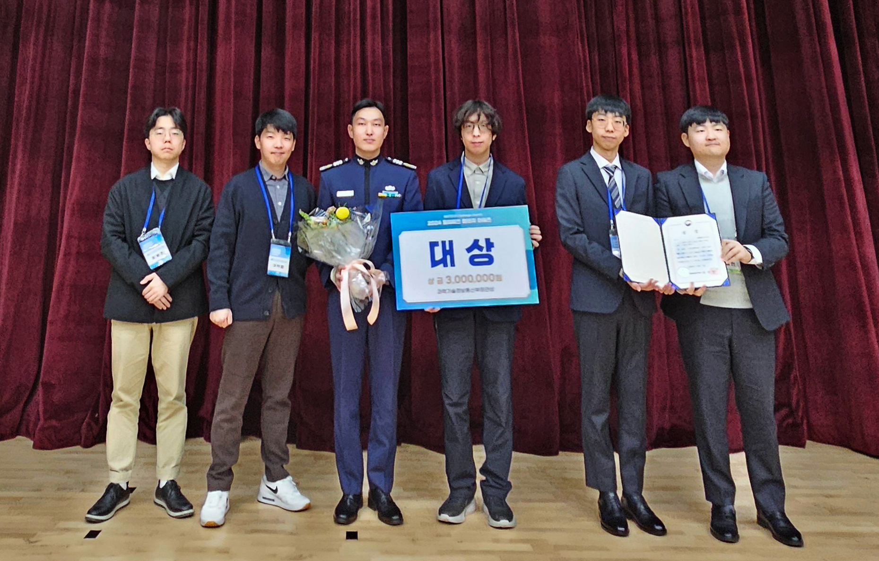
▲ GIST Department of Physics and Photon Science undergraduate students are taking a commemorative photo after receiving the Minister of Science and ICT Award (Grand Prize) at the 5th miliTECH Challenge.



