GIST Research Institute For Solar and Sustainable Energies Director Sanghan Lee receives Gwangju Metropolitan City Mayor's Award for contribution to energy industry development

- Recognized for contributing to strengthening the energy industry competitiveness of Gwangju Metropolitan City and raising citizens’ awareness through leading cooperation among industry, academia, research institutes, and government, developing new and renewable energy technologies, and regional specialized energy programs

- “We will contribute to strengthening the energy industry competitiveness of the region and the country and to sustainable development”

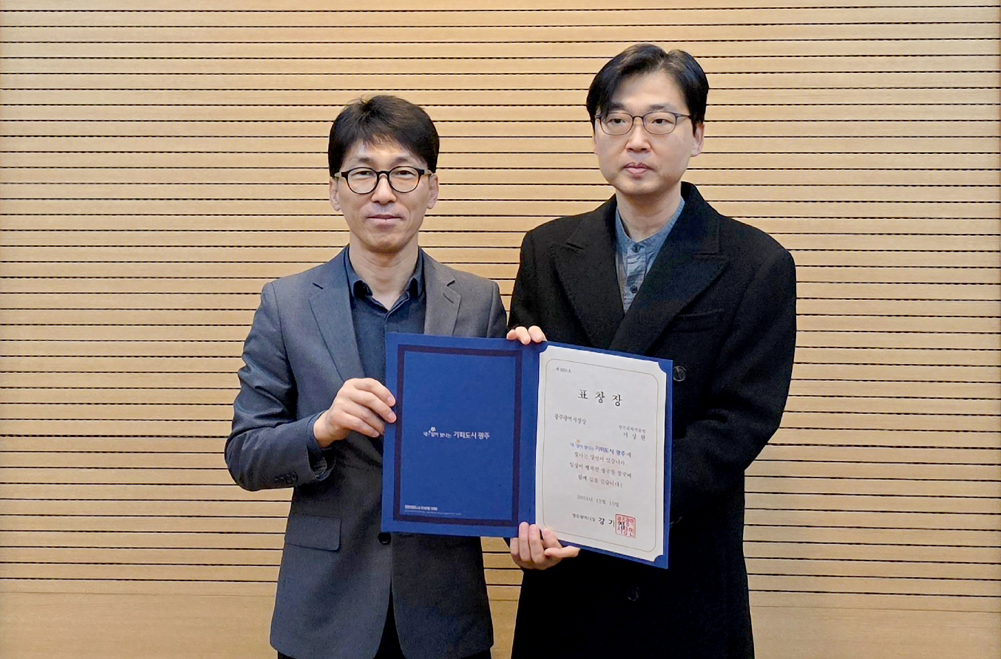

▲ GIST Research Institute For Solar and Sustainable Energies Director Sanghan Lee (right) poses for a commemorative photo after receiving a commendation from the Mayor of Gwangju Metropolitan City for his contribution to the development of the city’s energy industry.

The Gwangju Institute of Science and Technology (GIST, President Kichul Lim) announced that Director Sanghan Lee (School of Materials Science and Engineering professpr) of the Research Institute For Solar and Sustainable Energies was awarded the Gwangju Mayor’s Award on Monday, the 16th, for his contribution to the development of the energy industry in Gwangju Metropolitan City (hereinafter referred to as Gwangju City, Mayor Ki-jung Kang).

Director Lee has been proactively planning and operating various events in cooperation with Gwangju City to develop new and renewable energy technologies and raise citizens’ awareness of energy.

He participated in the ‘2024 Gwangju Science Invention Festival’, ‘2024 Korea Climate, Environment, Energy Fair (KEET 2024)’, and ‘BIXPO 2024 Gwangju Energy Innovation Conference’, presenting programs that combined advanced technologies such as solar energy, electric vehicles, and distributed energy with citizen participation, contributing to informing local residents of the importance of new and renewable energy.

In addition, for the convergence and development of the Gwangju energy industry, the GIST Next-Generation Energy Research Institute and the Energy Valley Technology Institute hosted the ‘Industry-Academia-Research-Government Technology Exchange Meeting’ to strengthen cooperation across the entire energy industry, including hydrogen, mobility, power systems, and batteries, thereby contributing greatly to securing energy technology competitiveness and creating an industrial ecosystem in the Gwangju region.

In particular, as the principal researcher of the National Future Hydrogen Source Technology Development Project, Director Lee Sang-won has achieved world-class results in the development sector through research on solar-based high-efficiency green hydrogen production technology.

As a result, he has published many research results in international academic journals such as ‘Advanced Energy Materials’, making Gwangju’s energy research capabilities known to the world. In addition, by producing excellent master’s and doctoral level talents through various new and renewable energy-related research projects, he has played an important role in industry, academia, and research, and has also contributed to the sustainable development of the energy industry.

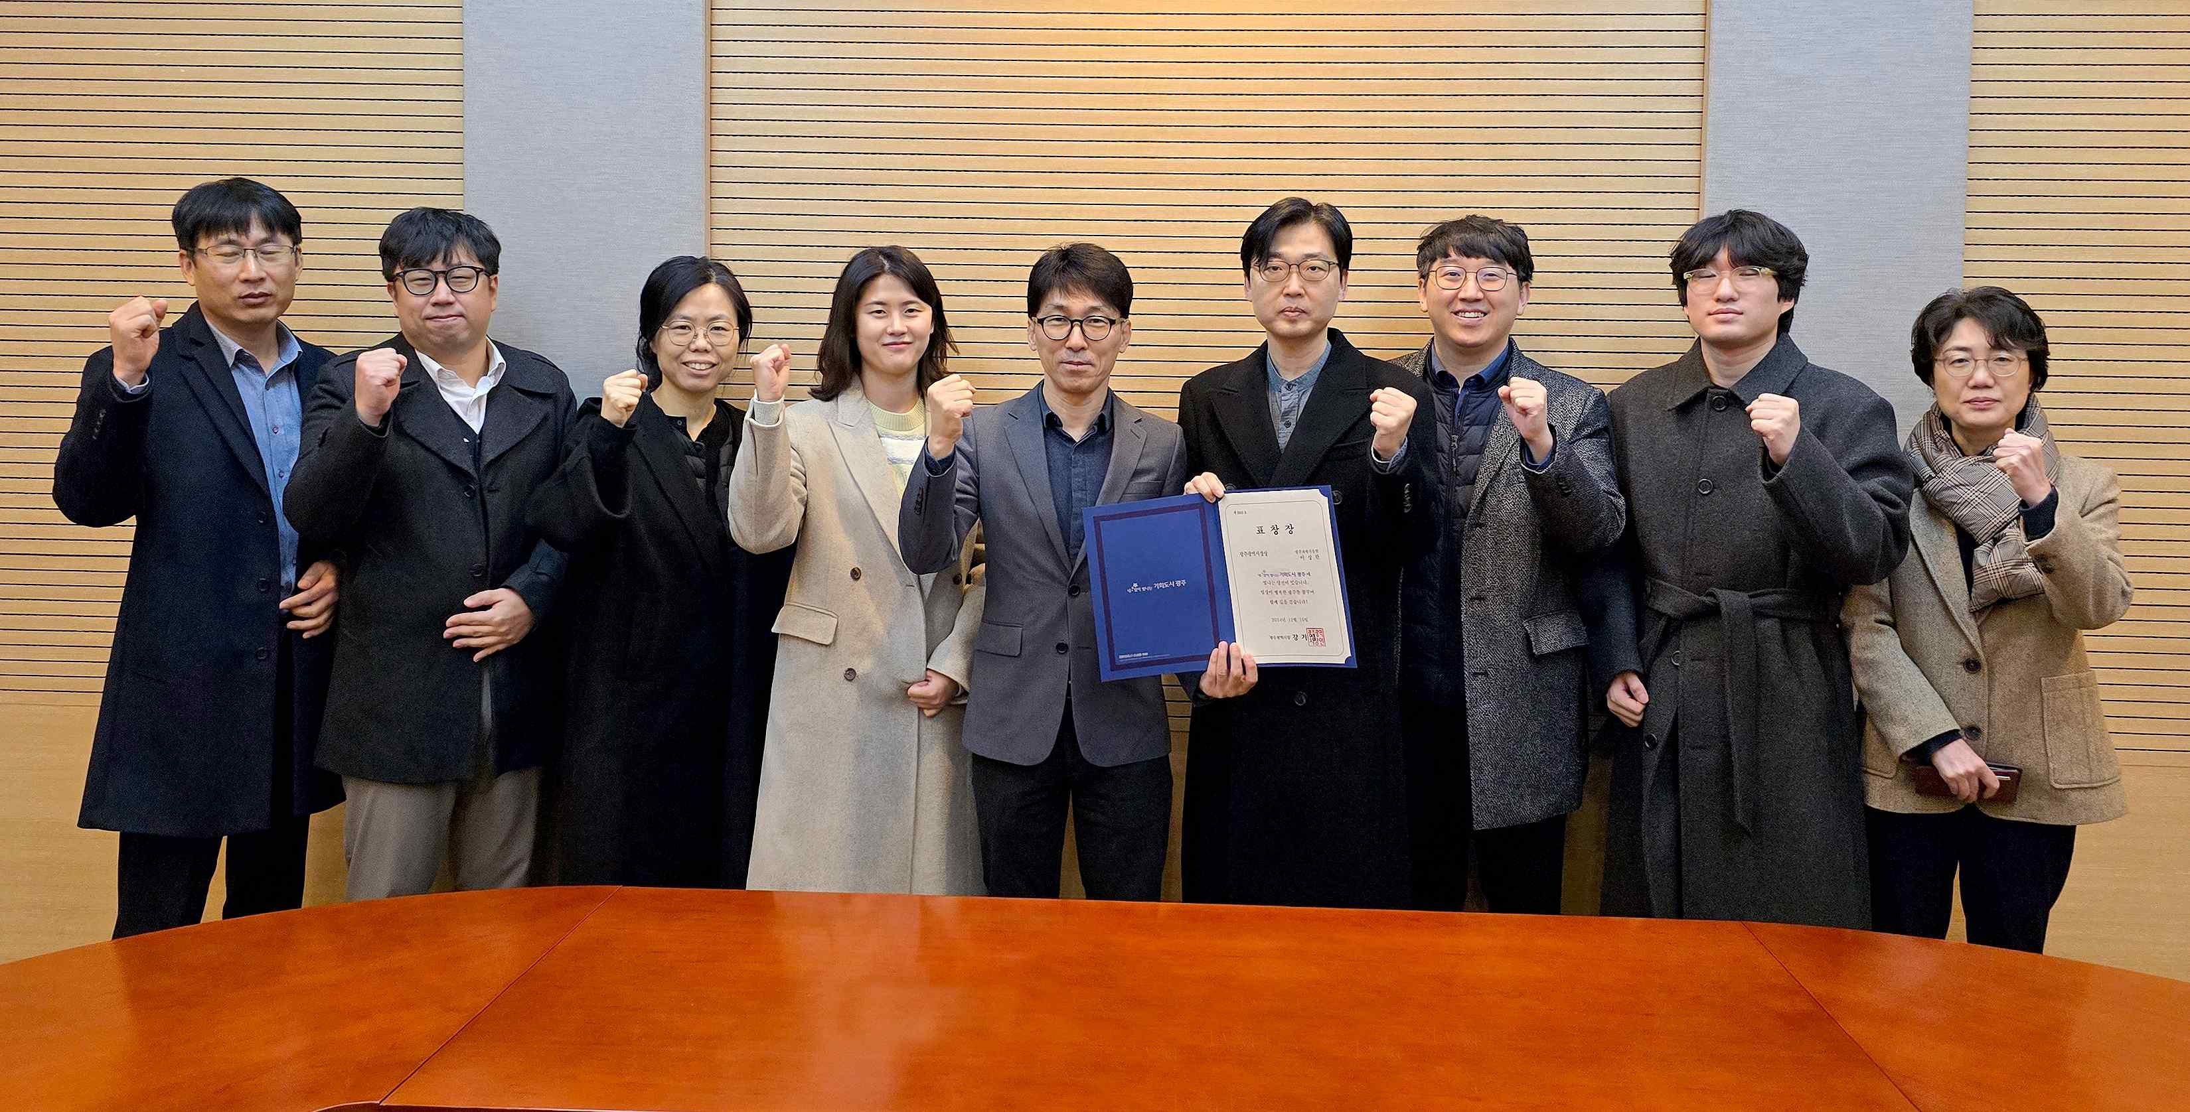

▲ GIST Research Institute For Solar and Sustainable Energies Director Sanghan Lee (fourth from the right) poses for a commemorative photo after receiving a commendation from the Mayor of Gwangju Metropolitan City for his contribution to the development of the city's energy industry.

Director Sanghan Lee said, "I feel a great sense of accomplishment in planning various programs that inform the importance of energy industry promotion and policy and contributing to the development of the energy industry and activating citizen participation in Gwangju Metropolitan City. We will continue to contribute to strengthening the competitiveness of the energy industry in the region and the country and to sustainable development."



