Professor Sanghan Lee and Professor Minjeong Ha receive Minister of Science and ICT Award for contribution to discovery of super-gap materials for national strategic technology

- Ministry of Science and ICT, 2024 Materials Research Group Performance Sharing Meeting held on the 12th (Thursday) to share excellent research results of materials from industry, academia, and research institutes and award 5 people with technology and industry contributions to the Minister... 2 faculty members of GIST School of Materials Science and Engineering receive awards

- Professor Sanghan Lee, Contributes to the discovery of innovative materials related to energy devices in the field of advanced materials

- Professor Minjeong Ha, Solving difficult technical problems in the field of magnetic materials

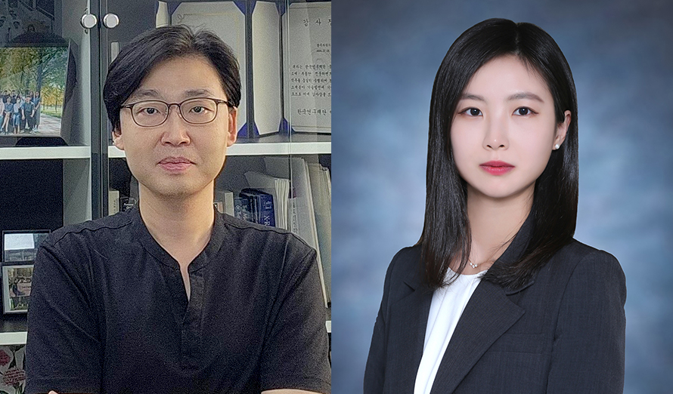

▲ (From left) Professor Sanghan Lee and Professor Minjeong Ha of the School of Materials Science and Engineering, who received the Minister of Science and Technology Award

The Gwangju Institute of Science and Technology (GIST, President Kichul Lim) announced on Wednesday, the 18th that Professors Sanghan Lee and Minjeong Ha of the School of Materials Science and Engineering were awarded the Minister’s Commendation from the Ministry of Science and ICT (MSIT) for their contributions to the discovery of ultra-gap materials in the field of national strategic technologies.

Professor Lee was honored with the Minister’s Commendation at the ‘2024 Materials Research Group Performance Sharing Meeting’ held on Thursday, December 12th for his contribution to the discovery of innovative materials related to energy devices in the field of advanced materials, which is the core of the global supply chain, and Professor Ha was honored with the Minister’s Commendation for her contribution to solving difficult technologies in the field of magnetic materials.

At the performance sharing meeting held that day, approximately 200 MSIT officials and industry-academia-research materials researchers attended, and a ceremony was held to award the Minister’s Commendation to five researchers who contributed to the development of technology and industry.

The GIST School of Materials Science and Engineering, which studies future smart convergence materials in the fields of ▴ healthcare ▴ energy/greentech ▴ AI ▴ connected mobility (infotainment) targeting inorganic, organic, bio-composite materials and fosters advanced human resources, produced two of the five awardees that day.

Professor Sanghan Lee has contributed greatly to the development of next-generation semiconductors and energy/environmental materials through the development of oxide semiconductor materials and photoelectrochemical devices for green hydrogen production for approximately 11 years since taking office at GIST.

In particular, the research results that dramatically improved the efficiency and stability of perovskite-based photoelectrodes were published in world-renowned journals such as 《Advanced Energy Materials》, 《Advanced Functional Materials》, and 《Advanced Science》, attracting attention from the academic world.

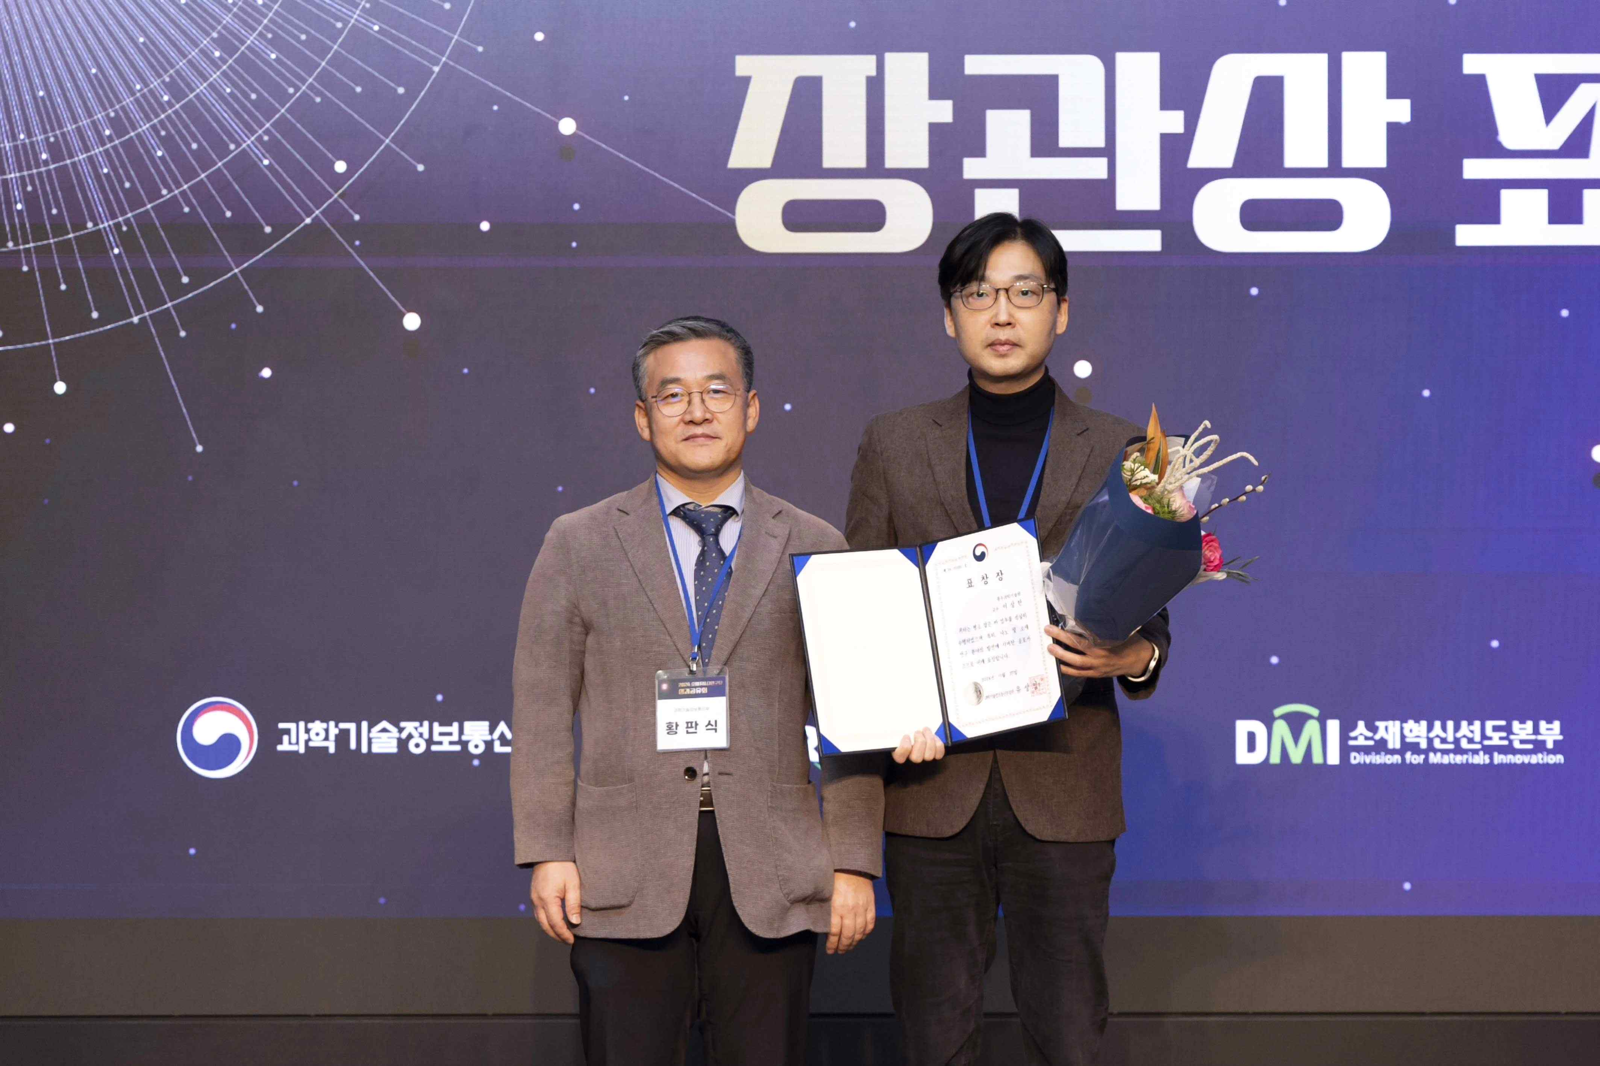

▲ At the 2024 Materials Research Group Performance Sharing Meeting, Professor Sanghan Lee of the School of Materials Science and Engineering at GIST is taking a commemorative photo after receiving the Minister of Science and ICT Award.

Professor Minjeong Ha, who was appointed to the School of Materials Science and Engineering at GIST in November 2021, is conducting research on non-rare earth magnetic nanomaterials and flexible spin devices, and has published research results related to the development of ultra-thin flexible spin devices and soft robots based on soft composite materials in major international academic journals such as 《Advanced Materials》 and 《ACS Nano》.

In particular, this award is significant in that Professor Ha has been recognized for her research capabilities and efforts despite being a new researcher, and it can be interpreted as recognition of the efforts of the School of Materials Science and Engineering at GIST to expand the research base and solve difficult problems in the field of national strategic technology.

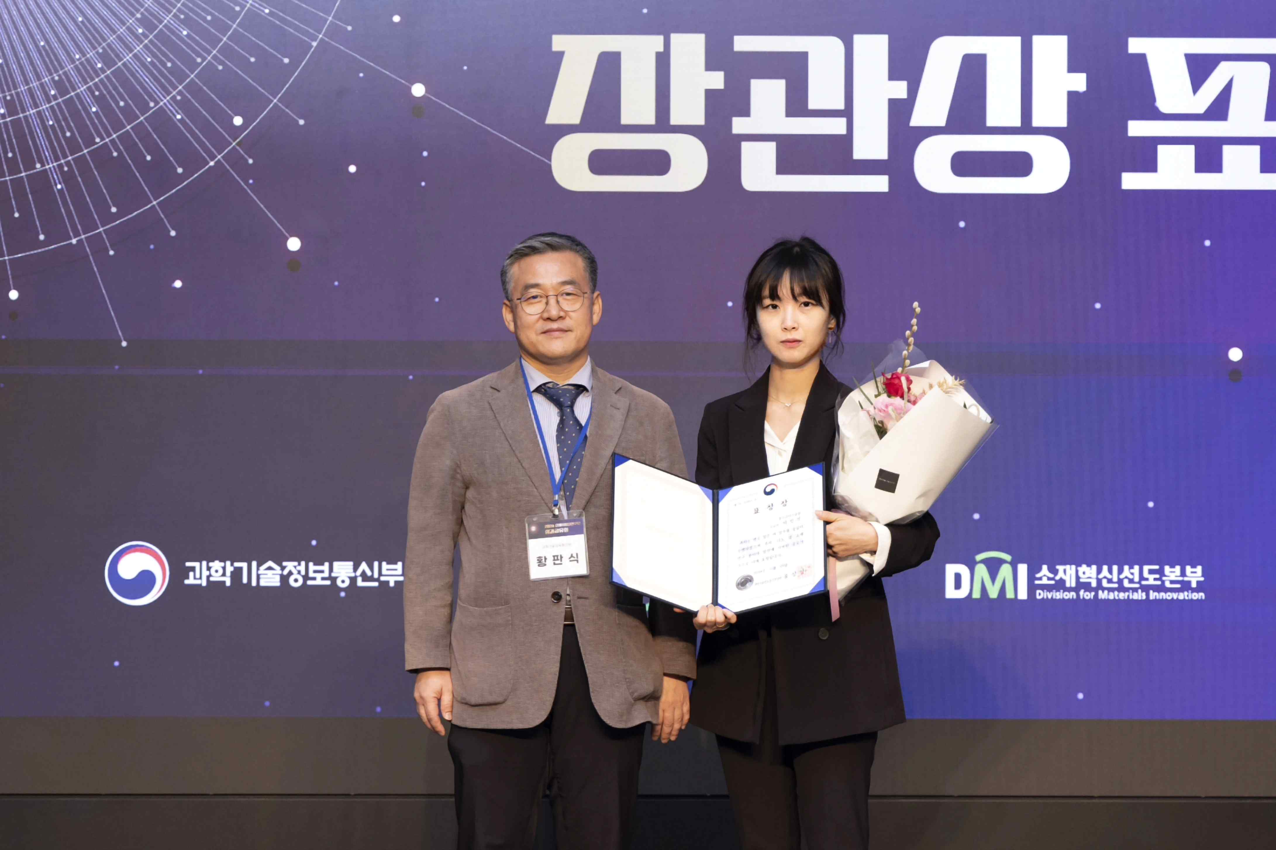

▲ Professor Minjeong Ha of the School of Materials Science and Engineering at GIST is taking a commemorative photo after receiving the Minister of Science and ICT Award at the 2024 Materials Research Group Performance Sharing Meeting.

Professor Sanghan Lee said, "We have contributed to the innovation of advanced materials technology through the synthesis of high-quality nano-scale thin film materials and the use of these materials in next-generation semiconductor devices and various applications in the energy and environment fields. We will continue to lead the field through innovative research and do our best to nurture future researchers."

Professor Minjeong Ha said, "We will secure original technology through the development of new magnetic materials and take the lead in the discovery and domestic production of key materials in the national strategic technology field. We will expand the application fields of materials and contribute to strengthening global science and technology competitiveness."

She also said, "As we are nurturing future generations in the materials field, we will do our best to foster excellent scientists and engineers with global leadership."



