GIST, IBS Center for Relativistic Laser Science to attract Professor Kyung Taec Kim… after IBS Center for Quantum Conversion Research

- IBS Relativistic Laser Science Research Group led by Professor Kyung Taec Kim of the Department of Physics and Photon Science, begins research on generating and measuring relativistic high-harmonic attosecond pulses from Monday the 16th

- New Research Group Director Kim: “Starting with research on quantum electrodynamic phenomena using powerful attosecond pulses, we will contribute to the advancement of science and technology encompassing astrophysics, chemistry, life, and quantum science.”

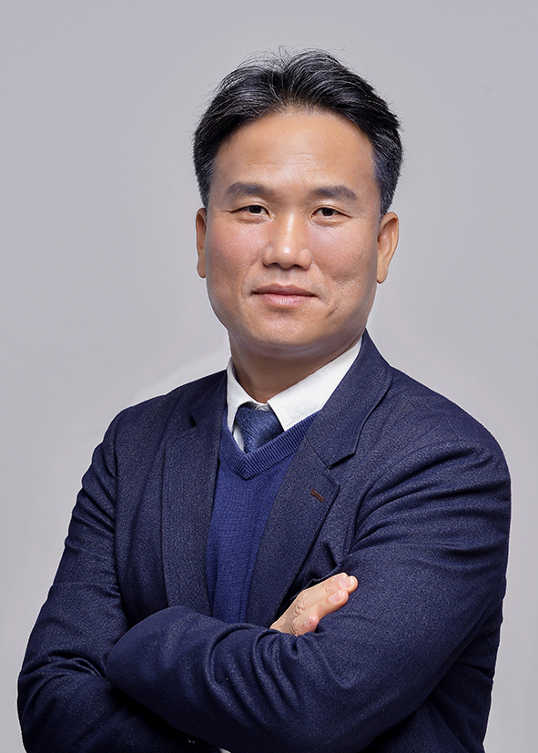

▲ Professor Kyung Taec Kim of GIST Department of Physics and Photon Science, appointed as Director of IBS Center for Relativistic Laser Science

The Gwangju Institute of Science and Technology (GIST, President Kichul Lim) announced that the Institute for Basic Science (IBS)* Center for Relativistic Laser Science led by Professor Kyung Taec Kim of the Department of Physics and Photon Science began full-scale research on Monday, December 16.

With this, GIST will be hosting the second IBS research group following the Quantum Transformation Research Group (Director Yousoo Kim, Professor of Chemistry at GIST) launched in September.

* IBS, a comprehensive research institute established for world-class basic science research, has established research groups, which are research organizations, at its headquarters or related universities. Among these, the ‘campus research groups’ are located at science and technology-specialized universities such as GIST, Korea Advanced Institute of Science and Technology (KAIST), Ulsan National Institute of Science and Technology (UNIST), and Pohang University of Science and Technology (POSTECH).

Ultra-intense laser research is a field that is widely applied not only to basic science but also to applied research and industries such as medical technology, space, and defense based on ultra-high power and high energy lasers. In particular, new light source technology using ultra-intense lasers is leading the innovation of semiconductor manufacturing processes and precision imaging technology, and is also becoming an important tool for nanotechnology and quantum science research.

The ultimate goal of the Center for Relativistic Laser Science, which conducts research on the generation and measurement of attosecond (100-billionth of a second) pulses of relativistic high-order harmonic waves (light generated by the interaction of a strong laser and a nonlinear medium), is to experimentally realize the generation of quantum electrodynamic plasma observed around neutron stars or black holes.

To this end, the Center for Relativistic Laser Science plans to intensively study strong field quantum electrodynamics phenomena that occur in extreme situations such as the collision of particles accelerated into the relativistic regime and light particles, with the goal of developing stable particle acceleration technology.

Professor Kyung Taec Kim received his master's and doctoral degrees in Physics from KAIST, and has served as a professor in the Department of Physics and Photon Science at GIST since 2014 after working at the Advanced Photonics Research Institute of GIST, the National Research Council of Canada (NRC), and the University of Ottawa. From 2014 to 2023, he served as a group leader and deputy research director at the IBS Center for Relativistic Laser Science (Director: Chang Hee Nam, research period: December 2012 to December 2023).

Professor Kim has attracted worldwide attention by proposing a method to overcome the limitations of existing technologies with a new extreme ultraviolet attosecond pulse compression technology. He has also achieved outstanding results, such as experimentally implementing a new extreme ultraviolet attosecond pulse generation method that can be used for nanostructure imaging and semiconductor technology applications using a powerful laser.

Representative achievements include the study of high-harmonic waves generated in a plasma mirror using a flat liquid sheet (2023, Nature Communications), the development of a new path considering the intensity of the light source during the generation of extreme ultraviolet light (2018, Nature Photonics), and the development of a tunneling ionization method capable of measuring the temporal characteristics of a laser field with high resolution (2018, Optica). Based on these excellent achievements, he was awarded the Optical Society of Korea Academic Award (2022), the Korean Physical Society Atomic and Molecular Physics Award (2020), etc.

Professor Kim said, "Attosecond science is not only useful for observing ultrafast changes in the properties of matter, but also provides a way to make the intensity of light extremely strong. Starting with the study of quantum electrodynamic phenomena using powerful attosecond pulses, we aim to contribute to the development of science and technology encompassing astrophysics, chemistry, life, and quantum science by clarifying the extreme interaction between light and matter."



