Professor Hyeon-Jin Shin receives 2024 Female Scientist of the Year Award

- Evaluation of ‘securing technology to implement wide-area semiconductors’ through research on future semiconductor materials and components... Publishing research results in authoritative international academic journals such as ‘Nature’

- “Contribute to securing global leadership in science and technology in the Republic of Korea and serve as a bridge for industry-academia technology cooperation... Efforts to become a good mentor for female scientists and engineers”

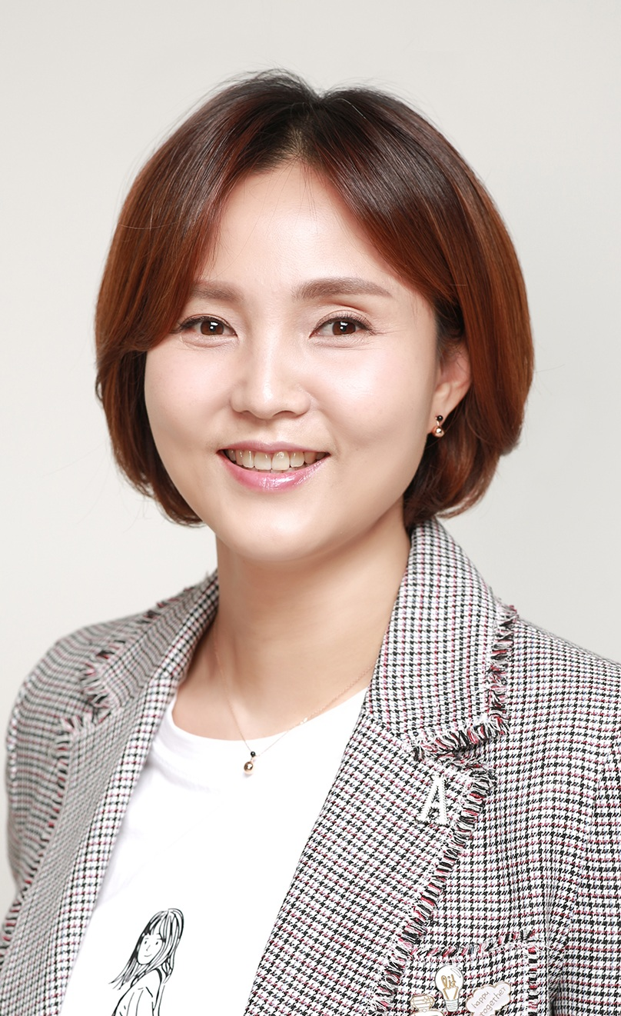

▲ Professor Hyeon-Jin Shin, recipient of this year's Women in Science and Technology Award

The Gwangju Institute of Science and Technology (GIST, President Kichul Lim) announced that Professor Hyeon-Jin Shin of the Department of Semiconductor Engineering won the 24th Female Scientist of the Year Award at the ‘2024 Korea Women Scientists and Engineers Conference’.

Hosted by the Ministry of Science and ICT and organized by organizations for women in science and technology, including the Korea Foundation for Women in Science, Technology, and Engineering, the Korean Federation of Women in Science and Technology Associations, and the Korean Association of Women Scientists and Engineers, the event was held on Thursday, December 6, at the Korea Science and Technology Center under the theme of ‘Creating the Future Together, Global Innovation Leadership of Women Scientists and Engineers.’

At the 2024 Korea Women Scientists and Engineers Conference, about 300 people including Minister of Science and ICT Sang-im Yoo, officials from the Ministry of Science and ICT, key figures from women’s science and technology organizations, and scientists and engineers from academia, industry, and research attended the event, where awards were given to women scientists and engineers and institutions that contributed to the development of science and technology with excellent achievements.

The Women in Science and Technology Award is selected in three categories: academic, industrial, and promotion. The academic category selects the winner by evaluating the excellence of research and development content in fields such as science, medicine, and engineering, the excellence of research and development results, and the ripple effect of research and development results over the past five years.

Professor Hyeon-Jin Shin, the winner of the academic category, was evaluated to have secured the technology to implement semiconductors on a large scale by clarifying the growth structure of two-dimensional materials to replace semiconductor silicon materials through ‘Research on large-area growth and interface control of two-dimensional materials for commercialization.’

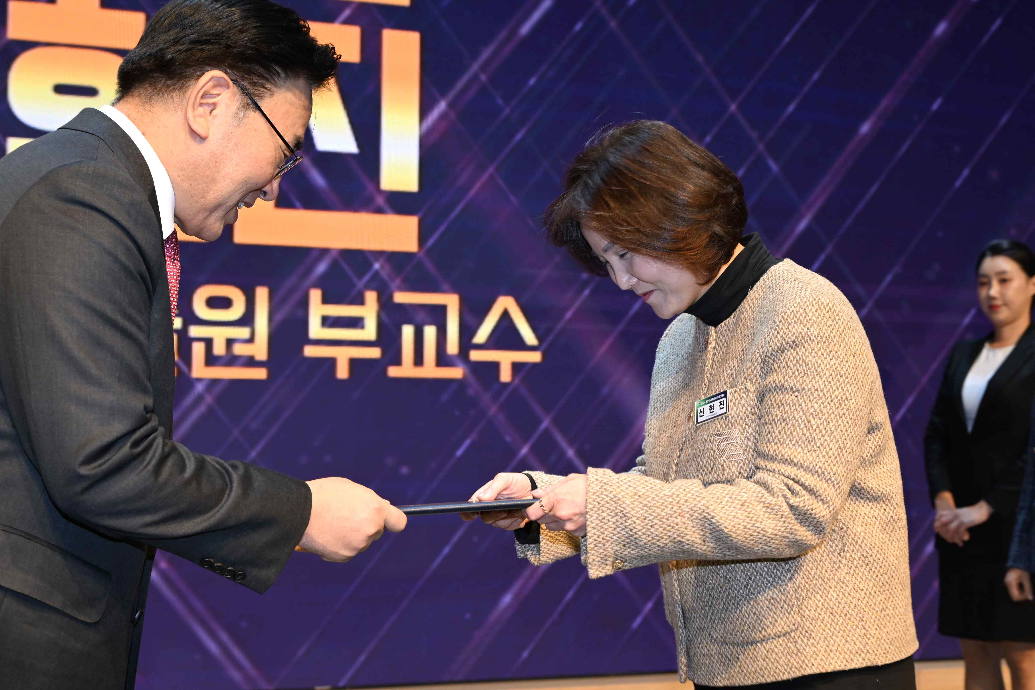

▲ Professor Hyeon-Jin Shin receives the Female Scientist of the Year Award at the ‘2024 Republic of Korea Women Scientists and Engineers Conference’ held at the Korea Science and Technology Center in Seoul on the 6th.

Professor Shin, who took office at GIST in 2023, has been conducting research on future semiconductor materials and devices in the industry for a long time, and since 2007, has been publishing the results of interface research for large-area growth of graphene and two-dimensional materials and improvement of device performance in authoritative international academic journals such as ‘Nature’ and ‘Nature Electronics.’

Professor Hyeon-Jin Shin said, "We will contribute to securing global leadership in science and technology in Korea by discovering the growth and characteristics of new two-dimensional materials and their applications, and serve as a bridge for industry-academia cooperation so that basic research can lead to commercialization. We will continue to strive to be good mentors so that excellent female scientists and engineers can be nurtured."



