Professor Hisam Kim receives commendation from Deputy Prime Minister and Minister of Education

- Recognized for his contribution to establishing evidence-based social policies and improving financial efficiency through continuous empirical research in social fields such as education... Awarded upon recommendation by the Korean Economic Association

- Presented research (‘Empirical Study of AI-based EdTech in Schools’) along with award at the joint conference of the Ministry of Education and major academic societies ‘Data-based Social Policy: Seeking Research-Policy Feedback Methods’ on Monday, the 25th

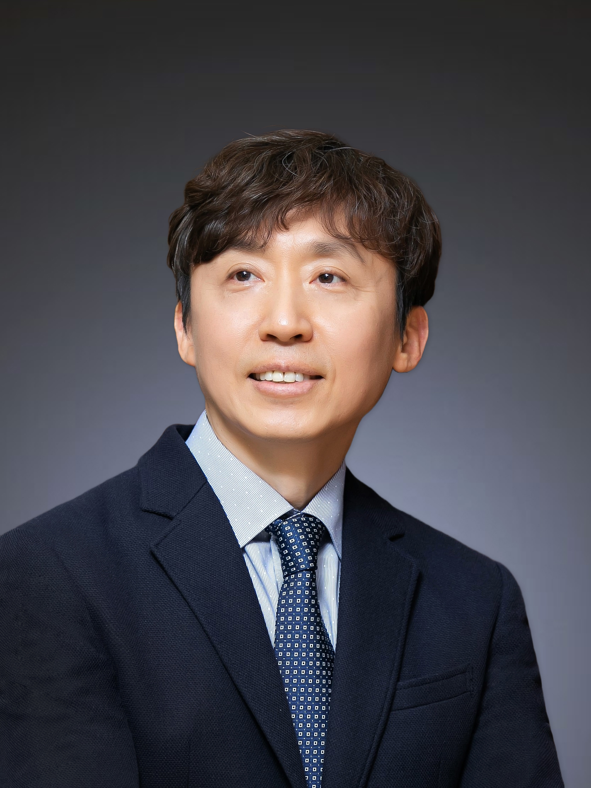

▲ Professor Hisam Kim of GIST, who received the Deputy Prime Minister and Minister of Education Award

The Gwangju Institute of Science and Technology (GIST, President Kichul Lim) announced that Professor Hisam Kim of the Division of Liberal Arts and Sciences received the Deputy Prime Minister and Minister of Education Award at the conference “Data-based Social Policy: Seeking Research-Policy Feedback Methods” co-hosted by the Ministry of Education, the Korean Economic Association, and major academic societies including the Korean Educational Research Association on Monday, November 25.

Professor Hisam Kim was recognized for his contributions to establishing evidence-based social policies and improving financial efficiency by conducting over 80 empirical studies and program evaluations in social fields including education, and the Korean Economic Association, the first and largest academic society in the field of economics in Korea, recommended Professor Kim.

Professor Hisam Kim, who took office at GIST in 2016, has actively performed national-level policy advisory roles, including ▴ member of the 6th and 7th Presidential Committee on Low Birth Rate and Aging Society ▴ member of the National Economic Advisory Council ▴ member of the National Statistics Committee ▴ member of the Future Talent Special Committee of the National Science and Technology Advisory Council Deliberation Council ▴ member of the Ministry of Strategy and Finance’s Mid- to Long-term Strategy Committee ▴ and a concurrent researcher at KDI. He is currently serving as the Planning Dean at GIST. Professor Kim received the Minister of Science and Technology Award (2020) for his contribution to innovation in science and engineering education and the Presidential Award (2022) for his contribution to population policy.

While working as a research fellow at the Korea Development Institute (KDI) (2006-2016), Professor Kim took an interest in data-based research to solve major social challenges in Korea. He has contributed to establishing evidence-based policies and expanding the horizons of economics through ▴ empirical studies on the education production function of primary and secondary education, ▴ empirical studies on the performance of higher education and the effectiveness of higher education support policies, ▴ empirical studies on the educational gap and social mobility, ▴ empirical studies on the current status and structure of the labor market, ▴ empirical studies on aging issues centered on retirement income, and ▴ empirical studies on quality of life, happiness, and social capital.

In addition, he also shared and communicated with various members of society through activities such as writing papers and books, contributing to the media, appearing on TV, and providing policy advice and lectures regarding research results and social practice directions.

Professor Hisam Kim, while introducing the results of an empirical analysis of the AI Pengtok pilot school where he was in charge of the research, gave a lecture to awardees on the topic of ‘School Empirical Study of AI-based EdTech’ and said, "Despite concerns that technology widens the gap, well-designed and wisely introduced technology in the educational field can greatly help to reduce educational gaps between classes, regions, and schools."

He also said, "We will continue to devote ourselves to empirical research that will serve as the basis for policies that can enhance the dynamism and growth potential of our economy and provide hope to future generations by reducing the gap and enhancing social mobility."

Meanwhile, the conference held at Le Meridien Seoul Myeongdong on this day was live-streamed online through two channels, including the Ministry of Education. At the conference, the Deputy Prime Minister and Minister of Education presented commendations to researchers who have contributed to the empirical study of social policies, and researchers from major academic societies, including the Korean Economic Association, presented excellent empirical research, and a government-academic roundtable discussion was held to establish a virtuous cycle structure of data opening, research/analysis, and policy feedback.

Professor Kim, who also participated as a designated panelist, examined the government's efforts and direction to increase policy effectiveness by increasing the usability of public data through the opening of public data and data linkage and feeding back the results analyzed by researchers into policy, and also introduced overseas reference cases.



