GIST graduate Dr. Geon-woo Lee appointed as assistant professor at Chosun University: ‘Virtuosic local talent’ who obtained bachelor’s, master’s, and doctoral degrees in Gwangju Metropolitan City has started nurturing future generations

- Obtained a master's degree (February 2019) and a doctorate (August 2024) from GIST and was appointed as an assistant professor in the Department of Information and Communication Engineering at Chosun University this fall semester... Obtained bachelor's, master's, and doctorate degrees from Gwangju Metropolitan City

- Announced numerous research results in the field of voice and audio, including noise removal and voice recognition using AI technology "I think the practical value of technology is important... I will strive to foster scientific talents with a challenging spirit"

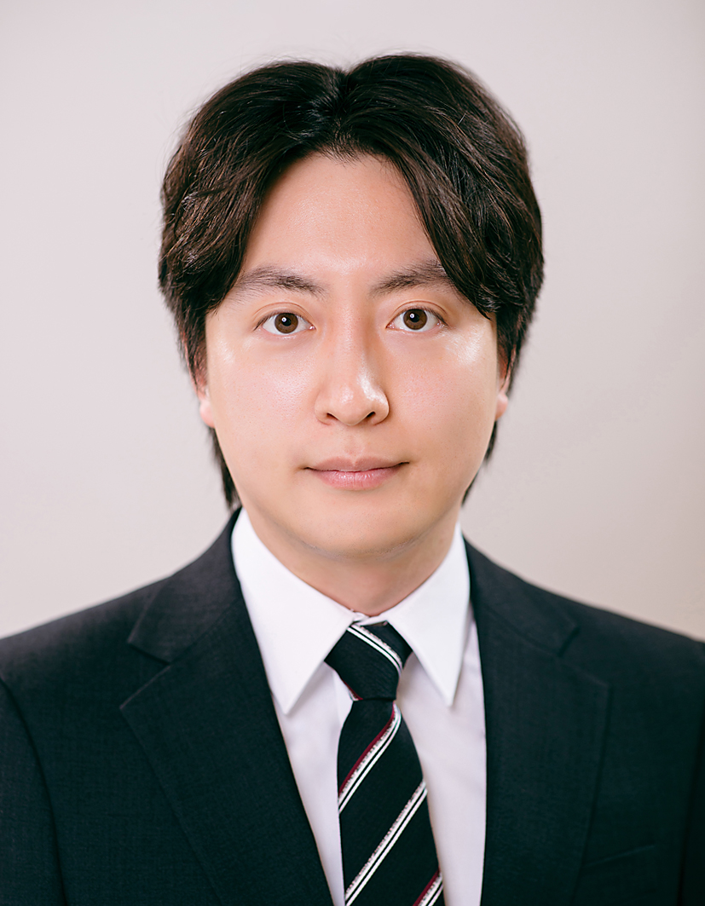

▲ Dr. Geon-woo Lee, appointed as an assistant professor at Chosun University

The Gwangju Institute of Science and Technology (GIST, President Kichul Lim) announced that Dr. Lee Geon-woo, a graduate of the AI Graduate School, has been appointed as an assistant professor in the Department of Information and Communication Engineering at Chosun University’s IT Convergence College.

Dr. Lee received his doctorate in August of this year under the supervision of Professor Hong Kook Kim of the School of Electrical Engineering and Computer Science (also a professor at the AI Graduate School) in the field of voice and audio signal processing, and was appointed as an assistant professor in the Department of Information and Communication Engineering at Chosun University on September 1.

Dr. Geon-woo Lee studied the fields of voice and audio signal processing, such as noise removal, speech recognition, and acoustic event detection using deep learning technology while completing his master's and doctoral courses at GIST, and won awards in various domestic and international competitions, including the Artificial Intelligence Grand Challenge hosted by the Information and Communication Planning and Evaluation Institute.

Meanwhile, Dr. Lee, who was born in Gwangju Metropolitan City, received his bachelor's degree from Chonnam National University in February 2017 and went on to GIST to obtain his master's degree (February 2019) and doctorate, showing that it is fully possible to contribute to the development of science and technology in the region and to nurture future generations after growing through the local education system.

Dr. Geon-woo Lee said, "It is important to secure technological excellence in R&D, but I think it is more meaningful to expand its value and challenge new problems by applying the technology to real situations. Based on the experience learned and acquired at GIST, we will focus on practical research while striving to produce scientific talents with a challenging spirit."



