Joonwoo Kim, a Ph.D. student in the School of Environment and Energy Engineering, wins the Minister of Environment Award in the Fine Dust Research Idea Contest

- Aerosol Technology Monitoring Lab (Director Professor Kihong Park) Joonwoo Kim Student Contest 1st Place... 12 award-winning works selected at the 2024 Atmospheric Environment Society Regular Conference held on October 23rd

- “Identifying the Causes of Fine Dust Generation in Rural Areas Based on Field Measurements”

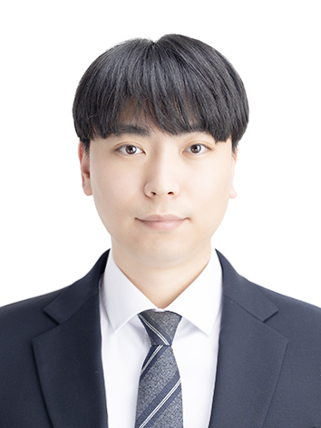
▲ Joonwoo Kim, Ph.D. student in the School of Environment and Energy Engineering

The Gwangju Institute of Science and Technology (GIST, President Kichul Lim) announced that Joonwoo Kim, a doctoral student in the School of Environment and Energy Engineering, won first place and the Minister of Environment Award at the ‘3rd Fine Dust Research Idea Contest’ hosted by the National Institute of Environmental Research and organized by the Korean Society for Air Pollution Research to discover next-generation environmental research talent.

This contest, which was held for university students under the slogan, ‘Our research today for a breathing Earth and a sustainable tomorrow,’ was held to find creative response capabilities to new environmental issues such as atmospheric environmental volatility and climate change.

Student Joonwoo Kim conducted a study on ‘Identifying the Causes of Fine Dust Generation in Rural Areas Based on Field Measurements’ at the Aerosol Technology and Monitoring Lab (Advisor: Kihong Park) and the Fine Dust Diagnosis Center (Director: Kihong Park) and said, "We decided to participate in this competition to utilize the fine dust component measurement data from regional air quality research institutes across the country to identify the cause of fine dust generation in Korea."

He also said, "I wanted to expand and apply the measurement and analysis methods developed and advanced in the lab to observational data from all over the country, and I am happy and honored to have been given a good research opportunity and to receive the Minister of Environment Award. I felt that I had greatly grown academically through the data analysis and paper writing methods I learned from my advisor during my doctoral program, and I will do my best to prepare so that this achievement can lead to the publication of a paper."

Meanwhile, 20 teams of university students from all over the country who passed the first research plan review participated in this contest, and at the '2024 Atmospheric Environment Society Regular Academic Conference' held in Jeju on October 23, a total of 12 award-winning works were selected, including ▴ 1 Minister of Environment Award, ▴ 1 National Institute of Environmental Research Director Award, ▴ 4 Excellence Awards, and ▴ 6 Encouragement Awards, based on the evaluations of expert judges.



