“Full-scale development of multimodal sarcopenia treatment begins” GIST, selected as a Ministry of Health and Welfare project to solve national challenges, 15 billion won in research funds for 4 years and 6 months

- GIST Department of Biomedical Science and Engineering Professor Dongryeol Ryu, large-scale consortium composed of medical, bio, and biomedical engineering experts from universities, university hospitals, and companies... Received 15 billion won in research funds for 4.5 years until February 2029

- Including GIST as the main research and development organization, Seoul Asan Medical Center, Kyungpook National University Hospital, Inha University Hospital, Dongguk University, JD Bioscience Co., Ltd., Aventi Co., Ltd., Exosystems Co., Ltd., Defi Co., Ltd., and Angel Robotics Co., Ltd. participated

- Aiming for predicting and diagnosing sarcopenia and developing multimodal digital therapeutics... “Expecting to strengthen the international competitiveness of the Korean biohealth industry and solving national health issues caused by the aging population”

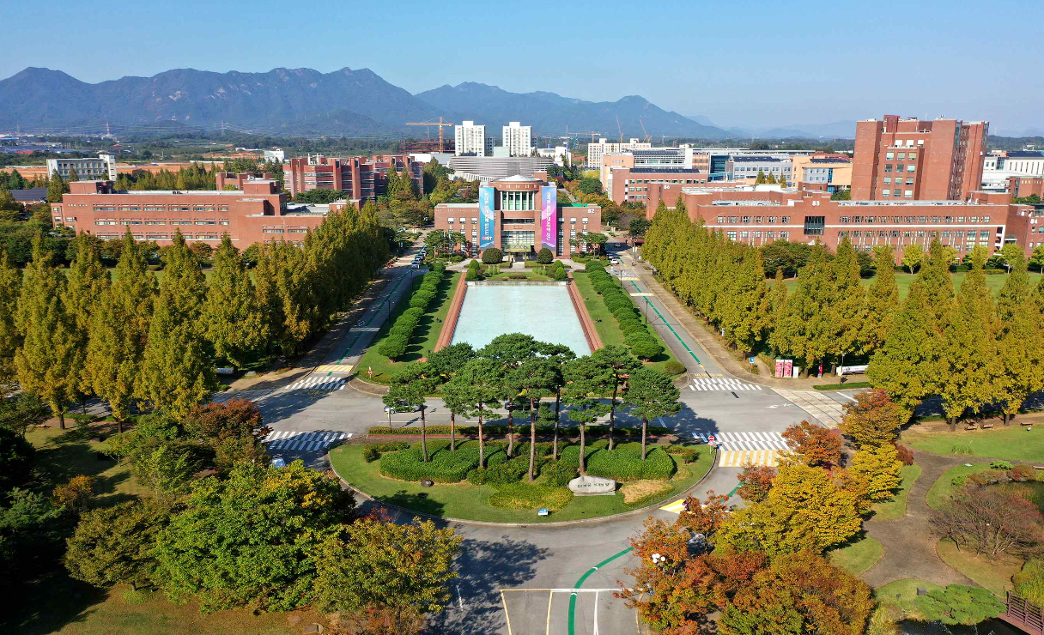▲ Panoramic view of GIST campus

As the ‘Korean ARPA-H Project’* was launched in earnest in July of this year, the green light has been given to the development of sarcopenia treatment as one of the major tasks for solving the national problem.

* Korean ARPA-H Project: A mission-oriented R&D project benchmarking the Advanced Research Projects Agency for Health (ARPA-H), a challenging and innovative research and development system in the US healthcare sector

The Gwangju Institute of Science and Technology (GIST, President Kichul Lim) announced that the ‘Multimodal Sarcopenia Treatment Consortium’ led by Professor Dongryeol Ryu of the Department of Biomedical Science and Engineering will receive KRW 15 billion in annual funding over the next four years and six months to take on the challenge of developing innovative sarcopenia treatment and technology that goes beyond the existing single treatment method.

This study, aimed at quantitatively and qualitatively improving sarcopenia, aims to develop a technology that utilizes digital and blood biomarkers that can predict and diagnose sarcopenia as well as monitor treatment effects, while also developing a multimodal digital therapeutic based on this.

The consortium, which includes a large number of medical, bio, and biomedical engineering experts from universities, university hospitals, and companies, including GIST, which Professor Dongryeol Ryu is affiliated with, Seoul Asan Medical Center (Professor Beom-jun Kim), Kyungpook National University Hospital (Professor Min-ji Kim), Inha University Hospital (Professor Jun-il Yoo), Dongguk University (Professor Seok-young Bang), JD Bioscience Co., Ltd. (CEO Jin Hee Ahn, Professor of Chemistry at GIST), Avanti Co., Ltd. (CEO Ki-seon Kwon), Exosystems Co., Ltd. (CEO Hu-man Lee), DeFi Co., Ltd. (CEO Sung-jun Yoon), and Angel Robotics Co., Ltd. (CEO Gyeong-cheol Gong), is expected to efficiently promote the development and commercialization of new treatments through close cooperation between specialized fields.

Professor Dongryeol Ryu is a world-renowned expert in the field of sarcopenia and aging research, and has been named one of the world's top 2% scientists by Stanford University and Elsevier, a global academic information analysis company, for three consecutive years.

Professor Ryu plans to attempt an innovative approach in this project based on his many years of accumulated research achievements and deep insights into improving muscle function and healthy aging.

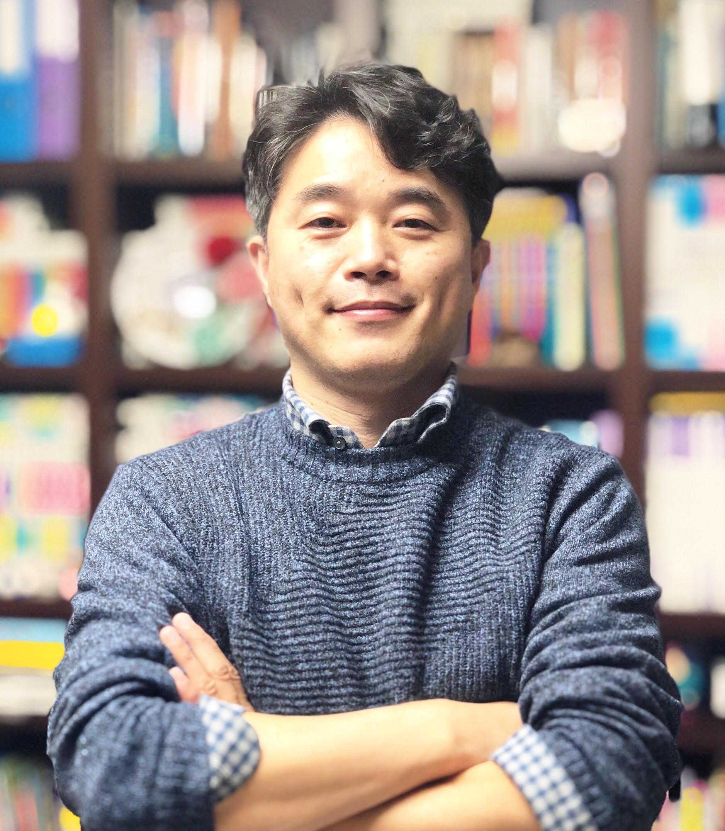
▲ GIST Department of Biomedical Science and Engineering Professor Dongryeol Ryu

Professor Dongryeol Ryu said, "This Korean ARPA-H project has set an important milestone for national health security and essential medical crisis response, and the development of sarcopenia treatment technology to prepare for an aging society is key. This project is expected to greatly contribute to strengthening the international competitiveness of the domestic biohealth industry and solving national health problems caused by the aging population."

In May of this year, the government planned a total of three projects after recruiting personnel to perform the five missions of the Korean ARPA-H project, including health security, welfare and care missions, big data analysis, and expert advice. The first project is ▴ Development of ultra-long-term vaccine stockpiling technology ▴ Establishment of a decentralized vaccine production system ▴ Development of multi-modal treatment technology for sarcopenia.



