“Research on future personal robots supporting real-virtual immersive experiences” Two GIST doctoral researchers selected for the Ministry of Education’s Academic Next Generation Support Project (Post-Doc. Growth-type joint research in the field of science and engineering)

- Research topic proposed by Assistant Professor Jieun Lee (Principal Investigator) and Postdoctoral Fellow Ahmed Elsharkawy (Co-Professor) in the School of Integrated Technology was selected... Received 450 million won in research funds for 3 years
- Professor SeungJun Kim participated as a mentor... Goal of developing technology to provide realistic haptic feedback and body movement guidance through the convergence of virtual reality and robotics technology

▲ (From left) Assistant Professor Jieun Lee of the School of Integrated Technology, Postdoctoral Researcher Ahmed, and Professor SeungJun Kim

The Gwangju Institute of Science and Technology (GIST, President Kichul Lim) announced that the ‘Research on Development of Real-time Dynamic Virtual-Real Haptic Feedback System Based on Personal Robot’ proposed by Research Assistant Professor Jieun Lee and Postdoctoral Researcher Ahmed of the School of Integrated Technology was selected as the subject of the ‘2024 Post-Doc. Growth Joint Research’ hosted by the Ministry of Education and the National Research Foundation of Korea.

The research team signed an agreement on August 30 and will receive a total of 450 million won over the next three years (August 2024 - August 2026) to develop a robot-based haptic feedback system that allows virtual reality (VR) users to experience physical interaction, and they will conduct a usability evaluation targeting human users.

In order for virtual reality users to receive haptic feedback corresponding to their body dynamics (movement and rotation, etc.), there is the economic burden of having to purchase multiple devices, as well as the inconvenience of having to wear the equipment. In addition, since users wearing VR headsets cannot see their actual surroundings, there is also a risk of colliding with obstacles in the surroundings due to body movements.

To solve these problems, the research team proposed a movement guidance technology that uses robots, especially personal robots, as an interaction medium to provide appropriate haptic feedback at the right time and location according to the user's dynamic movements and prevent safety issues caused by body movement.

Professor SeungJun Kim of the School of Integrated Technology supports joint research based on a mentor-mentee relationship with researchers selected for the project.

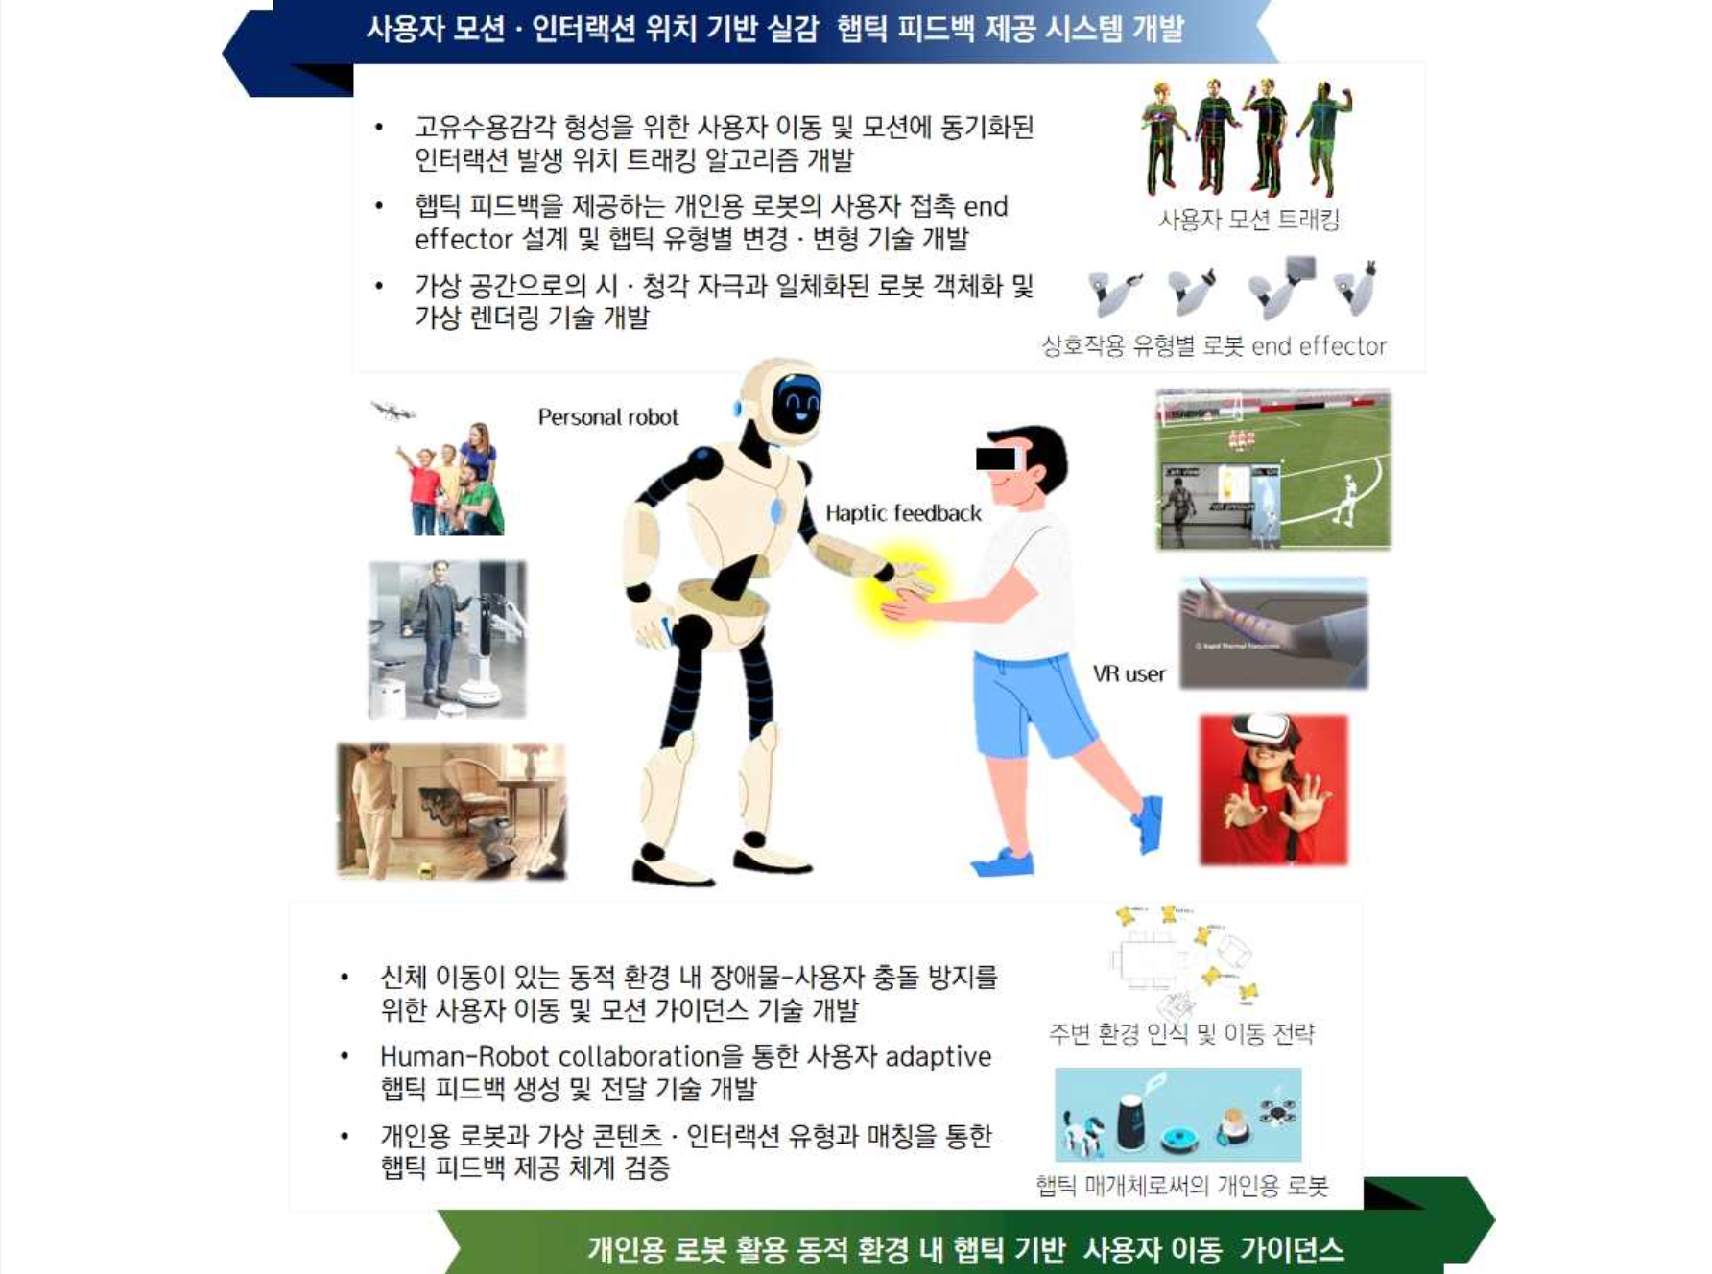▲ Development of a real-time dynamic virtual-real haptic feedback system based on personal robots Research objectives. Provide a sense of presence based on haptic feedback to virtual reality users by utilizing personal robots. Personal robots include home service robots, humanoids, and drones, and the robots deliver timely feedback according to the interaction and dynamic activity location of the virtual reality user.

Research Assistant Professor Jieun Lee, the principal investigator, said, "The convergence of virtual reality and robotics technology is a challenging approach to prepare for a future where robots become part of everyday life. This research is expected to advance the coexistence of virtual reality and robot systems that are realistic and free of physical movement."

Professor SeungJun Kim said, "It is very rewarding and rewarding to see two researchers who received their PhDs and conducted post-doctoral research at GIST grow into independent researchers. I expect that the growth-type joint research project will have a synergistic effect on the development of convergence research."



