"A Running Car is My Own Digital Cultural Space" GIST AI Graduate School Research Team Wins Edge AI Technology Contest

- AI Graduate School Meta-Evolutionary Machine Intelligence Laboratory Lab (Advisor: Professor Chang Wook Ahn) proposes a ‘small generative diffusion model’ that can operate on the specifications of a neural network processing unit (NPU) for vehicles, ranking first among 14 domestic university labs
- The first domestic vehicle-tailored diffusion model that requires high performance... Expected to be used to create various realistic contents to be used in infotainment systems for autonomous vehicles, research proposals to be advanced

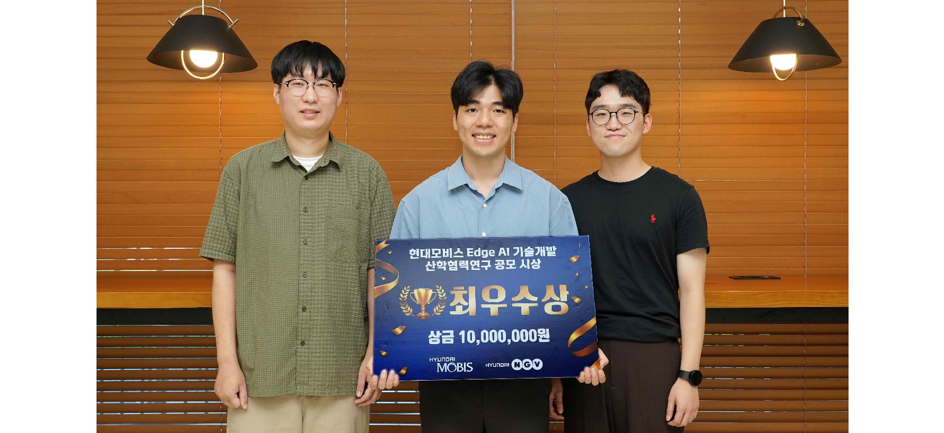▲ GIST AI Graduate School Professor Chang Wook Ahn's research team participated in the 'Edge AI Technology Development Industry-Academic Collaboration Research' contest and took a commemorative photo on campus after winning the grand prize. (From left) AI Graduate School doctoral student Donghyeon Lee, integrated student Wooseok Song, and doctoral student Chanmin Lee

The Gwangju Institute of Science and Technology (GIST, President Kichul Lim) announced that Professor Chang Wook Ahn’s research team from the Graduate School of AI won the grand prize in the ‘Edge AI* Technology Development Industry-Academic Collaboration Research’ contest.

This contest, hosted by Hyundai Mobis, was held for 14 research labs at domestic universities to generate ideas and develop functions for the In-Vehicle Infotainment (IVI)* service system, as well as to collect new technology ideas based on the in-vehicle neural processing unit (NPU).

* edge AI: This refers to AI being directly installed on a device, so that AI calculations are performed directly on the device.

* in-vehicle infotainment (IVI): A general term for entertainment and information systems that can be enjoyed in a car. It refers to devices or technologies that provide entertainment functions such as movies, games, TV, and SNS, as well as navigation and various services linked to mobile devices.

The research team of the Meta-Evolutionary Machine Intelligence Laboratory Lab (Advisor: Professor Chang Wook Ahn) consisting of Wooseok Song, a student in the integrated master's and doctoral program, and Donghyeon Lee and Chanmin Lee, doctoral students, proposed the development of a vehicle-tailored 'Tiny Diffusion Model' that can generate user-centered visual content by reflecting the characteristics of the driving situation under the theme of 'Development of a Sound-Landscape System Based on a Small Generative AI Model for Providing Realistic Driving Experience.'

This system allows drivers to enjoy personalized driving content on the IVI system (in-vehicle display) through the real-time current driving environment within the vehicle.

For example, when a car passes through a forest, driving content that conveys the feeling of walking through nature is generated. This allows drivers to have a realistic driving experience by receiving different real-time visual content (images/videos) every time they drive the same route every day.

As one of the generative AI technologies, the ‘diffusion model’*, which specializes in high-quality data generation, can generate high-quality content in various formats such as images, videos, and music, but due to the disadvantage of requiring very high computational costs, it cannot be applied to vehicles or mobile devices where the amount of computation is relatively limited.

* diffusion model: This is the latest generative AI model that learns the model by repeating the process of converting data into noise and then restoring it, thereby generating content such as images and videos.

The research team proposed a model lightweighting technique that was well-received for its design that can operate efficiently even on a 24TOPS (trillion operations per second) NPU (similar to a flagship smartphone) equipped with a vehicle embedding by applying a model lightweighting technique and a video customization framework to lower the model's specifications, unlike the existing high-cost diffusion model.

Student Wooseok Song said, "This is the first case in Korea where a high-performance diffusion model is customized for a vehicle. It is expected that it will be utilized to create various realistic contents that can be provided by IVI systems in autonomous vehicles in the future."

The research team of the GIST AI Graduate School's Meta-Evolutionary Machine Intelligence Laboratory Lab (Advisor: Professor Chang Wook Ahn) won the grand prize, receiving a plaque and prize money of 10 million won. The results of the research will be further developed through future industry-academic projects.



