GIST graduate students placed second in the ‘2024 CIS Student Grand Competition on Computational Intelligence in Biomedicine and Healthcare’ hosted by IEEE

- Students Yun-Ho Choi, Sangyeon Park, and Taekwan Ha from the GIST Cognition & Intelligence Lab (Advisor Professor Kyung-Joong Kim) took second place in the 2024 IEEE CIS Student Grand Competition on Computational Intelligence in Biomedicine and Healthcare... 38 student teams from 11 countries around the world participated.
- “Participating to realize and verify ideas from the lab... As a researcher, I will discover more possibilities and strive for excellent research results.”

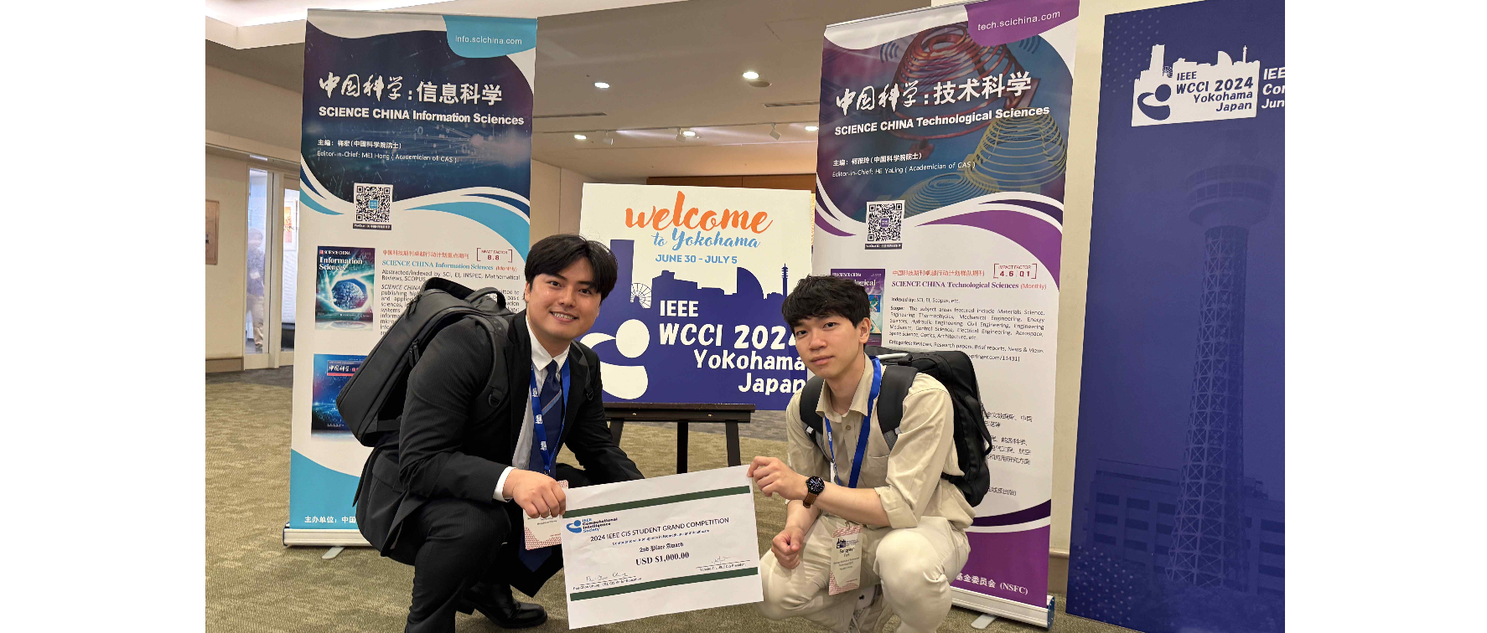▲ (From the left) Yun-Ho Choi, a combined master’s and doctoral program student, and Sangyeon Park, a master’s course student.

The Gwangju Institute of Science and Technology (GIST, President Kichul Lim) announced that graduate students of the School of Integrated Technology participated in the ‘2024 IEEE CIS Student Grand Competition on Computational Intelligence in Biomedicine and Healthcare’ and won second place.

Yun-Ho Choi, a combined master's and doctoral student in the School of Integrated Technology, and Sangyeon Park and Taekwan Ha, master's students, belong to the 'Cognition & Intelligence Lab (Advisor: Professor Kyung-Joong Kim)' developed ideas from the AI Healthcare team in the lab and achieved excellent results.

The 'Artificial Intelligence Healthcare' team is conducting research in the laboratory to solve various healthcare problems with artificial intelligence (AI) technology, such as patient treatment AI models, rehabilitation assistance AI robots, and medical data augmentation and decided to participate in this competition to win.

They discussed the topic of a safe artificial intelligence-based medical data generation system and showed that such generated data can be shared between institutions with less concern about infringing on individual privacy, and that increasing the amount of insufficient data can lead to smooth medical data utilization research.

In particular, the medical data generation technique proposed by the 'Artificial Intelligence Healthcare' team was well received as it can equalize the medical data of unevenly distributed patients or concentrate on data from underrepresented groups.

Student Yun-Ho Choi, representing the team, said, "We wanted to turn our ideas into reality and get them verified, and we are very happy that we were able to discover more possibilities as researchers and achieve good results through this competition. As a helper for humans, we will research artificial intelligence and strive to produce more creative and meaningful research results in the future."

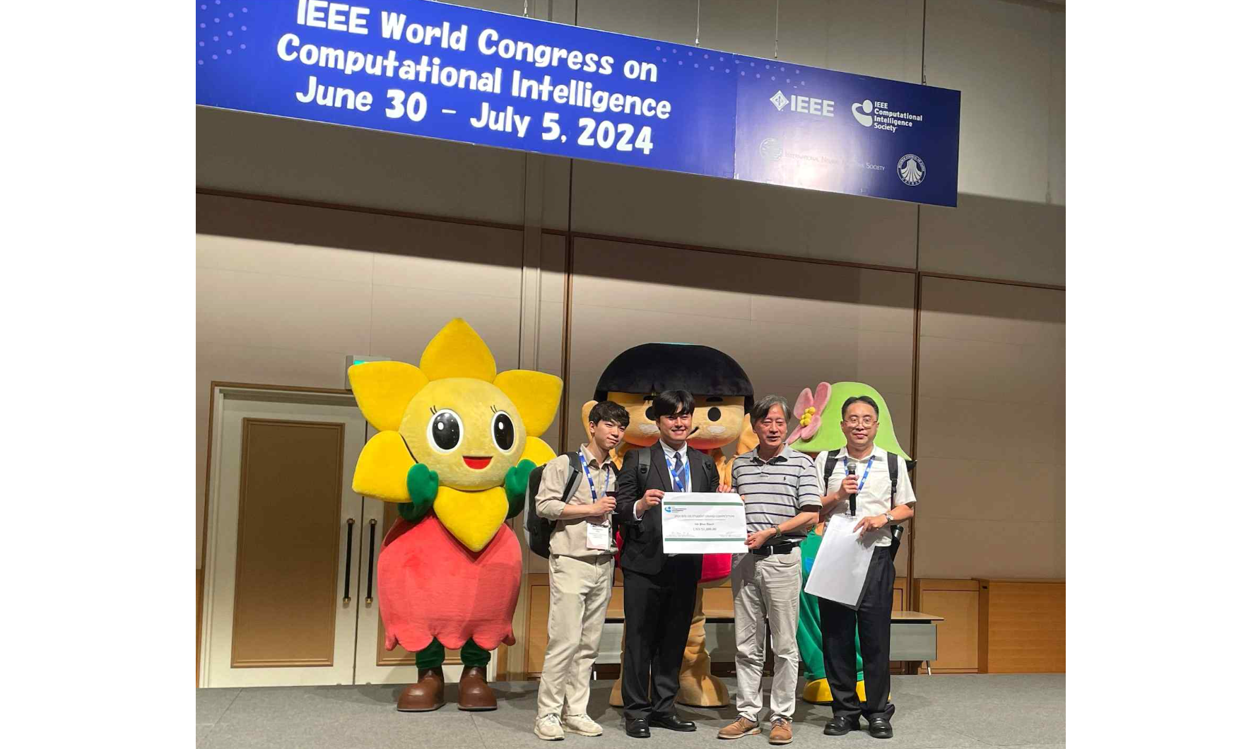▲ At the opening ceremony of the IEEE World Congress on Computational Intelligence, the ‘Artificial Intelligence Healthcare’ team from Professor Kyung-Joong Kim’s lab is taking a commemorative photo after winning second place in the ‘2024 IEEE CIS Student Grand Competition on Computational Intelligence in Biomedicine and Healthcare’. (From left) GIST School of Integrated Technology master's student Sangyeon Park, combined master's and doctoral program student Yun-Ho Choi, CIS president Yaochu Jin, student competition chair Chun-Rong Huang

Meanwhile, the 'Student Grand Competition on Computational Intelligence in Biomedicine and Healthcare', hosted by the Institute of Electrical and Electronics Engineers (IEEE), proposes a healthcare system using computer intelligence/artificial intelligence, produces a demo that materializes it, and produces the results. The contest was held from June 30 to July 5 in Yokohama, Japan.

Starting with the submission of the first proposal on January 31st, the first contest on March 25th, and the final presentation contest on June 30th, the competition lasted for a total of 5 months. 38 student teams from 11 countries around the world participated and took first place. A total of 3 teams received awards, from 1st to 3rd place.



