GIST students receive excellence and encouragement awards at ‘K-Digital Challenge: AI Startup Entrepreneurship Contest’

- Reap results by proposing start-up items using AI with differentiation, marketability, and technology... Video conversion service (‘Parrhesia’ team / Excellence Award), automatic traffic accident report production solution (‘Assist’ team / Encouragement Award)
- On Wednesday, July 10, agreement signed to support the production of AI prototypes and services with the Artificial Intelligence Industry Cluster Agency (AICA) and started a full-fledged business... “It helps in realizing the AI startup items we thought about in the lab.”

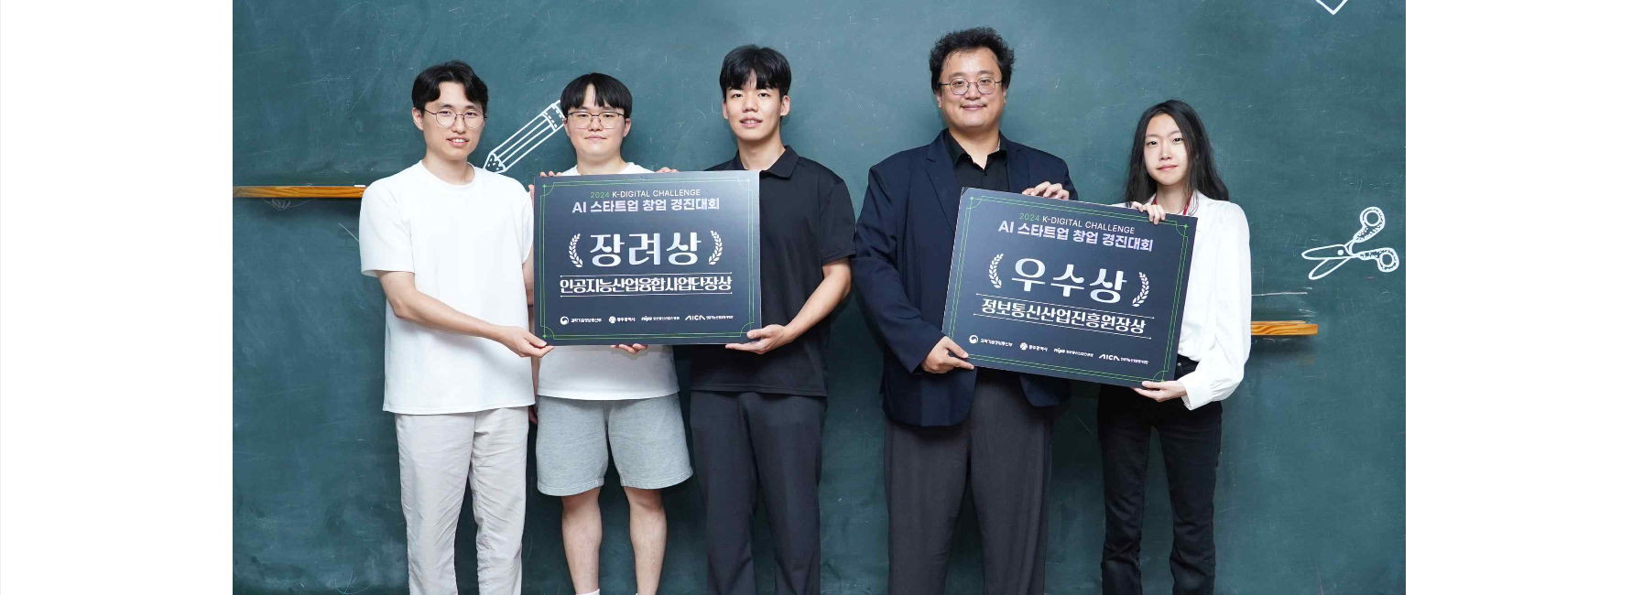▲ (From left) ‘Assist’ team (Hoosang Lee, Jun-ho Kim, Joo-seong Park (representative)) and ‘Parrhesia’ team (Ho-Taek Joo (representative) and SungHa Lee)

The Gwangju Institute of Science and Technology (GIST, President Kichul Lim) announced that the "Parrhesia" team from Professor Kyung-Joong Kim's lab and the "Assist" team from Professor Je Ha Ryu's lab at the School of Integrated Technology have won the first prize and the second prize, respectively, in the "K-Digital Challenge: AI Startup Startup Competition" (organized by the Ministry of Science and ICT . Gwangju Metropolitan City . Information and Communication Industry Promotion Agency . Artificial Intelligence Industry Convergence Business Unit).

The 'Parrhesia' team, consisting of Ho-Taek Joo, a doctoral student at the School of Integrated Technology, and SungHa Lee, a combined master's and doctoral student at the AI Graduate School, won the excellence award through the preliminaries, main rounds, and finals in this competition in which 64 teams of prospective entrepreneurs participated, and received a total of 70 million won in commercialization support.

The ‘Parrhesia’ team applied the AI image generation research being carried out in the ‘Cognition and Intelligence Lab (Advisor: Professor Kyung-Joong Kim)’ and announced it as a start-up item.

The startup item they proposed was a premium video beauty conversion service for prospective brides and grooms, and received high scores in recognition of its differentiation from other competitors, marketability, technology, business model, and the capabilities of the startup team.

As the first author, the ‘Parrhesia’ team has published top conference papers and SCI papers in the top 10% in the AI ​​field, won prizes in various AI competitions, and applied for numerous patents.

Joo-seong Park and Jun-ho Kim, undergraduate students in the School of Electrical Engineering and Computer Science, and Hoosang Lee, a doctoral student in the School of Integrated Technology, formed the ‘Assist’ team and won the encouragement award and received 35 million won in commercialization support.

The ‘Assist’ team proposed a solution for automatically producing objective traffic accident reports using artificial intelligence as a start-up item by applying AI traffic accident prediction research conducted in the ‘Robot AI Reinforcement Learning Lab (Advisor: Professor Je Ha Ryu)’.

In particular, Joo-seong Park, a member of the ‘Assist’ team, participated as a co-author of four papers related to traffic accidents despite being an undergraduate student.

Meanwhile, the ‘Parrhesia’ team and the ‘Assist’ team signed an agreement with the Artificial Intelligence Industry Cluster Agency on Wednesday, July 10th to promote the AI prototype and service production support project for the AI startup startup contest. (Agreement period: 2024. 7. 10. ~ 2024. 11. 30.)

Doctoral student Ho-Taek Joo represented the ‘Parrhesia’ team and said, “This competition helped us make up for the shortcomings of the business model and make the AI startup item we thought about in the lab a reality.” He added, “We hope to succeed as an AI startup in the future.” “We plan to lay the foundation for this,” he said, expressing his ambition. He then expressed his deep gratitude to the professor, saying, “Professor Kyung-Joong Kim has guided me in both material and spiritual research with encouragement and praise, and is currently providing great help in starting a business by suggesting collaboration between industry, academia, and research institutes.”

Joo-seong Park, an undergraduate student on the 'Assist' team, said, "I think we have achieved good results by supplementing our shortcomings through feedback we have received from various startup-related competitions." He added, "I first met Professor Jeha Ryu as an advisor for ‘Science Gifted Creative Research (R&E)’ when I was a student at Jeonnam Science High School and am grateful to the professor for always guiding me passionately.”

Meanwhile, the K-Digital Challenge: AI Startup Startup Competition was held as part of the AI Convergence Complex Creation Project (hereinafter referred to as the AI Convergence Complex Creation Project), which is jointly promoted by the Ministry of Science and ICT, Gwangju Metropolitan City, Korea Information and Communication Industry Promotion Agency, and the Artificial Intelligence Industry Convergence Project, and the AI Startup Startup Competition finals and award ceremony were held on June 20 and 21 at Hall A on the first floor of COEX in Seoul.



