GIST Department of Physics and Photon Science students won the grand prize at the 2024 Quantum Information Competition (Minister of Science and ICT Award)

- Spin and Quantum Information Lab (Advisor Professor Sang Yun Lee) students Seung Jae Hwang, Min Seok Kim, Seung Jae Baek, Jun Jae Choi, and Jaewon Kwak won the grand prize in the graduate student category... A total of 101 people from 24 teams participated and competed in a hackathon style for 3 days
- Held as a pre-event for the Ministry of Science and ICT’s ‘Quantum Korea 2024’, “Participate to learn more deeply in the field of quantum technology and quantum computing as an extension of laboratory study... I learned a lot in the process of working together.”

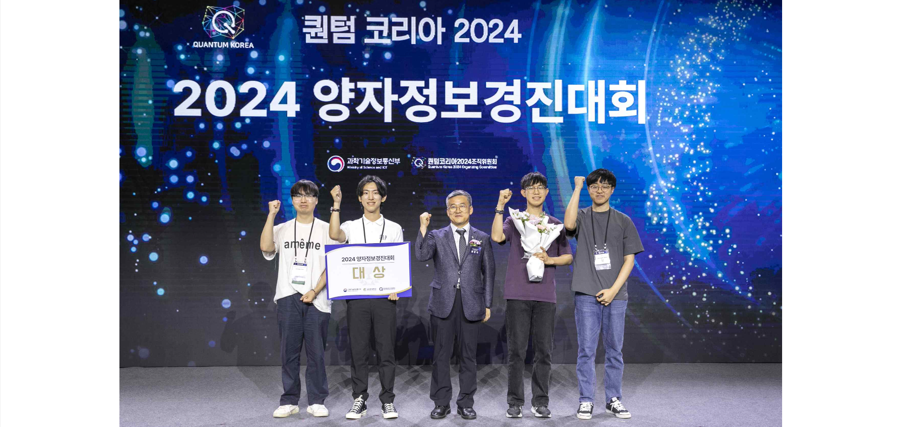▲ At the opening ceremony of 'Quantum Korea 2024', the 'Quantum Boom is Coming' team (advisor Professor Sang Yun Lee), consisting of 5 students from the Department of Physics and Photon Science at GIST, won the grand prize (Minister's Award) of the '2024 Quantum Information Competition' and took a commemorative photo. (From the left) Bachelor's degree student Jun Jae Choi, integrated Ph.D. course student Seung Jae Hwang, Ministry of Science and ICT Research and Development Policy Director Pan-sik Hwang, and bachelor's degree student Jaewon Kwak and Seung Jae Baek.

The Gwangju Institute of Science and Technology (GIST, President Kichul Lim) announced that the "Quantum Boom is Coming" team, comprised of five students from the Department of Physics and Photon Science, won the grand prize (Ministerial Award) at the opening ceremony of "Quantum Korea 2024" (co-hosted by the Ministry of Science and ICT and the Quantum Korea 2024 Organizing Committee), which was held on Tuesday, June 25th.

Five students from the Department of Physics and Photon Science, including integrated Ph.D. course student Seung Jae Hwang and undergraduate students Min Seok Kim, Seung Jae Baek, Jun Jae Choi, and Jaewon Kwak prepared to participate in the 'Quantum Information Competition' as an extension of their regular studies in the Spin and Quantum Information Lab (Advisor Professor Sang Yun Lee).

The ‘Quantum Boom is Coming’ team announced that they decided to participate in this competition because they believed it would be an opportunity to learn more about quantum technology and quantum computing through competition with students from other universities who have common interests.

On behalf of the team, Seung Jae Hwang said, "Rather than aiming for a prize, I entered the competition with the hope of learning as much as possible, and I am very happy to have won the grand prize. During the competition, I not only grew academically, but also learned a lot from the five team members working and collaborating together. I hope that this achievement will lead to excellent research results in the lab."

Meanwhile, as a pre-event for 'Quantum Korea 2024', students who participated in the competition, which was held for domestic university (graduate) students to promote the influx of outstanding future talents and support network building, submitted their results after solving a given problem using the quantum cloud from June 21 (Fri) to 23 (Sun).

A total of 101 participants from 24 teams of university students participated in the competition, and 10 teams were awarded, including two grand prizes (Minister's Award), two first prizes, and two second prizes, and the winners were selected based on the novelty of their ideas, the completeness and appropriateness of their results.

