GIST School of Materials Science and Engineering Professor Emeritus Jae-Suk Lee receives the International Award from the Polymer Society of Japan

- At the 73rd Annual Meeting of the Polymer Society of Japan on Thursday, June 6... Recognized for his achievements in basic research on polymer synthesis and applied research in the field of polymer materials, as well as his contribution to academic exchange in the field of polymers between Korea and Japan.

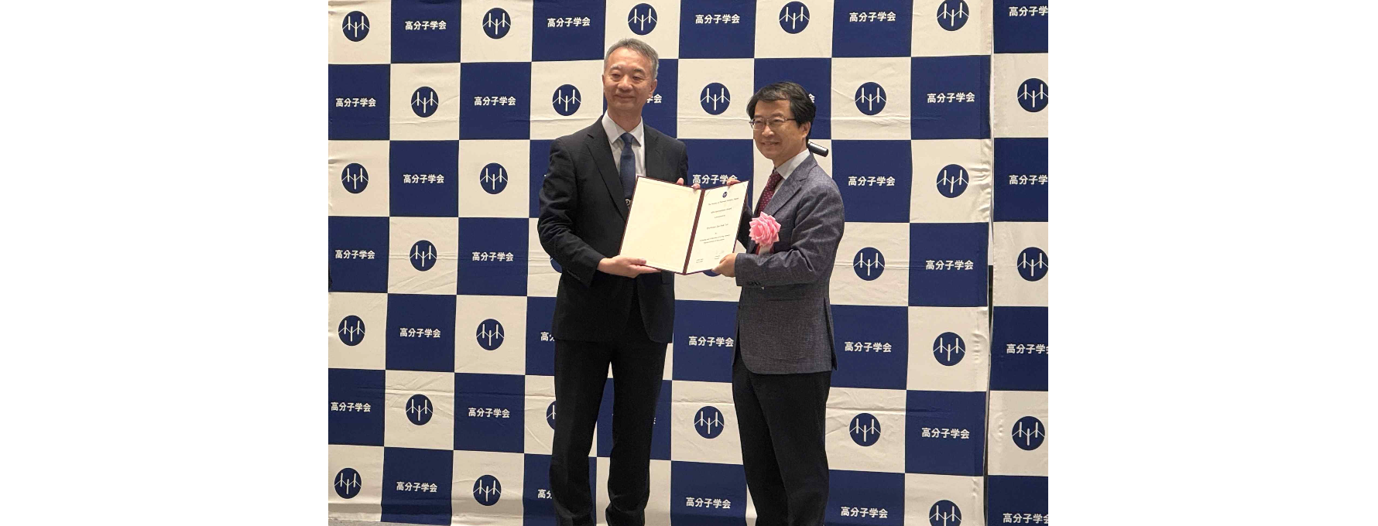▲ On June 6th, GIST School of Materials Science and Engineering Professor Emeritus Jae-Suk Lee received an international award from Society President Kozo Ito at the Polymer Society of Japan.

The Gwangju Institute of Science and Technology (GIST, President Kichul Lim) announced that Professor Jae-Suk Lee of the School of Materials Science and Engineering has been awarded the Polymer Society of Japan International Award. This prestigious award is given to foreign scientists who have made significant contributions to the advancement of polymer science and technology and have been actively involved in international exchange with Japan.

Professor Lee, who was appointed to GIST in 1994 at the beginning of its establishment, was the first scholar to discover the living property of isocyanate by anionic polymerization during polymer synthesis. In particular, he discovered the living property of the active terminal in the polymer synthesis of isocyanate and discovered living property. Basic research has been conducted on the use of polymers.

Professor Lee was selected for his fundamental research on polymer synthesis, as well as his significant academic and industrial contributions to the fields of polymer materials, including ▴ nanomaterials fabrication, ▴ synthesis of large bottlebrush block copolymers for photonic crystals, ▴ self-emulsion polymerization, ▴ molecular-level rule-ordering structure control, ▴ fine dust filter materials using electrolytes, and ▴ energy (fuel cells and batteries).

Professor Jae-Suk Lee, who is also a regular member of the Korea Academy of Science and Technology, has published over 260 papers in international academic journals to date and has received the Polymer Paper Award from the Korean Polymer Society, the LG Chem Polymer Academic Award, and the Korea Science and Technology Award. His books include 『My Education, Research, and Community Service (published by GIST PRESS)』.

▲ School of Materials Science and Engineering Professor Emeritus Jae-Suk Lee

Meanwhile, the Polymer Society of Japan* has been awarding the ‘International Award’ since 1994 by selecting researchers who have contributed to the development of polymer science and technology through outstanding research activities and who have made significant contributions to exchanges with Japan.

* Polymer Society of Japan: Founded in 1951 to develop and disseminate polymer-related studies and technology and promote polymer science and polymer industry. With over 10,000 active members, it is a representative academic society in Japan that hosts three major events, including the Annual Conference, Polymer Forum, and Polymer Materials Forum, as well as various academic presentations every year, contributing greatly to related studies and national industrial development.

This year’s award ceremony was held along with the award lecture at the ‘73rd Annual Meeting of the Japanese Polymer Society’ held at the Sendai International Center in Japan on Thursday, June 6.



