10 GIST faculty and staff received government awards and ministerial commendations for their contribution to science and technology promotion

- Commemorating the 2024 Science Technology and Information and Communication Day... Contribution to achievements in each field and innovation in science education
- Awarded the Science and Technology Medal (Professor Dong-Yu Kim), Science and Technology Award (Professor Chul-Seung Park), etc.

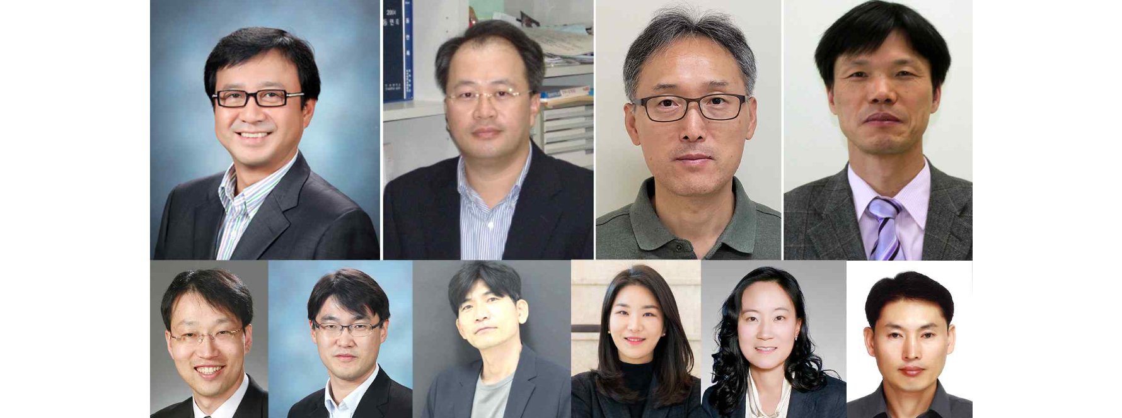▲ From the top left, (Innovation Medal) School of Materials Science and Engineering Professor Dong-Yu Kim, (Citation of Honor) School of Life Sciences Professor Chul-Seung Park, (Presidential Citation) School of Mechanical Engineering Professor Hyo Sung Ahn, Department of Physics and Photon Science Professor Hyyong Suk, From the bottom left (Prime Minister's Citation) School of Earth Sciences and Environmental Engineering Professor Jaeyoung Lee, School of Materials Science and Engineering Professor Myung-Han Yoon, School of Electrical Engineering and Computer Science Professor Young-Dahl Jho, School of Materials Science and Engineering Professor Eunji Lee, (Minister’s Citation) School of Life Sciences Professor Mi-Ryoung Song, Facilities Management Team member Jong-cheol Jeong

The Gwangju Institute of Science and Technology (GIST, President Kichul Lim) announced that 10 faculty members, including School of Materials Science and Engineering Professor Dong-Yu Kim, were awarded the Government Prize for Science and Technology Promotion and the Ministerial Citation for their contributions to the creation of excellent research results and the promotion of science and technology at the 2024 Science and ICT Day ceremony held at the Gwacheon National Science Center in Gwacheon, Gyeonggi Province, on April 22.

Materials Science and Engineering Professor Dong-Yu Kim, who received the Innovation Medal of Science and Technology Medal, is a pioneer in the synthesis of organic materials for organic electronic devices. He was recognized for his contribution to the development of academia by synthesizing new conjugated polymers applied to organic electronic devices and researching and developing basic device driving principles and new processing methods. Recently, he synthesized quinoid-based conjugated polymers containing radicals and identified the correlation between electrical and magnetic properties depending on the structure of the conjugated polymer. Through this, he laid the foundation for the development of core materials such as next-generation organic electronic devices, batteries, and spintronics.

The Science and Technology Citation of Honor was presented to School of Life Sciences Professor Chul-Seung Park, who has been recognized as a leading researcher in this field both domestically and internationally by publishing world-class results in the field of ion channels responsible for electrical signal transmission in nerve cells, and has contributed to the development of science and technology by continuously deriving numerous research results on electrical signal information transmission and regulatory mechanisms in nerve cells.

In addition, △ School of Mechanical Engineering Professor Hyo Sung Ahn, who contributed to the establishment of technology in the field of control systems by developing multiple unmanned aerial vehicle control and navigation systems, published two books (Springer, etc.) and a large number of papers (52 within 10%) in top-ranked journals, and △ Department of Physics and Photon Science Professor Hyyong Suk, who led the research of new technologies in the field of laser and plasma, including the development of a new method to diagnose nuclear fusion plasma using terahertz waves, and contributed to the promotion and popularization of science and technology, received the Presidential Citation.

The Prime Minister's Citation went to △ School of Earth Sciences and Environmental Engineering Professor Jaeyoung Lee, who established the Chemical Energy Storage and Conversion Process Future Research Center and founded Esus Corporation to cooperate with carbon neutrality and advancement into the hydrogen economy, △ School of Materials Science and Engineering Professor Myung-Han Yoon, who is conducting original research on the development of high-performance organic mixed conductors and the implementation of high-body compatibility, high-performance skin attachment, and implantable bioelectronic interfaces, △ School of Electrical Engineering and Computer Science Professor Young-Dahl Jho, who has been leading research that reflects the spirit of the times, such as pioneering future technologies in the information and communications and semiconductor fields and quantum electronics for implementing semiconductor quantum technology, △ School of Materials Science and Engineering Professor Eunji Lee received the award for her contributions to the development of highly functional nanomaterials and the fields of optoelectronics and biomedicine through his unique development of polymer nanoparticle structure control and real-time transmission electron microscope imaging technology.

The Minister of Science and Technology Promotion Citation included School of Life Sciences Professor Mi-Ryoung Song, who discovered key genes regulating the development of the brain and nervous system and identified their genomes, served as an expert member of the Korea Research Foundation, and as a member of the Comprehensive Biotechnology Policy Council of the Ministry of Science and ICT, and contributed to the development of national R&D policies and the empowerment and gender equality of women scientists and engineers and △ Facilities Management Team member Jong-cheol Jeong, was selected as the winner for contributing to accident prevention through preemptive safety diagnosis of electrical facilities and reducing power bills through stable operation of solar power facilities.

President Kichul Lim said, "We are grateful for the dedication of the awardees who have been at the forefront of science and technology advancement to give our country an edge in the fierce global competition for supremacy. Reflecting on the significance of Science and Technology Day (April 21) and Information and Communication Day (April 22), all GIST members will open a new path for innovation with a noble sense of mission."



