GIST appoints Ju-sang Yeo, former CEO of Magellan Technology Investment, as the first CEO of ‘GIST Holdings’

- Appointed as the first CEO of GIST Holdings, which was launched on Monday, April 1
- The first CEO, Ju-sang Yeo, expects local companies and GIST to grow together and coexist by achieving more systematic technology commercialization and revitalization of startups

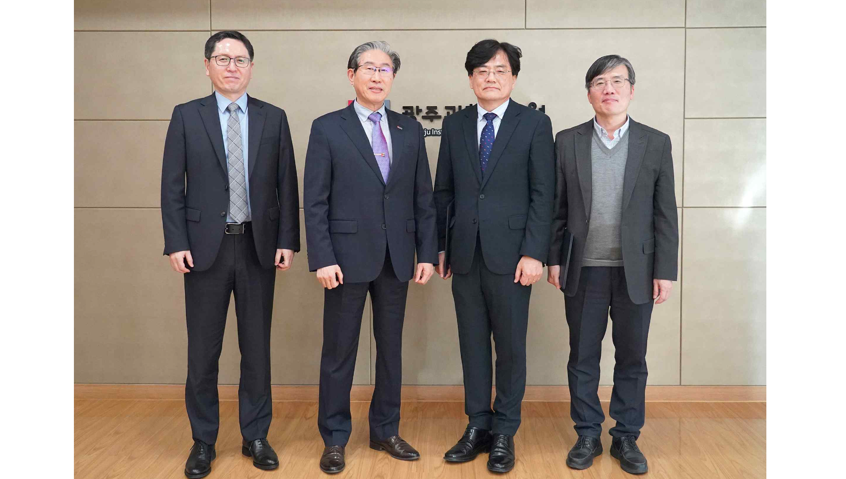▲ On April 1st, GIST launched ‘GIST Holdings’ and appointed Ju-sang Yeo, former CEO of Magellan Technology Investment, as the first representative and took a commemorative photo. (From left) GIST Vice President for Academic Affairs Sang-Don Kim, GIST President Kichul Lim, GIST Holdings' first CEO Ju-sang Yeo, and GIST Science and Technology Innovation Center Director Min-Gon Kim.

The Gwangju Institute of Science and Technology (GIST, President Kichul Lim) announced that it launched ‘GIST Technology Holdings Co., Ltd. (hereinafter referred to as GIST Holdings)’ on Monday, April 1 and appointed Ju-sang Yeo, former CEO of Magellan Technology Investment, as its first representative.

After taking office, President Kichul Lim announced a strategy to revive the local economy through ‘GIST Holdings’, which he established at the end of last year. Accordingly, an opening ceremony was held on January 17th of this year, and efforts are being made to discover excellent startups in Gwangju-Jeonnam, expand collaboration with local companies, and revitalize entrepreneurship through innovation.

The first CEO, Ju-sang Yeo, is the former CEO of Magellan Technology Investment, a venture capital company that invests in technology-focused companies, and is evaluated as contributing to the revitalization of domestic startups by operating its own incubation center and a fund specializing in early-stage companies.

In addition, he served as a member of the operating committee of the Youth Entrepreneurship Academy and Startup Success Package Project of the Ministry of SMEs and Startups, and as a judge and chairman of various government-sponsored startup competitions, and is a respected figure in the related industry as a person who has had a positive influence on revitalizing youth entrepreneurship.

Former CEO Yeo, who was recognized for his contribution to the quality of domestic startups through Magellan Technology Investment's intensive investment in technology-oriented early stage companies, also received the Minister of Science, ICT and Future Planning Award at the 2014 Korea Creative Economy Awards (contribution category).

'GIST Holdings' aims to establish 50 investment companies and achieve total sales of KRW 200 billion by 2030 with ▴ Support the establishment of investment companies through discovery of promising technologies and support for technology commercialization ▴ Customized accelerator for each field such as product development, commercialization, and technology marketing ▴ Promoting large-scale planned start-ups through strategic partnerships with investors ▴ Promoting investment support through the formation and operation of investment funds are the main projects.

President Kichul Lim said, "The establishment of GIST Holdings is the first step toward achieving the core goal of spreading the results of ‘GIST Vision 2053’, producing 30 unicorn-level companies. This is expected to revitalize the local economy by establishing a virtuous cycle model and lead the innovative economy with promising local companies."

The first representative, Ju-sang Yeo, said, "I feel a heavy burden on my shoulders after being appointed as the first representative. In the short term, we will focus on expanding investment assets and making initial investments in deep-tech fields with a large impact. In the mid- to long-term, we will produce a large number of high-quality unicorns based on a solid financial structure and a structured start-up system. We will do our best to help the southwestern region of Korea, where GIST is located, grow into a mecca of innovation that represents Korea."



