TEDi MEDi, a GIST faculty start-up company, was selected for Samsung Electronics' startup development program (C-Lab Outside)... Development of a prototype photobiomodulation sleep improvement wearable device

- Professors Jae Gwan Kim and Tae Kim of the GIST Department of Biomedical Science and Engineering started a business in 2021, conducted brain science-based sleep and dementia research, and developed a ‘digital treatment solution’... Hoping to contribute to healthy aging before a super-aging society
- Sleep Tech device, which improves the quality and quantity of sleep by increasing sleep pressure using near-infrared light, has completed preclinical testing and is in the prototype development stage... Innovative startup supported and cooperated by Samsung Electronics

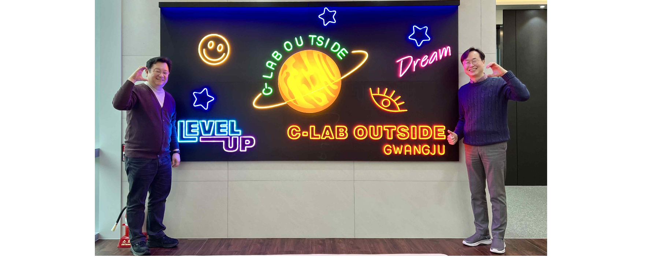▲ (From the left) Tae Kim and Jae Gwan Kim, respective representatives of Teddy Medi Co., Ltd.

The Gwangju Institute of Science and Technology (GIST, President Kichul Lim) announced that TEDi MEDi (representatives Jae-gwan Kim and Tae Kim), a teacher-founded startup, was selected as Samsung Electronics C-Lab Outside Gwangju.

Samsung Electronics held a contest for startups located in Gwangju Metropolitan City last November and selected three local innovative startups in the areas of artificial intelligence (AI), healthcare, and materials and components.

TEDi MEDi Co., Ltd. was founded by GIST Department of Biomedical Science and Engineering Professor Jae Gwan Kim (biomedical engineering major, PhD) and CEO Tae Kim (psychiatry major, MD-PhD), who are each representing GIST, based on research results showing that near-infrared light helps improve sleep and founded a company in October 2021 to commercialize it. Currently, they are focusing on researching sleep and dementia and developing digital treatment solutions based on brain science.

They received an investment of 100 million won from the Gwangju Creative Economy Innovation Center in December 2022 and participated in the Startup Promotion Agency's initial startup package project (KRW 100 million) in April 2023 and the TIPS program (KRW 500 million) in September of the same year. It has been recognized for its technology and business feasibility by being selected and is showing the synergy that can be created in the healthcare field when medicine and science technology meet.

‘Wearable device for improving sleep’ is the first product to be launched by TEDi MEDi Co., Ltd. and is in the prototype development stage after completing preclinical testing. This device, which utilizes photobioregulation technology, works on the principle that near-infrared light promotes the synthesis of adenosine triphosphate (ATP)* and decomposes it into adenosine, and adenosine improves sleep quality by increasing sleep pressure in the brain.

TEDi MEDi Co., Ltd. participated in the Consumer Electronics Show (CES) held in Las Vegas, USA in January of this year and conducted exhibitions and investment consultations at the startup exhibition hall ‘Eureka Park’.

* adenosine triphosphate (ATP): It is an organic compound that supplies energy to perform various life activities in living cells, such as muscle contraction, conduction of excitement in nerve cells, and material synthesis.

Professor Jae Gwan Kim said, "While wondering if there was a non-pharmacological way to help the many people suffering from sleep disorders, we confirmed the possibility through research results and decided to start a business. We are developing technologies that can help treat not only sleep but also various brain diseases through electronic medicines and digital therapeutics, and we hope to contribute to healthy aging as we look beyond an aging society to a super-aged society."

Professor Tae Kim said, "Both TEDi MEDi's near-infrared light irradiation device and transcranial ultrasound device have the expandability to be applied not only to sleep or dementia but also to other brain diseases. We will accelerate the development of digital healthcare products to help humanity lead a healthy life."

Meanwhile, the Samsung C-Lab Outside Program is an external startup development program that has been operated by Samsung Electronics since 2018, contributing to the development of the local economy by discovering and nurturing excellent startups.

Samsung Electronics executives and employees are matched one-to-one with each company to provide close, customized support, and receive up to 100 million won in business support for the next year and customized consulting for each stage of company growth from Samsung Electronics executives and employees. In addition, it promotes technological and management cooperation with Samsung Electronics and its affiliates and receives various support such as participation in domestic and international exhibitions such as CES and marketing development.



