[Personnel] Gwangju Institute of Science and Technology (GIST)

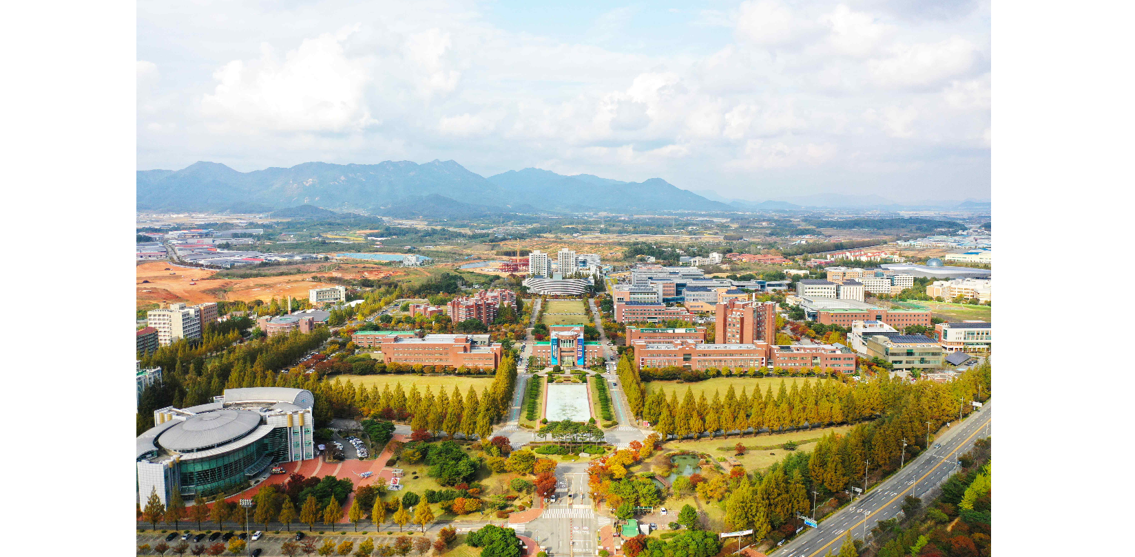▲ Panoramic view of GIST campus

□ Office of R&D Coordination Director Chang-Lyoul Lee
(as of March 8, 2024)

□ GIST Institute for Artificial Intelligence Director Wook Ahn Ahn
(as of February 27, 2024)

□ Graduate School of Energy Convergence Director Yun-su Kim
(as of February 23, 2024)



