GIST undergraduate students propose corporate document collaboration service using generative AI, winning '2024 KPMG Ideathon'

- The ‘OPTIMA’ team, comprised of 5 GIST undergraduate students, ranked 3rd out of 64 teams
- Development of ‘Docuflow’, a parallel document collaboration service using generative AI... expected to improve work productivity

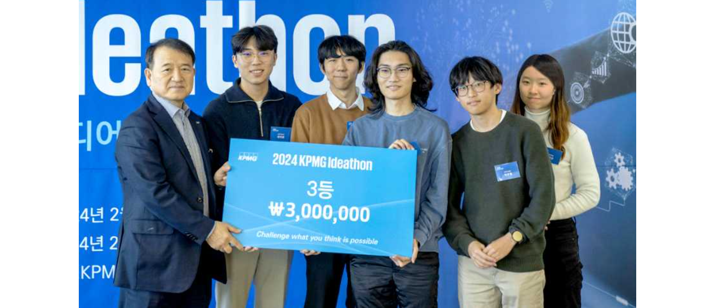▲ At the ‘2024 KPMG Ideathon’, the ‘OPTIMA’ team, composed of GIST undergraduate students, won third place and are taking a commemorative photo. (From left) Samjeong KPMG Chairman Kyo-tae Kim, GIST students Ik-jun Choi, Do-hyun Ko, Si-won Park, Joo-myeong Park, and In-seon Hwang

The Gwangju Institute of Science and Technology (GIST, President Kichul Lim) announced that the ‘OPTIMA’ team, composed of undergraduate students from the School of Electrical Engineering and Computer Science, won third place in the ‘2024 KPMG Ideathon’ contest.

Five undergraduate students, including Do-hyun Ko, Si-won Park, Joo-myeong Park, Ik-jun Choi, and In-seon Hwang, participated as the ‘OPTIMA’ team and received high praise for planning and developing an innovative corporate document collaboration tool using generative AI.

'Docuflow', a document collaboration service developed by the 'OPTIMA' team, utilizes ▴ Streamlined AI Search: LLM (Large language model) to provide information tailored to the user's intent quickly and accurately in real time ▴ Docuflow: enable multiple members to work on a single document at the same time ▴ Automation: provides all necessary functions for automation of business document creation, such as grammar check, automatic report generation, and approval pipeline construction.

'OPTIMA' team leader Ik-jun Choi said, "The document collaboration service ‘Docuflow’ is expected to contribute to improving corporate productivity by utilizing AI technology to innovate the entire document creation process from generative information search, analysis, collaboration, review, modification, approval, and follow-up management. Using this award as an opportunity, I would like to continue to develop technologies that are of practical help to companies."

On February 20th and 21st, each team presented their concrete ideas and evaluated platform utilization, technical feasibility, prototype completeness, theme suitability, market affinity, growth potential, and innovation. The awards ceremony was held at the Gangnam Finance Center in Seoul on the 23rd of last month.

