[Personnel] Gwangju Institute of Science and Technology (GIST)

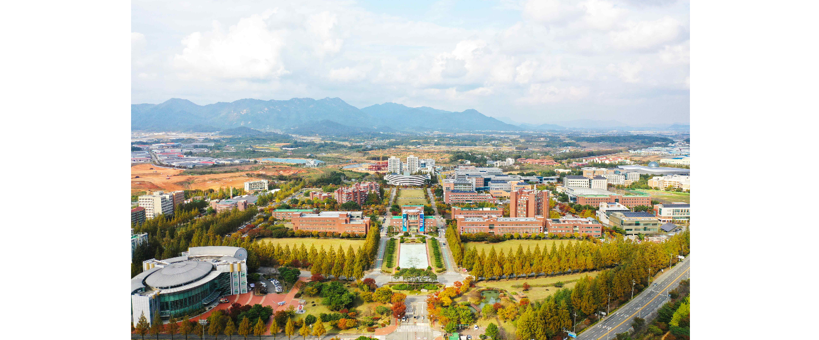▲ Panoramic view of GIST campus

□ Deputy Director (Vice-Department level)

△ Dukjo Kong, Vice Dean of AI Policy & Strategy Graduate School
(as of February 15, 2024)

□ Office Manager

△ Young-wook Cho, Office of Academic Planning Office Manager
(as of February 26, 2024)

□ Team Leader

△ School of Electrical Engineering and Computer Science Team Leader Seong-gye Park
△ School of Materials Science and Engineering Team Leader
△ School of Mechanical Engineering Team Leader Ran-young Jo
△ Institute of Integrated Technology Team Leader Su In Choi
△ Department of Biomedical Science and Engineering Team Leader Kyung-sook Min
△ Student Records Team Leader Ga-young Cha
△ Section of Student Services Team Leader Young-il Joo
△ Financing Team Leader Jaehong Park
△ Contract Team Leader Mi-yeon Kim
△ Research Management Team Leader Soo-hyang Jin
△ Development Fund Team Leader Seungjae Lee
(as of February 26, 2024)



