GIST Professor Emeritus Jae-Suk Lee publishes essay collection ‘My Education, Research, and Community Service’

- Contains in-depth insight and experience in education, research, and service... as a scholar who fulfills social responsibility
- A record of life as a world-class science and technology scholar who communicated with the local community and worked hard for development

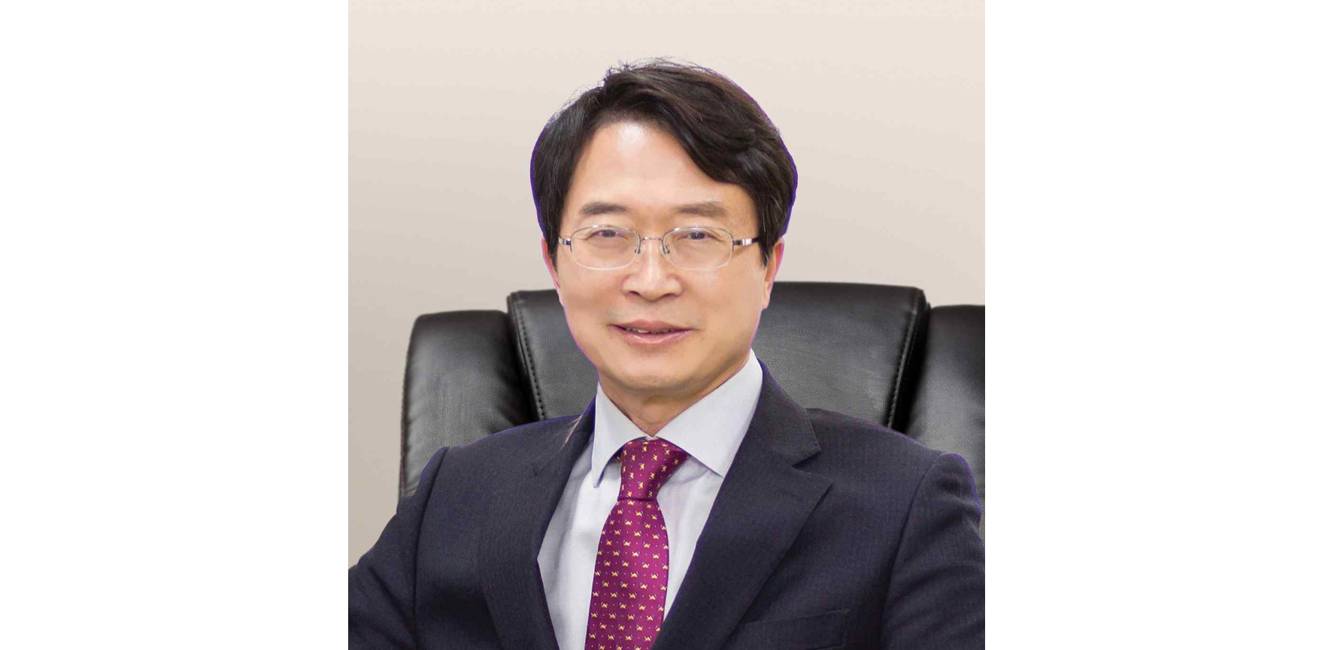▲ Professor Emeritus Jae-Suk Lee, School of Materials Science and Engineering

It is never easy to focus on one field for a long time and achieve results. A collection of essays has been published that honestly records how a professor at the National Institute of Science and Technology has lived a life of communicating with the community and striving for development through education, research, and service for 30 years.

GIST PRESS, the publishing company of Gwangju Institute of Science and Technology (GIST, President Kichul Lim), announced that Professor Emeritus Jae-Suk Lee of the School of Materials Science and Engineering published his book ‘My Education, Research, and Community Service’ on the 20th (Tuesday).

Professor Lee, who led the establishment of GIST, was initially appointed in 1994 and served as an associate professor, professor, distinguished professor, and visiting scholar, and is currently a professor emeritus. He is also a regular member of the Korea Academy of Science and Technology.

Professor Lee is a world-renowned scholar who first discovered the living property of isocyanate through anionic polymerization during polymer synthesis and has published over 260 papers in the world's leading international academic journals on living anionic polymerization of isocyanate, nanomaterial production, synthesis of large bottle brush block copolymers for photonic crystals, molecular level regularization, and self-emulsification polymerization.

This book depicts Professor Jae-Suk Lee's journey as a professor at the Gwangju Institute of Science and Technology, building relationships with the local community with the idea that he should lead by example and contribute to regional and national development.

Professor Lee has been teaching as an educator at GIST, a local research university, and he has consistently communicated through newspaper columns about his service to the community and his research. He has now collected the contents for this book.

By creating academic achievements while striving to fulfill social responsibilities, he is setting an example as a scholar who contributes to the development of the local community and the sustainable growth of the nation.

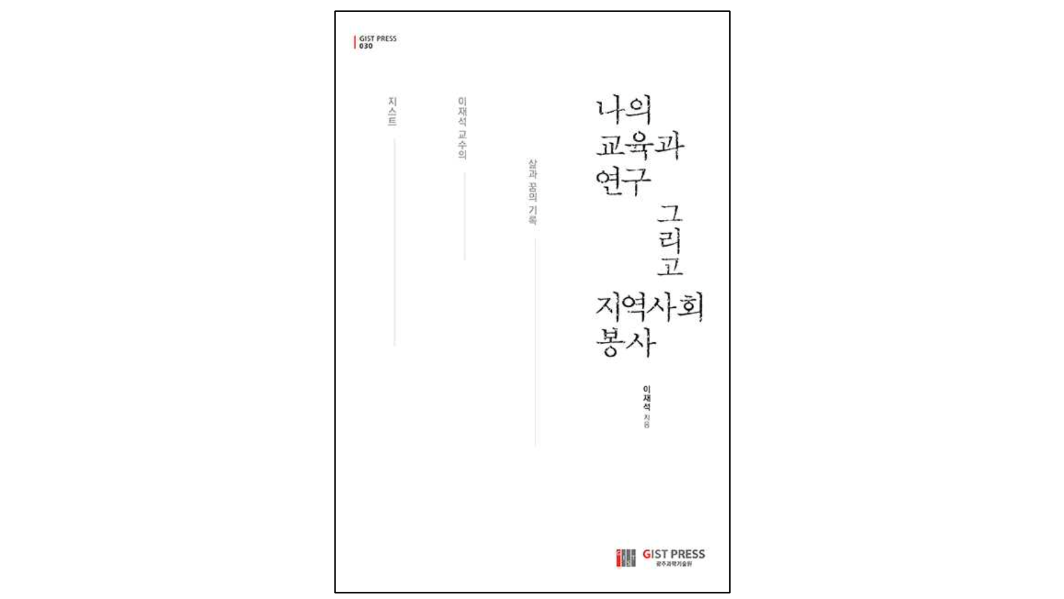▲ Cover of ‘My Education, Research, and Community Service’

The author's deep insight and practical experience in the fields of education, research, and social service are expected to serve as a good guide for everyone who wants to contribute to the community.

Professor Lee said, "This book is a memoir and record of my life as a professor, in which I organized and tied together the thoughts that were running around in my head. I hope this will be an opportunity to indirectly experience how professors at local research universities approach education, research, and service."

