GIST School of Earth Science and Environmental Engineering Professor Chul-Han Song publishes ‘Ultrafine Dust, Climate Change, and Carbon Neutrality’

- Contains energy-environment national policy suggestions through comprehensive and scientific consideration of the energy transition, carbon neutrality, and ultrafine dust issues

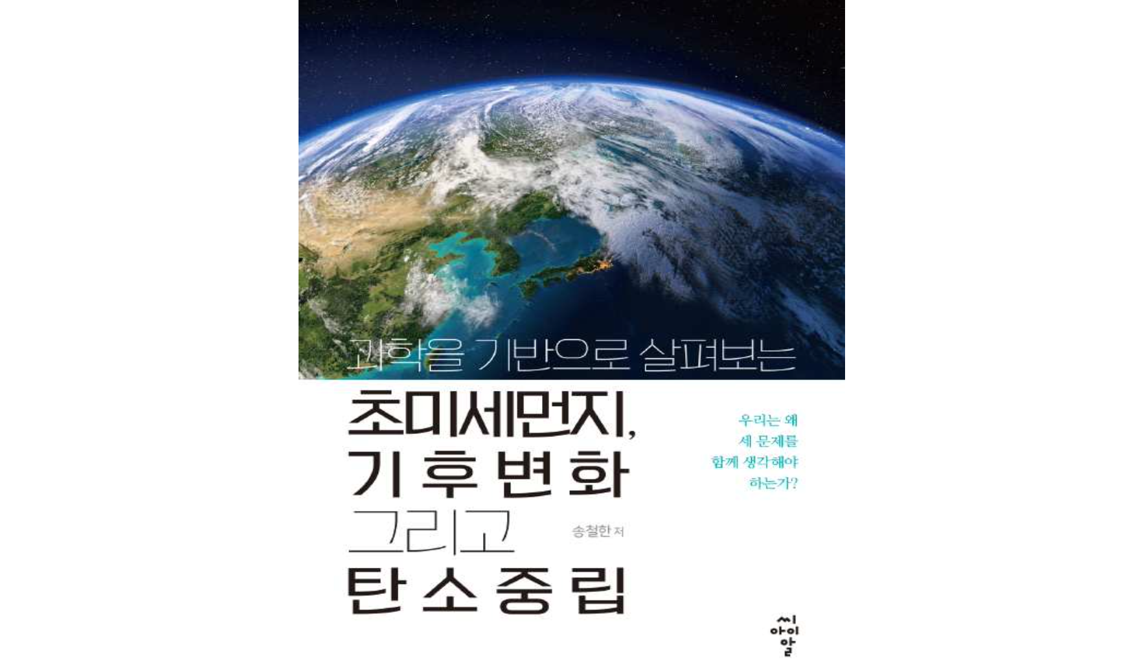▲ Cover of ‘Ultrafine Dust, Climate Change, and Carbon Neutrality’

In order to comprehensively deal with Korea's ultrafine dust problem, response to climate change, and energy transition, for which solutions are urgently needed, a scientific approach to the special situation of the Korean Peninsula is necessary. A commentary by an atmospheric environment expert has been published for this purpose and is attracting attention.

The Gwangju Institute of Science and Technology (GIST, President Kichul Lim) announced that School of Earth Science and Environmental Engineering Professor Chul-Han Song has published ‘A look at ultrafine dust, climate change, and carbon neutrality based on science’ (published by CR).

The author, Professor Chul-Han Song, said, "In relation to the issue of ultrafine dust, response to climate change, and realization of a carbon-neutral society, unrealistic political claims, ideological discussions, and utopian fantasies are prevalent in our country, and these discussions and thoughts are neither concrete nor scientific. We need to understand, discuss, and seek solutions based on more specific data and scientific facts."

This book examines energy-environment policies that can simultaneously solve the energy transition, carbon neutrality, and ultrafine dust problems. One policy includes strategies for ultrafine dust reduction and carbon neutrality, while also having an excellent energy policy. The author calls this ‘ultrafine dust-climate change-energy policy linkage’ and proposes to connect the three problems and approach the solution scientifically.

The book consists of three parts, and parts 1 and 2 deal with ultrafine dust and climate change issues. In Korea, it is estimated that about 17,300 people die prematurely every year due to ultrafine dust, and half of them die due to ultrafine dust coming from China to the Korean Peninsula.

The first part of the book looks at ultrafine dust, a very small dust that has a very large impact in environmental and health aspects, and at the same time has a significant impact on Earth's climate change, from various angles.

Part 3 looks into energy policy, carbon neutrality, nuclear power generation, etc., as well as the problems facing Korea's great energy transition.

Many people talk about renewable energy generation as a solution to air quality, health, climate change, and carbon society, but the actual maximum potential power generation capacity of renewable energy in Korea is only approximately 70% of the national power generation facility capacity as of 2019. It's just that. Considering these facts and circumstances, is carbon neutrality really an achievable goal in our country?

Professor Chul-Han Song, who was appointed to GIST in 2004, has been conducting research on air pollution and global climate and environmental changes in the School of Earth Science and Environmental Engineering.

Professor Song received the Prime Minister's Commendation last year in recognition of his contribution to developing a Korean-style air quality prediction modeling system and establishing a foundation for innovation in the air environment field. He has contributed to responding to pending air quality issues in Korea by serving as a member of the plenary session of the National Climate and Environment Conference under the President and as head of the National Strategic Fine Dust Project Group. He currently serves as vice president of the Korean Society of Atmospheric Environment.

Professor Chul-Han Song said, "It covers a variety of topics, including problems of hydrogen vehicles and the hydrogen economy in relation to solving ultrafine dust and carbon neutrality issues, nuclear phase-out issues, electrification of society and industry, and the health and environmental risks of aromatic hydrocarbons. I hope that this book will serve as a solid foundation for establishing national policies to comprehensively and scientifically solve the various problems facing our society."



