Three GIST students receive bronze awards at the Samsung Human Tech Paper Awards for their blue technology research

- GIST students Gyurin Kim, Doeun Kim, and Juhwan Kim received bronze medals at the 30th Samsung Human Tech Paper Awards ceremony held at the Vision Hall of Samsung Finance Campus on February 7
- Imitation of the eyes of Arctic reindeer, which adapts to seasonal changes and sees light... Development of a ‘plasmonic nanofilter that can program the color of light’

▲ (From the left) School of Electrical Engineering and Computer Science integrated course student Gyurin Kim, PhD student Doeun Kim, integrated course student Juhwan Kim

The Gwangju Institute of Science and Technology (GIST, President Kichul Lim) announced that School of Electrical Engineering and Computer Science Gyurin Kim and Juhwan Kim and doctoral student Doeun Kim (advisor: Professor Hyeon-Ho Jeong) won the bronze medal at the '30th Human Tech Paper Awards.'

The Human Tech Paper Award is Korea's largest academic paper award, run by Samsung Electronics every year since 1994 with the purpose of discovering future leaders in the field of science and technology. The award ceremony for this competition, jointly sponsored by the Science and Technology Information Society and the JoongAng Ilbo, was held at the Vision Hall of the Samsung Financial Campus in Seocho-dong, Seoul on February 7.

Gyurin Kim's team, who conducted research on 'Plasmonic nanofilters that can program the color of light' (paper: Programmable directional color dynamics using plasmonics), presented a method to keep the color of an object constant by generating electrical signals according to light conditions.

▲ Operation concept of ‘plasmonic nanofilter with programmable color of light’

Student Gyurin Kim said, "This was inspired by the reindeer's ability to optimally respond to the dramatic seasonal changes in the Arctic, such as all-day day (summer) or all-day night (winter)."

They successfully implemented everything from establishing the theoretical principles of a new nanofilter to actual device design, and presented examples that can be applied in real life through this, resulting in a high-quality thesis and presentation that received good reviews from the judges.

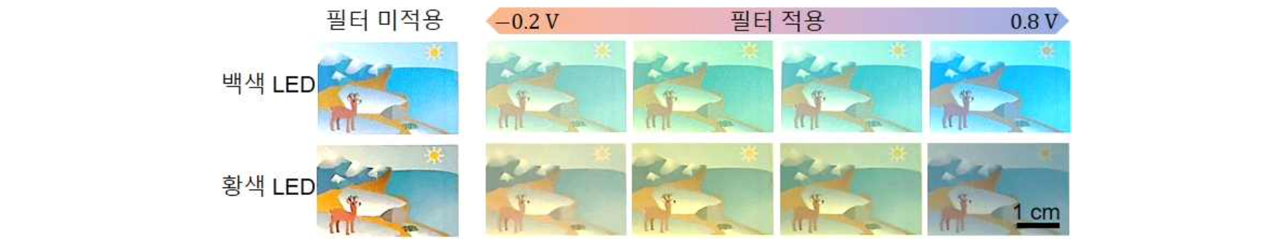▲ Optical filter that maintains the color of an object even under differently colored lighting

Student Gyurin Kim said, "I would like to thank Professor Hyeon-Ho Jeong for his sincere dedication to research and for always providing guidance. I would also like to express my gratitude to my colleagues who became academic comrades through lively discussions about theory and practice in the lab."

Meanwhile, a total of 1,189 papers were submitted to this competition, and 797 experts participated in the evaluation and selected 115 winning papers. Winners of bronze or higher are given the privilege of being exempted from the Samsung Recruitment Aptitude Test (GSAT) when applying for Samsung's third-level new employee recruitment.



