24 GIST professors selected as among the world’s top 2% researchers

- Reaching 12.8% of 188 full-time faculty
- 10 professors, including School of Mechanical Engineering Professor Hyo Sung Ahn, are ranked in the top 1% of the world's best

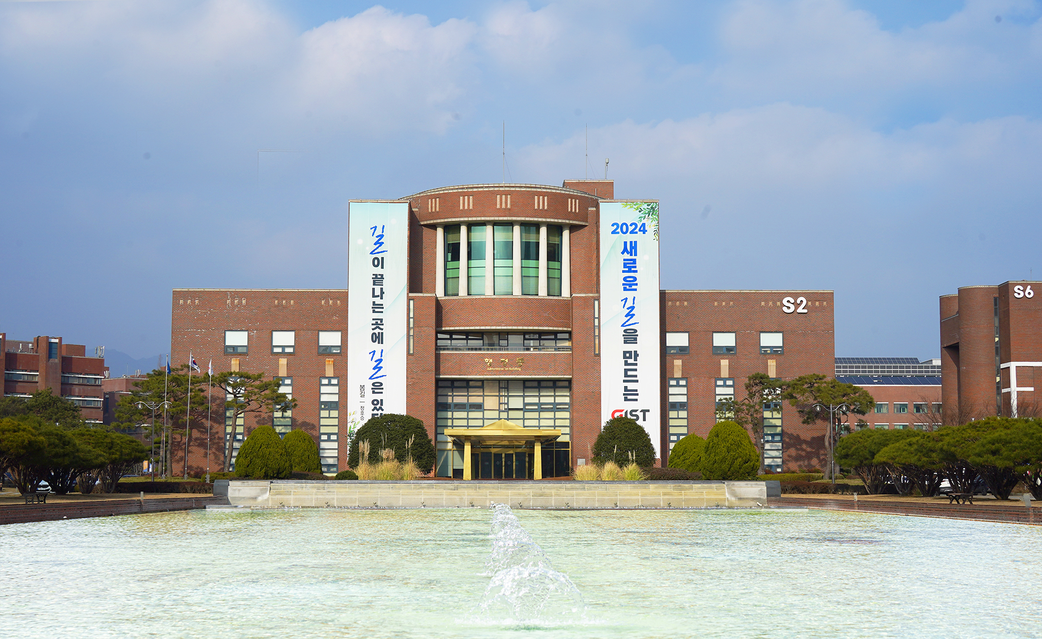▲ Panoramic view of GIST Administrative Building

The Gwangju Institute of Science and Technology (GIST, President Kichul Lim) announced that 24 professors were included among the researchers ranked in the ‘world’s top 2%’ based on paper citations. Among them, it was confirmed that there are 10 world-class researchers within 1%.

The ‘World’s Top 2% Researchers’ is an annual ranking of the world’s top researchers by Elsevier, a global academic information analysis company, and Professor John P.A. Ioannidis of Stanford University, USA, for the purpose of evaluating high-quality researchers in various fields. The list of 100,000 researchers is published using a complex method that goes beyond simple citation numbers.

At GIST, 24 professors, or about 12.8% of the total 188 full-time faculty members, were named among the ‘world’s top 2% researchers,’ including:

▴ School of Electrical Engineering and Computer Science Professors Byoung Seung Ham, Byeong Ha Lee, Young Min Song, and Minjae Lee ▴ School of Mechanical Engineering Professor Hyo Sung Ahn ▴ School of Materials Science and Engineering Professors Kwanghee Lee, Dong-Yu Kim, Jae Young Lee, Beongki Cho, Giyoong Tae ▴ School of Earth Sciences and Environmental Engineering Jaeyoung Lee, In Seop Chang, Kyoung-Woong Kim, Yunho Lee ▴ School of Life Sciences Professor Yong-Chul Kim ▴ AI Graduate School Professor Chang Wook Ahn.

School of Mechanical Engineering Professor Hyo Sung Ahn, who was ranked in the top 0.45% in the world, said, "GIST has proven its world-class research capabilities by ranking first in Korea for 16 consecutive years in the number of citations per professor in the QS World University Rankings last year. From the beginning, we have actively supported international academic exchange and joint research with world-class research universities and created an optimal research immersion environment."

Meanwhile, the recently released "Global Top 2% of World Scientists" analyzes the impact of researchers around the world who have published at least five papers in 22 scientific disciplines and 174 sub-disciplines, based on their citations from 1960 to 2022, as measured by SCOPUS, the leading index of scholarly publications.



