GIST student Sang-Hun Han receives Qualcomm Innovation Fellowship... Develops AI technology to create 3D human body with only a single image

- Sang-Hun Han, a combined master’s and doctoral student in Professor Hae-Gon Jeon’s lab, was finally selected for the ‘Qualcomm Innovation Fellowship Korea’ (Winner) for his achievements in restoring people in 3D
- High-quality 3D portrait restoration using a single high-resolution portrait photo... Dataset released for free

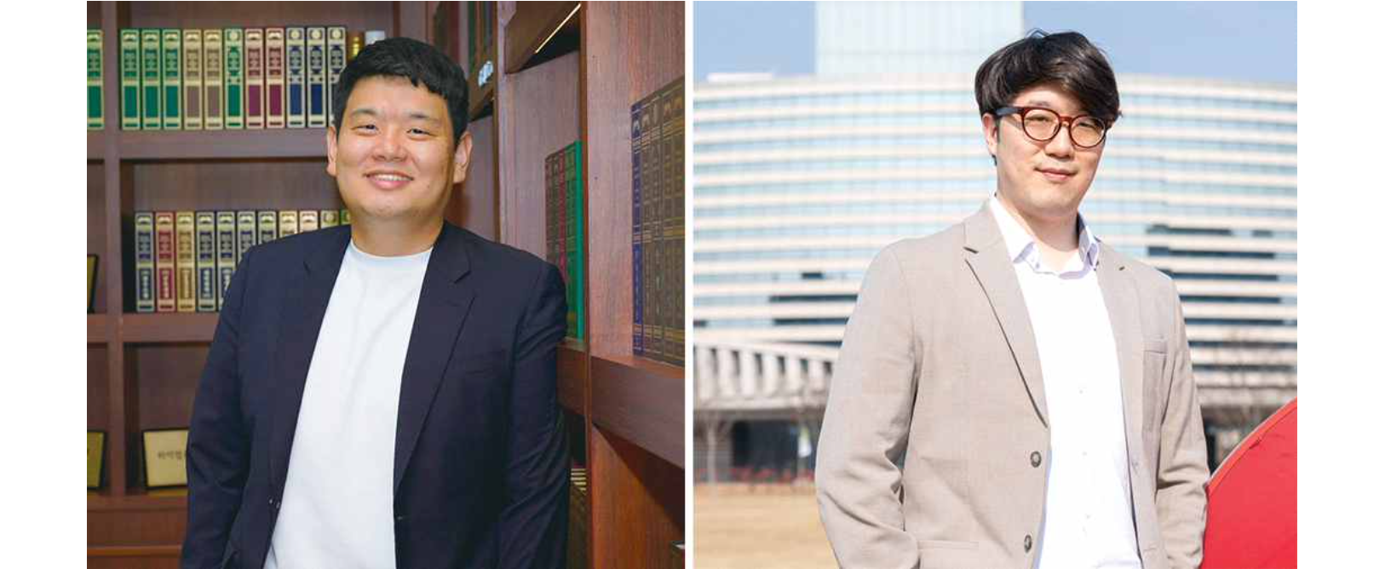

The Gwangju Institute of Science and Technology (GIST, President Kichul Lim) announced that Professor Hae-Gon Jeon's research team at the AI Graduate School succeeded in clearly restoring a 3D human image from a single image using artificial intelligence (AI) technology.

Sang-Hun Han, a student in the integrated Ph.D. program (advisor Professor Hae-Gon Jeon), was among the 15 papers selected as winners of the Qualcomm Innovation Fellowship Korea (QIFK) 2023.

‘QIFK 2023’, held on Tuesday, November 28 by Qualcomm Technologies Inc., the parent company of Qualcomm in Korea, pursues independence and creativity in research activities for domestic master’s and doctoral course researchers. Furthermore, the goal is to encourage outstanding performance.

The paper, led by Professor Hae-Gon Jeon and conducted by Sang-Hun Han, involves devising an artificial intelligence algorithm to restore people in high-quality 3D from a single high-resolution image.

The researchers segmented the high-resolution image into face, torso, arms, and legs, analyzed the geometric information, and reconstructed the human figure in multiple steps, resulting in a high-quality human model in real time.

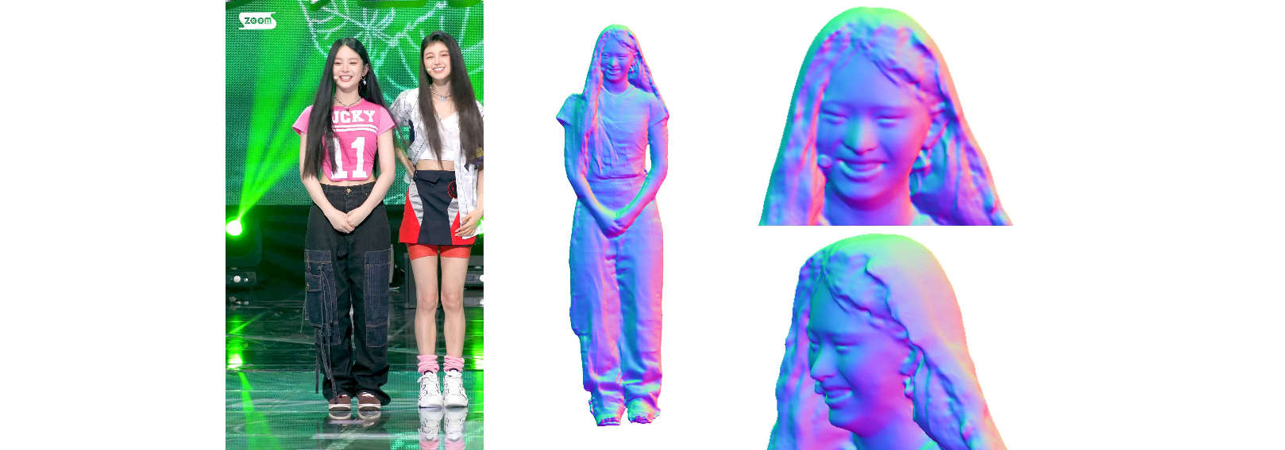▲ Results of applying this study to video. This is the result of restoring the model of this study using images extracted from Youtube videos. Even though the extracted video image is not clear, it consistently shows the results of expressing the facial expressions of people and wrinkles in fabric in detail in consecutive images.

3D character restoration is a core technology in the VR/AR and metaverse industries. In particular, detailed human body modeling that is similar to a real person even when viewed with the human eye is essential for creating a realistic virtual space. However, it requires many resources, including a studio equipped with expensive cameras and equipment for time-synchronized filming, as well as hiring skilled workers who can operate such equipment.

Recently, technology to restore 3D people from a single image using artificial intelligence is being researched, but there are limitations in expressing detailed parts such as facial expressions and wrinkles in clothes due to low resolution and limitations in computing power.

Additionally, due to the lack of datasets for training artificial intelligence, existing commercial datasets have good quality, but require a lot of cost for learning. On the other hand, non-commercial datasets have the disadvantage of being of poor quality and showing severe statistical bias compared to people observed in real life, as most of the human body models are adult men in their 20s.

To solve this problem, the team created a dataset of 2,000 different people as three-dimensional human body models, which they made freely available to the public for research purposes to advance the field.

For filming, the research team placed 80 DSLR cameras in a studio to surround the person, took multi-view images at the same time, and extracted feature points from them to construct a high-quality 3D human body model.

Unlike non-commercial datasets, this is diverse and has high value as a dataset because it includes a variety of genders, age groups, clothes, and postures.

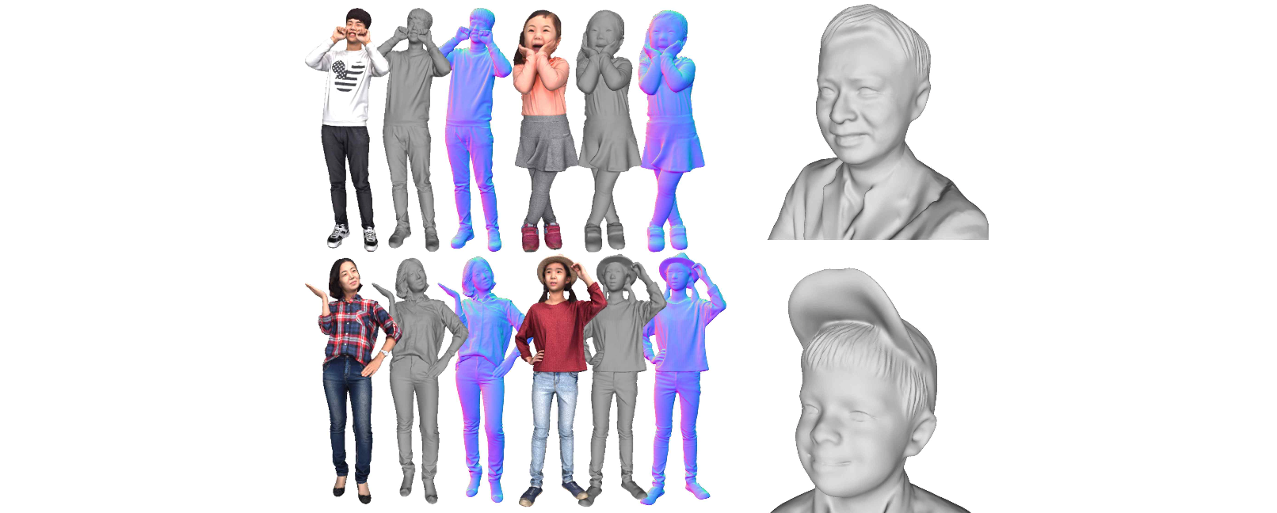▲ Examples of 3D human body dataset created in this study. The human body dataset created by the research team has the largest number of objects and high-quality models among non-commercial datasets, and it also has diversity in various statistical data such as gender, race, age, posture, and hairstyle. The research team is releasing it free of charge for research purposes.
https://github.com/SangHunHan92/2K2K

Professor Hae-Gon Jeon said, "The findings are significant because they pave the way for more researchers to conduct three-dimensional reconstructions of the human body, which are being led by a handful of institutions, including Carnegie Mellon University, MIT, and the Max Planck Institute in Germany. Until now, research on reconstructing the human body in three dimensions could only be started by purchasing large-scale paid datasets. GIST's collaboration with Dr. Ju Hong Yoon of the Korea Electronics Technology Research Institute has made the high-quality data available for free."

The professor also said, "The body 3D restoration technique, which restores 3D information for each human body and then combines it, has the advantage of reducing GPU usage, so even research groups lacking research equipment can download and use it without much burden."

This research was led by Professor Hae-Gon Jeon of the AI Graduate School and jointly conducted by integrated course student Sang-Hun Han and the team of Dr. Ju Hong Yoon and Dr. Min-Gyu Park of the Intelligent Image Processing Research Center at the Korea Electronics Research Institute with support from the ‘Artificial Intelligence-based Metaverse Implementation Project’ hosted by GIST with support from the Ministry of Science and ICT (Special Research and Development Zone) and Gwangju Metropolitan City and the ‘Multicultural Virtual Studio’ project and the ‘AI Innovation Hub’ project of the Ministry of Science and ICT.

Not only was it selected for 'QIFK' for its research achievements, but it was also selected as one of the 'Highlights' in the top 2.5% of papers submitted to CVPR (Conference on Computer Vision and Pattern Recognition), the world's largest artificial intelligence and computer vision society, and it also won a silver award at the 29th Samsung Human Tech Paper Award.



