GIST School of Earth Sciences and Environmental Engineering, outstanding graduate career paths... Over the past two years, six graduates have been appointed as professors in succession

- Appointment of professors at Korean private and national universities... demonstrates excellence in curriculum, education, and research of the School of Earth Sciences and Environmental Engineering

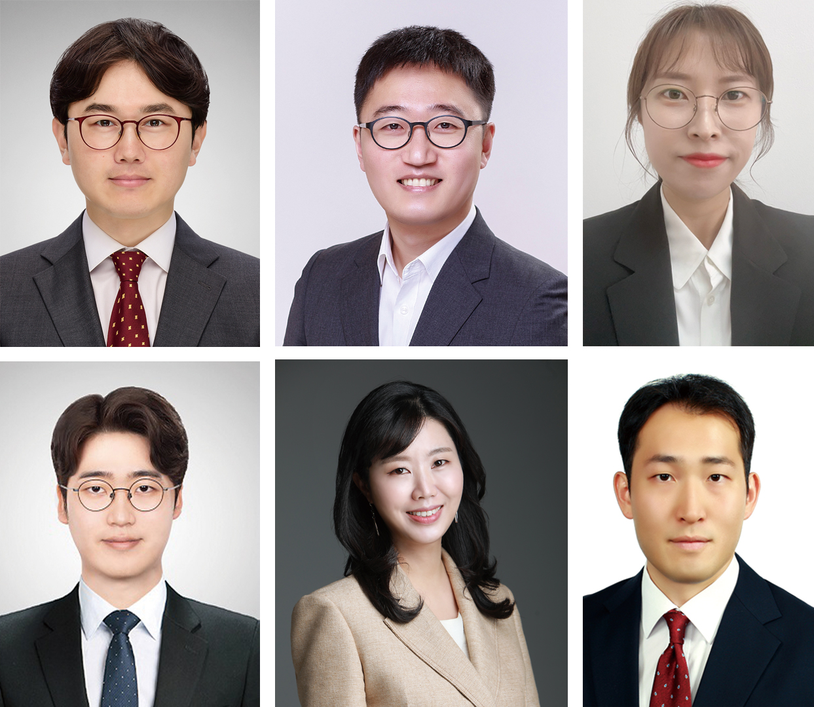▲ (Top row, from left) Dr. Kwan-ho Jeong (Assistant Professor, Chosun University), Dr. Seunghwa Lee (Assistant Professor, Changwon National University), Dr. Yuri Yang (Assistant Professor, Kangwon National University) / (bottom row, from left) Dr. Seokyoon Moon (Assistant Professor, Seoul National University of Science and Technology), Dr. Yunhyeong Choi (Associate Professor, Korea University), and Dr. Rak-Hoon Son (Assistant Professor, Pukyong National University)

The School of Earth Sciences and Environmental Engineering (Dean Yunho Lee) of the Gwangju Institute of Science and Technology (GIST, President Kichul Lim), which celebrates its 30th anniversary this year, is attracting attention for producing excellent graduates.

The School of Earth Sciences and Environmental Engineering currently has 23 faculty members conducting in-depth research in major fields such as ▴ ‘Earth and Climate Change’ ▴ ‘Water Science and Engineering’ ▴ ‘Sustainable Energy and Resources’. In particular, they focus on responding to the climate crisis, which is a global environmental problem, on carbon neutrality research, and on nurturing future talent.

Among these, alumni of the School of Earth Sciences and Environmental Engineering have been appointed as assistant professors, associate professors, etc. in succession over the past two years, proving once again the excellence of the department.

There are six in total △ Dr. Kwan-ho Jeong (advisor: Joon Ha Kim, graduated in February 2016) Assistant Professor, Department of Environmental Engineering, Chosun University △ Dr. Seunghwa Lee (advisor Jaeyoung Lee, graduated in August 2017) Assistant Professor, Department of Smart Green Engineering, Changwon National University △ Dr. Yuri Yang (Advisor: Hor-Gil Hur, graduated in February 2020) Assistant Professor, Department of Environmental Convergence, Kangwon National University △ Dr. Seokyoon Moon (Advisor Professor Youngjune Park, graduated in February 2021) Assistant Professor, Department of Future Energy Convergence, Seoul National University of Science and Technology △ Dr. Yunhyeong Choi (Advisor: Professor Kyoung-Woong, master’s degree in February 2005) Associate Professor, Department of Health and Environmental Convergence Science, Korea University △ Dr. Rak-Hoon Son (Advisor Professor Jin-Ho Yoon, graduated in February 2022) was appointed as an assistant professor in the Department of Earth and Environmental System Sciences at Pukyong National University.

First, Dr. Kwan-ho Jeong used mathematical modeling and numerical solutions at the Environmental Systems Engineering Laboratory (ESEL) to precisely analyze the flow and concentration distribution of the reverse osmosis (RO) membrane module in the pressure vessel. He earned a doctoral degree by proposing methods to improve process performance and energy efficiency. After graduation, Dr. Jeong worked as a postdoctoral researcher at Nanyang Technological University in Singapore for approximately three years from November 2016 to November 2019, performing mathematical modeling and numerical analysis of migration phenomena occurring in physical, biological, and electrochemical water treatment processes. through precise analysis and presented a method to improve process performance through process modeling and simulation.

In particular, Dr. Jeong conducted research on membrane contamination and physicochemical properties of the membrane surface in the reverse osmosis seawater desalination process and published them in top international journals such as ‘Water research’, ‘Desalination’, and ‘Journal of Membrane Science’. Dr. Jeong emphasized, “We aim to contribute to solving environmental problems through research on water reuse and seawater desalination using artificial intelligence, and we will train students to become creative and ethical environmental engineering experts.”

Dr. Seunghwa Lee received his doctoral degree from the Electrochemical Reaction & Technology Laboratory (ERTL) for his thesis ‘Research on electrochemical fuelization of carbon dioxide using copper-based electrode catalysts.’ After graduation, he worked as a postdoctoral researcher at École Polytechnique Fédérale de Lausanne (EPFL), where he conducted research on the synthesis of various electrochemical catalysts and real-time electrochemical reaction mechanisms for developing green energy conversion and storage systems.

In particular, as the lead author and co-author, he conducted a study on the characteristics and mechanisms through real-time analysis of the oxygen evolution reaction (OER) electrochemical catalyst, which is known to be a bottleneck in water electrolysis research, and published the results in the 'Journal of the American Chemical Society, Energy and Environmental Science' and Angewandte Chemie International Edition' and other top international journals. Dr. Lee said, “Focusing on the development of eco-friendly energy conversion and storage systems based on electrochemical reactions, we aim to conduct research that enables a carbon circular economy through various catalyst synthesis, reactor development, and real-time interface reaction analysis.”

Dr. Yuri Yang received her doctoral degree from the Applied Environmental Microbiology Laboratory (AEML) for her thesis on ‘Valorization of lignocellulosic biomass, an agricultural by-product, by integrating high-temperature and alkaline laccase treatment of Caldalkalibacillus thermarum Strain TA2.A1.’ After graduation, she worked as a postdoctoral researcher at GIST for approximately 3 years, researching the enhancement of enzyme activity through improved research on Laccase enzymes and the decomposition of herbicides and plastics with a non-specific, non-degradable organic pollutant decomposition system using the glucose oxidase-based Bio-Fenton reaction.

In particular, as the lead author, the results of herbicide and plastic decomposition research using a non-specific non-degradable organic pollutant decomposition system were published in world-class journals such as Chemosphere and Journal of Hazardous Materials. Dr. Yang said, “I would like to contribute to nurturing experts in the agricultural environment field by continuing research on the decomposition of various non-degradable organic pollutants using microorganisms.”

Dr. Seokyoon Moon received his doctoral degree from the Carbon Energy Systems Laboratory (CnESL) with a thesis on ‘Identification of thermodynamic specificity through control of lattice structure of clathrate hydrate and application to energy environment system.’ After graduation, he worked as a postdoctoral researcher at Columbia University in New York for about a year, where he conducted research to systematically characterize the thermodynamic and spectroscopic properties of crustacean hydrate for carbon dioxide processing and hydrogen energy storage.

In particular, as the lead author and co-author, he published the results of 'Carbon dioxide capture before and after hydrate-based combustion' and 'Discovery of tuning phenomenon in sI and sII crystal structures for maximizing the amount of carbon dioxide capture' in the Chemical Engineering Journal, a world-renowned journal ranked in the top 5% of the chemical engineering field. Based on the results, such as ‘Discovering the optimal storage amount according to the concentration of hydrated blue hydrogen for mixing next-generation hydrogen’, it was published in ‘Renewable and Sustainable Energy Reviews’, a renowned academic journal ranked within the top 5% in the field of eco-friendly and sustainable technology. “We aim to conduct research that will enable a circular economy by focusing on carbon, resources and energy,” said Dr. Moon.

Dr. Yunhyeong Choi completed her master's degree at the Soil and Environment Laboratory (SEL) and his doctorate in environmental health at the University of Michigan in 2011. During her study, she received a master's degree with a thesis on ‘Abatement of Arsenic Contamination in Contaminated Groundwater Using Iron/Manganese Oxide Reduction.’ After graduation, she worked as a postdoctoral researcher at Seoul National University for about a year and conducted research on the effects of exposure to hazardous substances on the development of diseases, especially exposure to heavy metals and organic pollutants, hearing loss, and chronic geriatric diseases and evaluated the relationship between them. From 2014 to early 2023, she served as an associate professor in the Department of Preventive Medicine at Gachon University School of Medicine.

In particular, she was selected as a Presidential Postdoc by the Ministry of Education in 2013, and the study titled ‘Case Study on Humidifier Disinfectant Exposure in Hospitals: Focusing on 4th Humidifier Disinfectant Victim Applicants’ also won the 30th Science and Technology Excellence Paper Award in 2020. Dr. Choi, whose main specialty is environmental health, is researching the relationship between exposure to hazardous environments and disease onset and the relationship between nutritional intake and disease development to prevent chronic geriatric diseases, and she has published numerous SCI papers suggesting desirable preventive methods for health promotion. Dr. Choi said, “The goal of my research is to find effective ways to improve the health and prevent diseases in our society and to effectively convey and communicate them to the public.”

Dr. Rak-Hoon Son received his doctoral degree from the Climate Analysis & Modeling Laboratory (CAM) with a research thesis on ‘future outlook for forest fire weather and improving forest fire weather predictability of numerical models using machine learning.’ After graduation, Dr. Son worked as a postdoctoral researcher at the Max Planck Institute for Biogeochemistry for approximately 1 year and 6 months from March 2022 to August 2023, and has been conducting research on extreme climate prediction and modeling, which he majored in in graduate school.

In particular, the results of research on integrating deep learning-based forest fire prediction models into operational global land surface models were pre-published in the top international journal 'Journal of Advances in Modeling Earth Systems' (on-review). Dr. Son said, “I aim to conduct research to warn and respond to future climate crises using deep learning and machine learning,” and added, “I will strive to become a respected educator who serves as a role model for my juniors.”

Dean Yunho Lee said, "The succession of PhDs from our department becoming professors is a result of proving the excellence of GIST's School of Earth Sciences and Environmental Engineering, which has established itself as one of the world's leading research hubs in the field of environmental research. I am proud that the alumni from the School of Earth Sciences and Environmental Engineering are demonstrating their capabilities in their respective fields."



